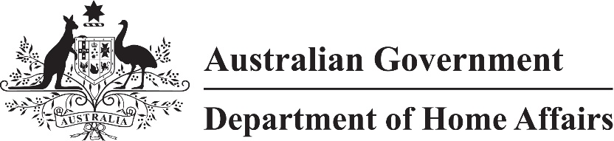
LIN 22/048
Migration (Arrangements for Electronic Travel Authority (Class UD) visa applications) Instrument (LIN 22/048) 2022
I, Michael Willard, delegate of the Minister, make this instrument under subregulation 2.07(5) of the Migration Regulations 1994 (the Regulations).
Dated 5 April 2022

Michael Willard
First Assistant Secretary
Immigration Programs Division
Department of Home Affairs

1 Name
This instrument is the Migration (Arrangements for Electronic Travel Authority (Class UD) visa applications) Instrument (LIN 22/048) 2022.

2 Commencement
This instrument commences on 5 April 2022.

3 Definitions
In this instrument:
AustralianETA means a mobile app that is made available or has been made available (including before the commencement of this instrument), by or on behalf of the Commonwealth.
Electronic Travel Authority visa means a Subclass 601 (Electronic Travel Authority) visa within the meaning given by the Regulations.

4 Making an application
For subitem 1208A(1) and paragraph 1208A(3)(a) of Schedule 1 to the Regulations, an application for an Electronic Travel Authority visa must be made using the AustralianETA application form on AustralianETA.
Note Applications for an Electronic Travel Authority visa can also be made in accordance with subregulation 2.07AB(1) or (2) of the Regulations.

