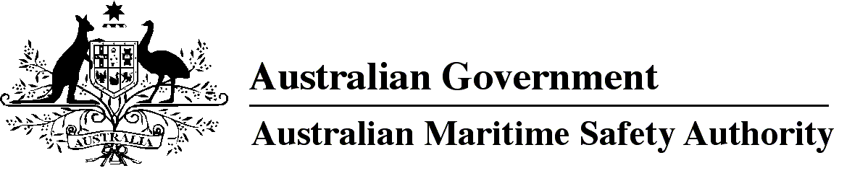

AMSA MO 2022/2

Marine Orders Amendment (Marine Order 505 — consequential changes) Order 2022

I, Michael Kinley, Chief Executive Officer of the Australian Maritime Safety Authority, (the National Marine Safety Regulator under section 9 of the *Marine Safety (Domestic Commercial Vessel) National Law*), make this Marine Order under subsection 163(1) of the *Marine Safety (Domestic Commercial Vessel) National Law* and under subsection 342(1) of the *Navigation Act 2012*.

29 March 2022

**Michael Kinley**  
Chief Executive Officer

Division 1 Preliminary 3

1 Name of Marine Order 3

2 Commencement 3

3 Amendment of Marine Orders 3

Schedule 1 4

Division 1 Preliminary

1 Name of Marine Order

This Marine Order is *Marine Orders Amendment (Marine Order 505 — consequential changes) Order 2022*.

2 Commencement

This Marine Order commences immediately after the commencement of *Marine Order 505 (Certificates of competency**— national law) 2022*.

3 Amendment of Marine Orders

Each Marine Order mentioned in Schedule 1 to this Marine Order is amended in accordance with the Schedule.

Schedule 1

(section 3)

Division 1 *Marine Order 504 (Certificates of operation and operation requirements — national law) 2018*

[1] Section 15, definition of *certificate of recognition*

omit

[2] Section 15, after definition of *Marine Order 501*

insert

***Marine Order 505*** means *Marine Order 505 (Certificates of competency — national law) 2022.*

[3] Section 15, definition of *NSCV Part D*

omit

[4] Schedule 1, subclause 6(5)

substitute

(5) For subclause (4):

***certificated*** means a person:

(a) who holds a certificate of competency required to undertake a duty or perform a function that is mentioned in Schedule 1 of Marine Order 505 for the kind of certificate; or

(b) who, in accordance with section 7 of Marine Order 505, is not required to hold a certificate of competency.

***Rule 1*** means that, if the chief engineer holds a certificate permitting the holder to be the chief mate, the number of certificated crew for the vessel may be reduced by 1 if the number of uncertificated crew is increased by 1.

***Rule 2*** applies only to a vessel with ≤ 750 kW propulsion power and means that, if the master holds a certificate permitting the holder to be the chief engineer, the number of certificated crew and master for the vessel may be reduced by 1 if the number of uncertificated crew is increased by 1.

[5] Schedule 1, subclause 6(6), Note after paragraph(k)

omit

[6] Schedule 1, subclause 6(16), paragraph (b)

omit

NSCV Part D

insert

Marine Order 505

[7] Schedule 2, clause 5, paragraph (c)

omit

NSCV Part D

insert

Marine Order 505

Division 2 *Marine Order 21 (Safety and emergency arrangements) 2016*

[8] Paragraph 10(2)(a)

omit each mention of

*Marine Order 505 (Certificates of competency) 2013*

insert

*Marine Order 505 (Certificates of competency — national law) 2022*

Division 3 *Marine Order 71 (Masters and deck officers) 2014*

[9] Section 4, definitions of *Master <24 m NC* *certificate of competency* and *Master <35 m NC* *certificate of competency*

substitute

***Master <24 m NC*** ***certificate of competency*** means a certificate of competency of that name mentioned in *Marine Order 505 (Certificates of competency*— *national law) 2022* that is issued by the National Regulator under the national law.

***Master <45 m NC*** ***certificate of competency*** means a certificate of competency of that name mentioned in *Marine Order 505 (Certificates of competency*— *national law) 2022* that is issued by the National Regulator under the national law.

[10] Section 4, after definition of *master duties or functions*

insert

***National Regulator*** has the same meaning as in section 9 of the national law.

[11] Section 4, Note 2

omit

IMO

insert

IMO

national law

[12] Schedule 2

omit each mention of

Master <35 m

insert

Master <45 m

Division 4 *Marine Order 72 (Engineer officers) 2014*

[13] Section 4, definition of *Engineer Class 3 NC certificate of competency*

substitute

***Engineer Class 3 NC*** ***certificate of competency*** means a certificate of competency of that name mentioned in *Marine Order 505 (Certificates of competency* — *national law) 2022* that is issued by the National Regulator under the national law.

[14] Section 4, definition of *Marine Engine Driver Grade 1 NC certificate of competency*

substitute

***Marine Engine Driver Grade 1 NC*** ***certificate of competency*** means a certificate of competency of that name mentioned in *Marine Order 505 (Certificates of competency* — *national law) 2022* that is issued by the National Regulator under the national law.

[15] Section 4, after definition of *Marine Engine Driver Grade 1 NC certificate of competency*

insert

***National Regulator*** has the same meaning as in section 9 of the national law.

[16] Section 4, Note 2

omit

IMO

insert

IMO

national law

Note

1. All legislative instruments and compilations of legislative instruments are registered on the Federal Register of Legislation under the *Legislation Act 2003.* See https://www.legislation.gov.au.