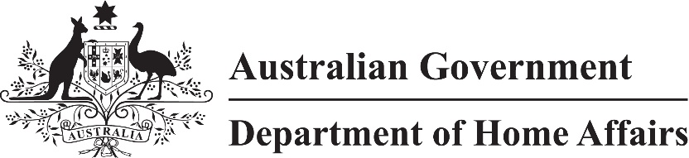

LIN 22/009

Migration (Arrangements for Temporary Work (International Relations) (Class GD) visa applications) (LIN 22/009) Instrument 2022

I, Paul Denman, delegate of the Minister, make this instrument under subregulation 2.07(5) of the *Migration Regulations 1994* (the Regulations)*.*

Dated 3 March 2022

Paul Denman

Acting Senior Executive Service Band One  
Immigration Programs Division  
Department of Home Affairs

1 Name

This instrument is the Migration (Arrangements for Temporary Work (International Relations) (Class GD) visa applications) *(LIN 22/009) Instrument 2022*.

2 Commencement

This instrument commences on 5 March 2022.

3 Definitions

In this instrument:

***ImmiAccount*** means the interactive portal for online services available through the Department’s website at https://immi.homeaffairs.gov.au.

***stream visa*** means a Subclass 403 (Temporary Work (International Relations)) visa in the stream to which the visa belongs.

*Note* For the meaning of ***stream***—see Regulations, regulation 2.03.

***written notice*** means an email from the Department inviting a person to make an application using a form and in a manner other than an Internet form through ImmiAccount including instructions about how to return the form to the Department.

4 Amendment to IMMI 18/085

Schedule 1 amends *Migration (IMMI 18/085: Arrangements for Temporary Work and Temporary Activity Visa Applications) Instrument 2018*.

Making an application for an Australian Agriculture Worker, Domestic Worker (Diplomatic or Consular), Pacific Labour Scheme or Seasonal Worker Program stream visa

(1) For subitem 1234(1) and paragraph 1234(3)(a) of Schedule 1 to the Regulations, an application for the following visas must be made using form 1403 (Internet) through ImmiAccount:

(a) an Australian Agriculture Worker stream visa;

(b) a Domestic Worker (Diplomatic or Consular) stream visa;

(c) a Pacific Labour Scheme stream visa;

(d) a Seasonal Worker Program stream visa.

(2) However, if a person has received a written notice, an application may be made using form 1403 in accordance with the instructions in the written notice.

Making an application for a Foreign Government Agency, Government Agreement or Privileges and Immunities stream visa

(1) For subitem 1234(1) and paragraph 1234(3)(a) of Schedule 1 to the Regulations this section specifies the requirements for making an application for the following visas:

(a) Foreign Government Agency stream visa;

(b) Government Agreement stream visa;

(c) Privileges and Immunities stream visa.

(2) A primary application or combined application must be made using:

(a) form 1403 (Internet) through ImmiAccount; or

(b) if a person has received a written notice—form 1403 in accordance with the instructions in the written notice.

(3) All other applications must be made using:

(a) form 1481 (Internet) through ImmiAccount; or

(b) if a person has received a written notice—form 1481 in accordance with the instructions in the written notice.

Schedule 1 Amendment

(section 4)

[1] Section 9

omit

[2] Schedule 4

omit