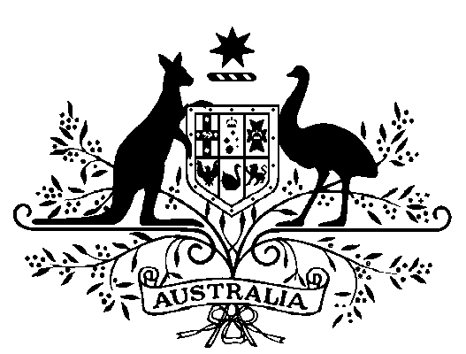

**Australian Prudential Regulation Authority -   
Full-Time Member - Appointment 2021**

I, General the Honourable David Hurley AC DSC (Retd), Governor-General of the Commonwealth of Australia, acting with the advice of the Federal Executive Council and under subsection 16(2) of the *Australian Prudential Regulation Authority Act 1998*, appoint Margaret Rose Cole as a full-time member of the Australian Prudential Regulation Authority for a period of five years beginning on 1 July 2021.

Dated 18 March 2021

David Hurley

Governor‑General

By His Excellency’s Command

Josh Frydenberg  
Treasurer