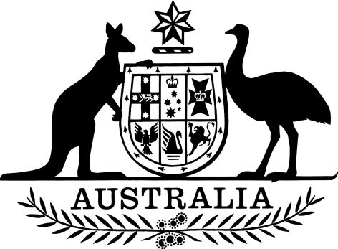

Road Vehicle Standards Rules Commencement Instrument (No. 1 of 2021)
I, Michael McCormack, Deputy Prime Minister and Minister for Infrastructure, Transport and Regional Development, do the following:
1. Acting under item 6 of the table in subsection 2(1) of the Road Vehicle Standard Rules 2019, fix the commencement date for sections 88 to 107 of those Rules as
1 April 2021.
2. Acting under item 8 of the table in subsection 2(1) of Road Vehicle Standards Rules 2019, fix the commencement date for sections 125 to 143 of those Rules as
1 April 2021.
3. Acting under item 15 of the table in subsection 2(1) of Road Vehicle Standards Rules 2019, fix the commencement date for sections 254 to 255 of those Rules as
1 April 2021.
Dated 25/3/2021
Michael McCormack
Deputy Prime Minister and Minister for Infrastructure, Transport and Regional Development

