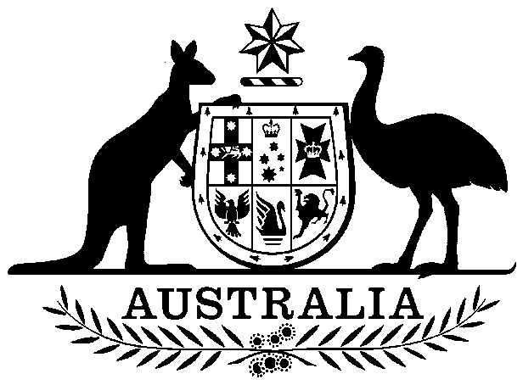

COMMONWEALTH OF AUSTRALIA

##### **Environment Protection and Biodiversity Conservation Act 1999**

###### DECLARATION OF AN APPROVED WILDLIFE TRADE OPERATION – COMMONWEALTH CORAL SEA FISHERY, January 2021

I, LAURA TIMMINS, Senior Director, Wildlife Trade Office, as Delegate of the Minister for the Environment, have considered in accordance with section 303FN of the *Environment Protection and* *Biodiversity Conservation Act 1999* (EPBC Act) the application from the Commonwealth Coral Sea Fishery, public comments on the proposal as required under section 303FR and advice on the ecological sustainability of the operation. I am satisfied on those matters specified in section 303FN of the EPBC Act. I hereby declare the operations for the harvesting of specimens that are, or are derived, from fish or invertebrates taken in the Commonwealth Coral Sea Fishery as defined under the *Fisheries Management Act 1991* (Cth) and the Fisheries Management Regulations 2019 (Cth), but not including

1. specimens that belong to taxa listed under section 209 of the EPBC Act (Australia’s List of Migratory Species), or
2. specimens that belong to taxa listed under section 248 of the EPBC Act (Australia’s List of Marine Species), or
3. specimens that belong to eligible listed threatened species, as defined under section 303BC of the EPBC Act, or
4. specimens that belong to taxa listed under section 303CA of the EPBC Act (Australia’s CITES List).

to be an approved wildlife trade operation, in accordance with subsection 303FN(2) and paragraph 303FN(10)(d), for the purposes of the EPBC Act.

Unless amended or revoked, this declaration:

1. is valid until 7 January 2024 and;
2. is subject to the conditions applied under section 303FT specified in the Schedule.

Dated this 7 day of January 2021

Laura Timmins

………….…….…………………………………

Delegate of the Minister for the Environment

Notes:

1. Under the Administrative Appeals Tribunal Act 1975, a person whose interests are affected by this decision may apply for a statement of reasons and for independent review of the decision. An application for a statement of reasons may be made in writing to the Department of Agriculture, Water and the Environment within 28 days of the date of the declaration. An application for independent review may be made to the Administrative Appeals Tribunal on payment of the relevant fee within 28 days of the date of the declaration, or if reasons are sought, within 28 days of receipt of reasons. Further information may be obtained from the Director, Wildlife Trade Assessments Section, Department of Agriculture, Water and the Environment, Telephone: (02) 6274 1917 Email: sustainablefisheries@environment.gov.au..

2. Australia’s obligations under the Convention on International Trade in Endangered Species of Wild Fauna and Flora (CITES) are met through Part 13A of the EPBC Act. Specimens of species listed in Appendix II of Australia’s CITES list under section 303CA of the EPBC Act may only be exported, under a CITES export permit issued under the EPBC Act, if Australia’s CITES Scientific Authority has issued a non-detriment finding for that species. Further information, including a list of species for which non detriment findings have been issued and the fisheries from which they may be sourced, is available from htttp://www.environment.gov.au/topics/biodiversity/wildlife-trade/internationally-endangered-plants-and-animals-cites/how-export.

Declaration of the harvest operations of the Commonwealth Coral Sea Fishery as an approved wildlife trade operation, January 2021

**ADDITIONAL PROVISIONS (section 303FT)**

Relating to the harvesting of fish specimens that are, or are derived from, fish or invertebrates, other than specimens of species listed under Part 13 and Part 13A of the *Environment Protection and Biodiversity Conservation Act 1999* (EPBC Act), taken in the Commonwealth Coral Sea Fishery:

1. The Australian Fisheries Management Authority must ensure that operation of the Coral Sea Fishery is carried out in accordance with the management arrangements defined under the *Fisheries Management Act 1991 (CTH)*, and the Fisheries Management Regulations 2019 (CTH).
2. The Australian Fisheries Management Authority must inform the Department of Agriculture, Water and the Environment of any intended material changes to the Coral Sea Fishery’s management arrangements that may affect the assessment against which *Environment Protection and Biodiversity Conservation Act 1999* decisions are made.
3. The Australian Fisheries Management Authority must inform the Department of Agriculture, Water and the Environment of any intended changes to fisheries legislation that may affect the legislative instruments relevant to this approval.
4. The Australian Fisheries Management Authority must provide reports to the Department of Agriculture, Water and the Environment annually as per Appendix B of the *Guidelines for the Ecologically Sustainable Management of Fisheries - 2nd Edition*.
5. The Australian Fisheries Management Authority must limit the take of species listed under the Convention on the International Trade of Endangered Species (CITES), from the area of the Coral Sea Fishery to no more than:
6. 40 tonnes per year (1 July – 30 June) of any mixture of species belonging to the family Acroporidae.
7. 50 individual Humphead Maori Wrasse (*Cheilinus undulates*) per year   
   (1 July – 30 June). Consistent with the trigger limits in the relevant Harvest Strategy, no more than 10 individuals can be caught without assessment of the catch. The assessment must be done in consultation with the CITES Scientific Authority.
8. 1 tonne per year of Black Teatfish (*H. whitmaei*)
9. By 1 December 2021, the Australian Fisheries Management Authority must review the science underpinning the catch limit for Humphead Maori Wrasse (*Cheilinus undulatus*). This review must include independent, expert scientific advice.
10. As part of the annual reporting requirement referred to in Condition 4, the Australian Fisheries Management Authority must report the following to the Department of Agriculture, Water and the Environment, as the CITES Scientific Authority of Australia:
11. the harvested weight and locations of harvest for each coral species. This reporting must be undertaken at a species-level.
12. the number of individual Humphead Maori Wrasse (*Cheilinus undulatus*), their sex, lengths and locations of harvest.
13. any assessments, management changes or findings relevant to the management of CITES-listed species in the Coral Sea Fishery
14. The Australian Fisheries Management Authority must update the science underpinning the Coral Sea Fishery – Sea Cucumber Sector Harvest Strategy by December 2021, including undertaking a fishery independent survey in the area of the fishery, to ensure that the harvest strategy is supported by up to date scientific information and supports a longer-term export approval for the fishery.
15. By 1 December 2022, the Australian Fisheries Management Authority must complete a review of the Coral Sea Fishery Harvest Strategy – Sea Cucumber Sector and develop, at a minimum:
16. species-specific trigger limits and reference points (or proxies) for species listed under CITES; and
17. ongoing data collection and monitoring plans required to support ongoing fishing of these species.