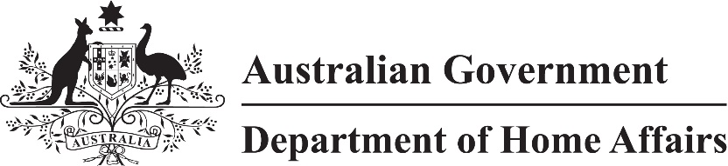

LIN 21/097

Migration (Class of persons for Visitor (Class FA) visa nil VAC) Amendment Instrument (LIN 21/097) 2021 (No. 2)

I, Sandra Jeffery, delegate of the Minister, make this instrument under subparagraph 1236(2)(a)(iv) of Schedule 1 to the *Migration Regulations 1994* (the Regulations)*.*

Dated 13 December 2021

Sandra Jeffery

Senior Executive Service, Band One

Immigration Programs Division

Department of Home Affairs

1 Name

This instrument is the Migration (Class of persons for Visitor (Class FA) visa nil VAC) *Amendment Instrument (LIN 21/097) 2021 (No. 2)*.

2 Commencement

This instrument commences on 15 December 2021.

3 Amendment

Schedule 1 amends Migration (Class of persons for Visitor (Class FA) visa nil VAC) Instrument (LIN 21/021) 2021.

Schedule 1 Amendment

(section 3)

1 Paragraph 4(d)

omit

31 December 2021

insert

30 June 2022

2 After section 4

insert

5 Application of amendments made by LIN 21/097

The amendments made by Migration (Class of persons for Visitor (Class FA) visa nil VAC) *Amendment Instrument (LIN 21/097) 2021 (No. 2)* apply to visa applications made after 26 February 2021.