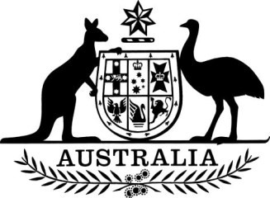

Carbon Credits (Carbon Farming Initiative—Measurement of Soil Carbon Sequestration in Agricultural Systems—Revocation) Instrument 2021

I, Angus Taylor, Minister for Industry, Energy and Emissions Reduction, make the following legislative instrument.

Dated: 1 December 2021

Angus Taylor

Minister for Industry, Energy and Emissions Reduction

Contents
1 Name........................................................................................................................................ 3
2 Commencement........................................................................................................................ 3
3 Authority.................................................................................................................................. 3
4 Interpretation............................................................................................................................ 3
5 Revocation of methodology determination............................................................................... 3

1 Name
This is the Carbon Credits (Carbon Farming Initiative—Measurement of Soil Carbon Sequestration in Agricultural Systems—Revocation) Instrument 2021.
2 Commencement
This instrument commences on the day after it is registered.
3 Authority
This instrument is made under subsection 123(1) of the Carbon Credits (Carbon Farming Initiative) Act 2011.
4 Interpretation
In this instrument:
Act means the Carbon Credits (Carbon Farming Initiative) Act 2011.
5 Revocation of methodology determination
The Carbon Credits (Carbon Farming Initiative—Measurement of Soil Carbon Sequestration in Agricultural Systems) Methodology Determination 2018 made under subsection 106(1) of the Act is revoked.

