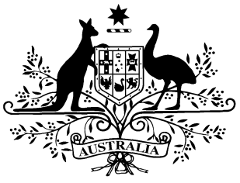

PB 124 of 2021

National Health (Paraplegic and Quadriplegic Program) Special Arrangement Amendment Instrument 2021 (No. 2)

National Health Act 1953
___________________________________________________________________________

I, DAVID LAFFAN, Assistant Secretary, Pharmacy Branch, Technology Assessment and Access Division, Department of Health, delegate of the Minister for Health, make this Amendment Instrument under subsection 100(2) of the National Health Act 1953.
Dated 29 November 2021

DAVID LAFFAN
Assistant Secretary
Pharmacy Branch
Technology Assessment and Access Division
Department of Health
___________________________________________________________________________
1 Name of Instrument
- This Instrument is the National Health (Paraplegic and Quadriplegic Program) Special Arrangement Amendment Instrument 2021 (No. 2).
- This Instrument may also be cited as PB 124 of 2021.
2 Commencement
This Instrument commences on 1 December 2021.
3 Amendments to National Health (Paraplegic and Quadriplegic Program) Special Arrangement 2021
Schedule 1 amends the National Health (Paraplegic and Quadriplegic Program) Special Arrangement 2021 (PB 31 of 2021).

Schedule 1 Amendments
- Schedule 1, entry for Macrogol 3350 in the form Sachets containing powder for oral solution 13.125g with electrolytes, 30
omit:
 |  |  | LaxaCon | EA | 2
- Schedule 2
omit:
EA | Amneal Pharmaceuticals Pty Ltd | 11 163 167 851

