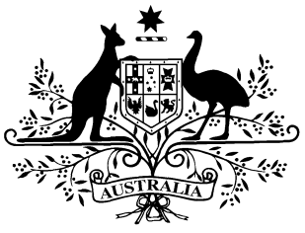

**PB 66 of 2021**

**National Health (Paraplegic and Quadriplegic Program) Special Arrangement Amendment Instrument 2021 (No. 1)**

*National Health Act 1953*

___________________________________________________________________________

I, MARIANA CRANK, Assistant Secretary (Acting), Pharmacy Branch, Technology Assessment and Access Division, Department of Health, delegate of the Minister for Health and Aged Care, make this Amendment Instrument under subsection 100(2) of the *National Health Act 1953*.

Dated 29 JUNE 2021

**MARIANA CRANK**

Assistant Secretary (Acting)

Pharmacy Branch

Technology Assessment and Access Division

Department of Health

___________________________________________________________________________

1. **Name of Instrument**
2. This Instrument is the *National Health (Paraplegic and Quadriplegic Program) Special Arrangement Amendment Instrument 2021 (No. 1)*.
3. This Instrument may also be cited as PB 66 of 2021.
4. **Commencement**

This Instrument commences on 1 July 2021.

1. **Amendment of *National Health (Paraplegic and Quadriplegic Program) Special Arrangement 2021* (PB 31 of 2021)**

Schedule 1 amends the *National Health (Paraplegic and Quadriplegic Program) Special Arrangement 2021* (PB 31 of 2021).

**Schedule 1 Amendments**

[1] Schedule 1, entry for Macrogol 3350 in the form Sachets containing powder for oral solution 13.125g with electrolytes, 30

omit:

|  |  |  | lax-sachets | AE | 2 |
| --- | --- | --- | --- | --- | --- |