Family Law (Superannuation) (Interest Rate for Adjustment Period) Determination 2021
I, Guy Francis Thorburn, Australian Government Actuary, make the following determination under regulation 45D of the Family Law (Superannuation) Regulations 2001.
Dated: 15 June 2021
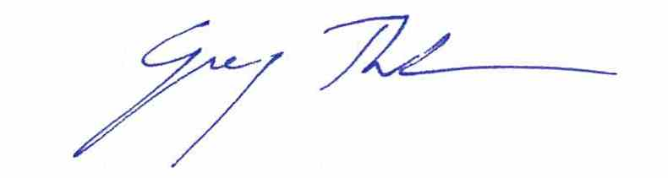
Guy Francis Thorburn
Australian Government Actuary

Contents
1 Name of determination 1
2 Commencement 1
3 Authority 1
4 Definition 1
5 Adjustment period—financial year 1
6 Adjustment period—less than 12 months within financial year 1
7 Adjustment period—12 months not within financial year 1
8 Adjustment period—less than 12 months not within financial year 2

1 Name of determination
This determination is the Family Law (Superannuation) (Interest Rate for Adjustment Period) Determination 2021.

2 Commencement
This determination commences on 1 July 2021.

3 Authority
This determination is made under regulation 45D of the Family Law (Superannuation) Regulations 2001.

4 Definition
In this determination:
regulations means the Family Law (Superannuation) Regulations 2001.

5 Adjustment period—financial year
For subregulation 45D(3) of the regulations, the interest rate for the adjustment period, being the financial year beginning on 1 July 2021, is 0.057.

6 Adjustment period—less than 12 months within financial year
(1) This section applies to an adjustment period of less than 12 months that begins and ends in the financial year beginning on 1 July 2021.
(2) For subregulation 45D(4) of the regulations, the method for working out the interest rate for the adjustment period is by using the formula:
${\text{1.0}\text{57}}^{\frac{\text{d}}{\text{365}}} \text{-} \text{1}$
where:
d is the number of days in the adjustment period.

7 Adjustment period—12 months not within financial year
(1) This section applies to an adjustment period of 12 months that begins in the financial year beginning on 1 July 2020 and ends in the financial year beginning on 1 July 2021.
(2) For subregulation 45D(6) of the regulations, the method for working out the interest rate for the adjustment period is by using the formula:
${\text{1.0}\text{57}}^{\frac{\text{d1}}{\text{d1 + d2}}} \text{ x} {\text{1.0}\text{57}}^{\frac{\text{d}\text{2}}{\text{d1 + d2}}} \text{ - 1}$

where:
d1 is the number of days in the adjustment period in the financial year beginning on 1 July 2020.
d2 is the number of days in the adjustment period in the financial year beginning on 1 July 2021.

8 Adjustment period—less than 12 months not within financial year
(1) This section applies to an adjustment period of less than 12 months that begins in the financial year beginning on 1 July 2020 and ends in the financial year beginning on 1 July 2021.
(2) For subregulation 45D(6) of the regulations, the method for working out the interest rate for the adjustment period is by using the formula:
${\text{1.0}\text{57}}^{\frac{\text{d1}}{\text{365}}} \text{ x }{\text{1.0}\text{57}}^{\frac{\text{d2}}{\text{365}}}\text{ - 1}$
where:
d1 is the number of days in the adjustment period in the financial year beginning on 1 July 2020.
d2 is the number of days in the adjustment period in the financial year beginning on 1 July 2021.

