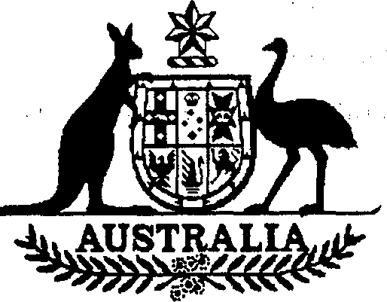

Charter of the United Nations (Anti­ terrorism — Persons and Entities) List 2002 (No 1)
I, ALEXANDER DOWNER, Minister for Foreign Affairs, issue this List under subregulation 7 (1) of the Charter of the United Nations (Anti-terrorism Measures) Regulations 2001.
Dated 10th March 2002

Alexander Downer
Minister for Foreign Affairs

Name of List
This List is the Charter of the United Nations (Anti-terrorism — Persons and Entities) List 2002 (No 1).

Commencement
This List commences on gazettal.

Persons, entities and assets
For subregulation 7(1) of the Charter of the United Nations (Anti-terrorism Measures) Regulations 2001, the persons and entities in Schedule 1 are listed.
Note Under subregulation 7 (1), the Minister must be satisfied that a person or entity is mentioned in paragraph 1 (c) of Resolution 1373 (2001) of the Security Council of the United Nations.

Schedule 1 Persons and entities
(section 3)

AFGHAN SUPPORT COMMITTEE (ASC) (a.k.a. AHYA UL TURAS; a.k.a. JAMIAT AYAT-UR-RHAS AL ISLAMIA; a.k.a. JAMIAT IHYA UL TURATH AL ISLAMIA; a.k.a. LAJNAT UL MASA EIDATUL AFGHANIA) Grand Trunk Road,
near Pushtoon Garhi Pabbi, Peshawar, Pakistan; Cheprahar Hadda, Mia Omar Sabaqah School, Jalalabad, Afghanistan

AL-JAZIRI, Abu Bakr; Peshawar, Pakistan; nationality: Algerian (individual)

AL-LIBI, Abd al-Mushin (a.k.a. ABU BAKR, Ibrahim Ali Muhammad) (individual) CONTINUITY IRA (CIRA), United Kingdom
FIRST OF OCTOBER ANTIFASCIST RESISTANCE GROUP (GRAPO), Spain

LASHKAR E-TAYYIBA (a.k.a. ARMY OF THE RIGHTEOUS; a.k.a. LASHKAR E-TOIBA; a.k.a. LASHKAR-I-TAIBA), Pakistan

LOYALIST VOLUNTEER FORCE (LVF), United Kingdom

MAHMOOD, Sultan Bashir-Ud-Din (a.k.a. MAHMOOD, Sultan Bashiruddin; a.k.a. MEHMOOD, Dr. Bashir Uddin; a.k.a. MEKMUD, Sultan Baishiruddin), Street 13, Wazir Akbar Khan, Kabul, Afghanistan; alt. DOB 1937; alt. DOB 1938; alt. DOB 1939; alt. DOB 1940; alt. DOB 1941; alt. DOB 1942; alt. DOB 1943; alt. DOB 1944;
alt. DOB 1945; nationality Pakistani (individual)

MAJEED, Abdul (a.k.a. MAJEED, Chaudhry Abdul; a.k.a. MAJID, Abdul); DOB 15 Apr 1939; alt. DOB 1938; nationality Pakistani (individual)

ORANGE VOLUNTEERS; United Kingdom

RED HAND DEFENDERS (RHD); United Kingdom

REVIVAL OF ISLAMIC HERITAGE SOCIETY (RIHS) (a.k.a. JAMIA IHYA UL TURATH; a.k.a. JAMIAT IHIA AL-TURATH AL-ISLAMIYA; a.k.a. REVIVAL OF ISLAMIC SOCIETY HERITAGE ON THE AFRICAN CONTINENT) Pakistan
office; Afghanistan office; (NOTE: office in Kuwait is NOT proscribed)

TUFAIL, Mohammed (a.k.a. TUFAIL, S.M.; a.k.a. TUFAIL, Sheik Mohammed); nationality Pakistani (individual)

2 Charter of the United Nations (Anti-terrorism — Persons and Entities) List 2002

.

ULSTER DEFENCE ASSOCIATION (a.k.a. ULSTER FREEDOM FIGHTERS);
United Kingdom

UMMAH TAMEER E-NAU (UTN) (a.k.a. FOUNDATION FOR CONSTRUCTION;
a.k.a. NATION BUILDING; a.k.a. RECONSTRUCTION FOUNDATION; a.k.a. RECONSTRUCTION OF THE ISLAMIC COMMUNITY; a.k.a. RECONSTRUCTION OF THE MUSLIM UMMAH; a.k.a. UMMAH TAMEER I- NAU; a.k.a. UMMAH TAMIR E-NAU; a.k.a. UMMAH TAMIR I-NAU; a.k.a. UMMAT TAMIR E-NAU; a.k.a. UMMAT TAMIR-I-PAU), Street 13, Wazir Akbar Khan, Kabul, Afghanistan; 60-C, Nazim Ud Din Road, Islamabad F 8/4, Pakistan

Charter of the United Nations (Anti-terrorism — Persons 3
and Entities) List 2002

