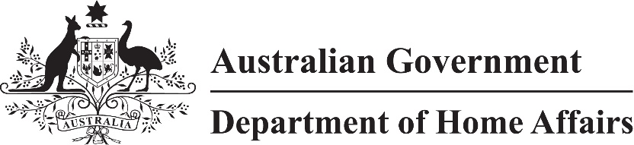

LIN 21/033

Migration (Class of persons for Visitor (Class FA) visa nil VAC) Amendment Instrument (LIN 21/033) 2021

I, Sandra Jeffery, delegate of the Minister for Immigration, Citizenship, Migrant Services and Multicultural Affairs, make this instrument under subparagraph 1236(2)(a)(iv) of Schedule 1 to the *Migration Regulations 1994*.

Dated 23 April 2021

Sandra Jeffery

Senior Executive Service, Band One

Immigration Programs Division

Department of Home Affairs

1 Name

This instrument is the Migration (Class of persons for Visitor (Class FA) visa nil VAC) *Amendment Instrument (LIN 21/033) 2021*.

2 Commencement

This instrument commences on 27 February 2021.

3 Amendment

Schedule 1 amends Migration (Class of persons for Visitor (Class FA) visa nil VAC) Instrument (LIN 21/021) 2021.

Schedule 1 Amendment

[1] Paragraph 4(c)

omit

, other than in the Frequent Traveller stream,