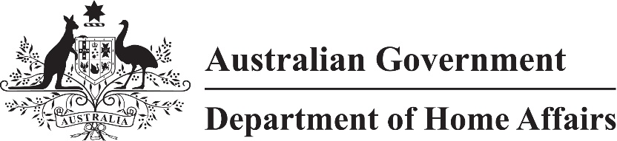
LIN 21/005
Migration (Specified courses and exams for registration as a migration agent) Amendment Instrument (LIN 21/005) 2021
I, Jason Wood, Assistant Minister for Customs, Community Safety and Multicultural Affairs, make this instrument under subregulation 5(4) of the Migration Agents Regulations 1998.
Dated 15 March 2021
Jason Wood
Assistant Minister for Customs, Community Safety and Multicultural Affairs

1 Name
This instrument is the Migration (Specified courses and exams for registration as a migration agent) Amendment Instrument (LIN 21/005) 2021.

2 Commencement
This instrument commences on the later of:
- immediately after the commencement of Parts 1 and 2 of Schedule 1 to the Migration Agents Amendment (Regulation of Migration Agents) Regulations 2020; and
- the day after registration.

3 Amendment
Schedule 1 amends the Migration (IMMI 18/003: Specified courses and exams for registration as a migration agent) Instrument 2018 (F2017L01708).

Schedule 1 Amendment
(s.3)
[1] Section 3
substitute
This instrument is made under subregulation 5(4) of the Regulations.
[2] Subsections 6(1) and (2)
omit
subregulation 5(1)
insert
subregulation 5(2)
[3] Subsections 7(1) and (2)
omit
subregulation 5(2)
insert
paragraph 5(3)(a)
[4] Paragraph 7(1)(a)
substitute
(a) the Capstone Assessment if passed before 1 January 2021;
[5] Subsection 7(3)
substitute
(3) For paragraph 5(3)(a) of the Regulations, if a person is not in a class of persons specified in subsection (2), a prescribed examination is the combination of:
(a) any of the following exams:
(i) the Capstone Assessment if passed before 1 January 2021;
(ii) the common assessment items relating to registration if passed before 1 January 2018; and
(b) any of the following exams in English language proficiency:
(i) IELTS Academic test;
(ii) TOEFL iBT test.
[6] Subsection 7(4)
omit
[7] Subsection 8(1)
omit
subsection 5(4)
insert
paragraph 5(3)(b)
[8] Subsection 9(1)
omit
subregulation 5(5)
insert
paragraph 5(3)(c)

