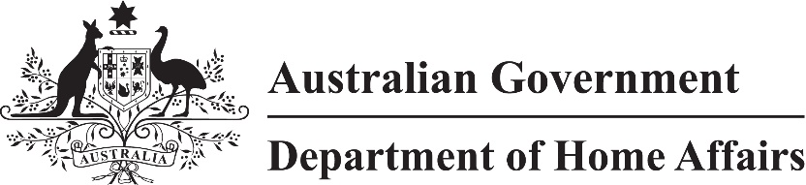

LIN 21/008

Migration (Post COVID-19 economic recovery event for Subclass 408 visas) Instrument (LIN 21/008) 2021

I, Jodie Bjerregaard, delegate of the Minister for Immigration, Citizenship, Migrant Services and Multicultural Affairs, make this instrument under paragraph 408.229(b) of Schedule 2 to the *Migration Regulations 1994 (*the Regulations)*.*

Dated 25 February 2021

Jodie Bjerregaard

Senior Executive Service, Band One

Immigration Programs Division

Department of Home Affairs

1 Name

This instrument is the Migration (Post COVID-19 economic recovery event for Subclass 408 visas*) Instrument (LIN 21/008*) 2021.

2 Commencement

This instrument commences on 27 February 2021.

3 Definitions

In this instrument:

***COVID-19*** means the pandemic declared by the World Health Organization on 11 March 2020, caused by the coronavirus COVID‑19.

***Subclass 408 visa*** means a Subclass 408 (Temporary Activity) visa.

4 Event

For paragraph 408.229(b) of Schedule 2 to the Regulations, the period of recovery from the economic effects of COVID-19 in Australia is a specified event (the event).

5 Class of persons

For paragraph 408.229(c) of Schedule 2 to the Regulations, an applicant is in a specified class of persons in relation to the event if the applicant:

(a) is employed full time as an essential staff member of an overseas business that:

(i) is relocating to Australia; and

(ii) will assist in Australia’s response to the event; and

(b) will assist with the establishment of the business’s operation in Australia; and

(c) makes an application for a Subclass 408 visa between 27 February 2021 and 30 June 2022; and

(d) has not previously been granted a visa in accordance with this instrument.