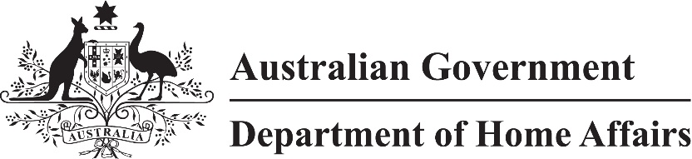

LIN 21/021

Migration (Class of persons for Visitor (Class FA) visa nil VAC) Instrument (LIN 21/021) 2021

I, Jodie Bjerregaard, delegate of the Minister for Immigration, Citizenship, Migrant Services and Multicultural Affairs, make this instrument under subparagraph 1236(2)(a)(iv) of Schedule 1 to the *Migration Regulations 1994 (*the ***Regulations***)*.*

Dated 24 February 2021

Jodie Bjerregaard

Senior Executive Service, Band One

Immigration Programs Division

Department of Home Affairs

1 Name

This instrument is the Migration (Class of persons for Visitor (Class FA) visa nil VAC) Instrument (LIN 21/021) 2021.

2 Commencement

This instrument commences on 27 February 2021.

3 Definitions

In this instrument:

***VAC*** means visa application charge.

Note *visa application charge* is defined in the *Migration Act 1958*.

4 Class of persons for nil VAC

For subparagraph 1236(2)(a)(iv) of Schedule 1 of the Regulations, an applicant for a Subclass 600 (Visitor) visa is specified if:

(a) the applicant is outside Australia at the time of application; and

(b) the application is made between 27 February 2021 and 31 December 2022; and

(c) the applicant was granted a Subclass 600 (Visitor) visa, other than in the Frequent Traveller stream, while outside Australia before 21 March 2020; and

(d) that visa expired, or will expire between 20 March 2020 and 31 December 2021; and

(e) that visa was:

(i) a multiple entry visa; or

(ii) a single entry visa that was not used to enter Australia; and

(f) if the applicant has made a previous application after the commencement of this instrument—a decision has not been made to grant or refuse to grant the visa.

5 Repeal

*Migration (LIN 20/045: Class of persons for Visitor (Class FA) visa applications) Instrument 2020* (F2020L00157) is repealed.