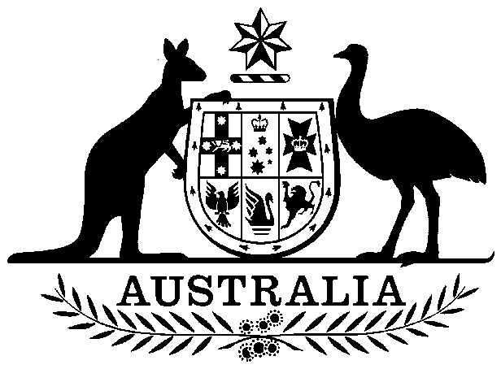

COMMONWEALTH OF AUSTRALIA

##### **Environment Protection and Biodiversity Conservation Act 1999**

###### DECLARATION OF AN APPROVED WILDLIFE TRADE OPERATION - NSW SOUTHERN CROSS BOTANICALS BEACH-CAST SEA KELP FISHERY, FEBRUARY 2020

I, Louise Vickery, Assistant Secretary, Environment Approvals and Wildlife Trade Branch, as Delegate of the Minister for the Environment, have considered in accordance with section 303FN of the *Environment Protection and* *Biodiversity Conservation Act 1999* (EPBC Act) the application from Southern Cross Botanicals. I am satisfied on those matters specified in section 303FN of the EPBC Act. I hereby declare the operations for the harvesting of specimens that are or are derived from marine vegetation, taken in the New South Wales Southern Cross Botanicals Beach-cast Sea Kelp Fishery as defined in the management regime in force under the *Fisheries Management Act 1994* (NSW), *Fisheries Management (General) Regulation 2019* (NSW)*,* the *Fisheries Management (Aquaculture) Regulation 2017* (NSW) and the *Marine Estate Management Regulation 2017* (NSW) but not including:

1. specimens that belong to taxa listed under section 209 of the EPBC Act (Australia’s List of Migratory Species), or
2. specimens that belong to taxa listed under section 248 of the EPBC Act (Australia’s List of Marine Species), or
3. specimens that belong to eligible listed threatened species, as defined under section 303BC of the EPBC Act, or
4. specimens that belong to taxa listed under section 303CA of the EPBC Act (Australia’s CITES List).

to be an approved wildlife trade operation, in accordance with subsection 303FN(2) and paragraph 303FN(10)(d), for the purposes of the EPBC Act.

Unless amended or revoked, this declaration:

1. is valid from the date of publishing on the Federal Register of Legislation until the   
   7th April 2023, and;
2. is subject to the conditions applied under section 303FT specified in the Schedule.

Dated this 9th day of April 2020

………….…….…………………………………

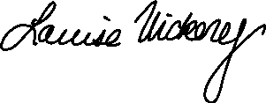

Delegate of the Minister for the Environment



A person whose interests are affected by this declaration may, within 28 days, make an application in writing to the Department of Agriculture, Water and the Environment for the reasons for the decision.  
  
An application for independent review of the decision (under section 303GJ (1) of the *Environment Protection and Biodiversity Conservation Act 1999*) may be made to the Administrative Appeals Tribunal (AAT), on payment of the relevant fee by the applicant, either within 28 days of receipt of the reasons for the decision, or within 28 days of this declaration if reasons for the decision are not sought. Applications should be made to the Deputy Registrar, AAT in your Capital City. Please visit the AAT’s website at <http://www.aat.gov.au/> for further information.

You may make an application under the *Freedom of Information Act 1982* (Cth) to access documents relevant to this decision. For further information, please visit <http://www.environment.gov.au/foi/index.html>.

Further enquiries should be directed to Wildlife Trade Assessments Section, Department of Agriculture, Water the Environment, Email: [wta@environment.gov.au](mailto:wta@environment.gov.au), Telephone: (02) 6274 1900 (option 2).

**SCHEDULE**

**ADDITIONAL PROVISIONS (section 303FT)**

Relating to the harvesting of marine vegetation specimens that are, or are derived from, marine vegetation, other than specimens of species listed under Part 13 of the *Environment Protection and Biodiversity Conservation Act 1999* (EPBC Act), taken in the NSW Southern Cross Botanicals Beach-cast Sea Kelp Fishery subject to the following conditions:

**Condition 1:**

Southern Cross Botanicals must ensure that the operation of the NSW Southern Cross Botanicals Beach-cast Sea Kelp Fishery is carried out in accordance with the management regime for the NSW Southern Cross Botanicals Beach-cast Sea Kelp Fishery in force under:

1. the *Fisheries Management Act 1994* (NSW);
2. permits issued by the NSW Department of Primary Industries to suppliers of Sea Kelp to Southern Cross Botanicals for the harvest of Sea Kelp, and
3. the NSW Southern Cross Botanicals Beach-cast Sea Kelp Fishery wildlife trade operation application (2019).

**Condition 2:**

Southern Cross Botanicals must inform the Department of Agriculture, Water and the Environment of any intended material changes to the NSW Southern Cross Botanicals Beach-cast Sea Kelp Fishery management arrangements that may affect the assessment against which *Environment Protection and Biodiversity Conservation Act 1999* decisions are made.

**Condition 3:**

Southern Cross Botanicals must provide a report annually, by 1 May each year, to the Department of Agriculture, Water and the Environment on the NSW Southern Cross Botanicals Beach-cast Sea Kelp Fishery. The report must include:

1. dates, species, locations, method of harvest and quantities of Sea Kelp received by Southern Cross Botanicals;
2. a copy of the current permit issued by the NSW Department of Primary Industries to the supplier(s) providing Sea Kelp to Southern Cross Botanicals, and
3. any interactions with, and steps taken to mitigate impacts on the EPBC Act listed shorebird – Hooded Plover (eastern) (*Thinornis rubricollis rubricollis*).