

Australian Medical Research and Innovation Priorities 2020 – 2022 Determination 2020

I, Ian Frazer, Chair of the Australian Medical Research Advisory Board, make the following instrument on behalf of the Advisory Board, under subsection 32E(1) of the Medical Research Future Fund Act 2015.

Dated: 3 November 2020
Professor Ian Frazer, AC
Chair, Australian Medical Research Advisory Board

Contents
1. Name of Instrument 3
2. Commencement 3
3. Cessation 3
4. Authority 3
5. Schedules 3
Schedule 1 4

- Name of Instrument
This instrument is the Australian Medical Research and Innovation Priorities 2020 – 2022 Determination 2020.
- Commencement
This instrument commences on the day after it is registered.
- Cessation
This instrument will cease to be in force as if repealed at the end of two years after the instrument is registered.
- Authority
This instrument is made under subsection 32E(1) of the Medical Research Future Fund Act 2015.
- Schedules

Schedule 1 to this determination contains the Australian Medical Research and Innovation Priorities 2020 – 2022.

Schedule 1

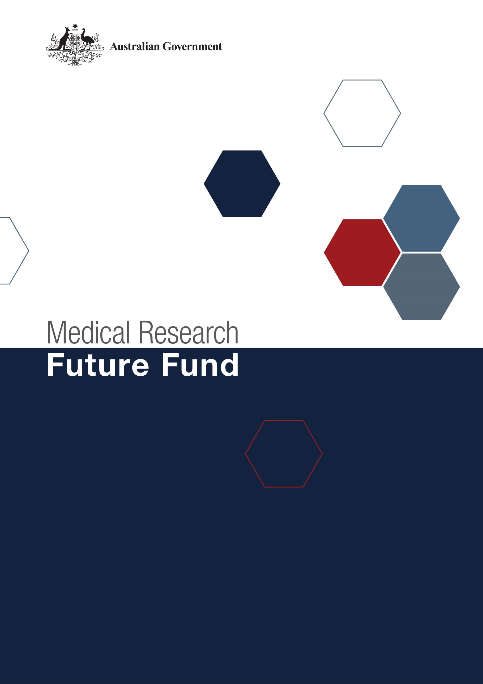
Australian Medical Research
and Innovation Priorities
2020-2022

Australian Medical Research and Innovation Priorities 2020-2022
Preamble
In accordance with the Medical Research Future Fund Act 2015 (the Act), the independent Australian Medical Research Advisory Board (AMRAB) must develop a five-year Australian Medical Research and Innovation Strategy and a set of related Australian Medical Research and Innovation Priorities (Priorities) to be in force for two years. The inaugural Medical Research Future Fund (MRFF) Strategy 2016-2021 was delivered to Government in early November 2016 with the second set of Priorities 2018-2020 delivered in early November 2018.
This document comprises the third set of MRFF Priorities spanning the period 2020-2022.
The Act requires AMRAB to take into account the following when determining the Priorities:
- the burden of disease on the Australian community;
- how to deliver practical benefits from medical research and medical innovation to as many Australians as possible;
- how to ensure that financial assistance provided under the MRFF complements and enhances other financial assistance provided for medical research and innovation; and
- any other relevant matters.
The Priorities for 2020-2022 were developed by AMRAB following a comprehensive national consultation process. Community and sector engagement on the development of the Priorities is critically important as the Priorities serve to inform future Government decisions on MRFF initiatives and investments. The 2020 consultation engaged the Australian public, organisations with expertise in health and medical research and innovation, consumer representatives, clinicians and health services managers. Full information about the national consultation, including the analysis of submissions, forums and roundtables, can be found at www.health.gov.au/mrff.
Australia has faced unprecedented challenges in the past year, including the devastating effects of bushfires and the COVID-19 pandemic. The Australian health system and medical research sector have demonstrated their immense ability and capacity to innovate and respond to these challenges. At the same time, research has continued on the priorities that are critical to ongoing improvements in health care and health outcomes, and to Australia’s preparedness for future health crises.
The current Strategy (2016-2021) and accompanying Priorities (2018-2020) have provided a wide-ranging platform that has allowed the MRFF to be responsive to the current health challenges, while continuing to funding projects that stimulate health and medical research across the entire research pipeline to achieve the MRFF’s strategic objectives. These Priorities maintain this adaptive approach. They will ensure investment in research is flexible and meets the needs of the changing health and medical landscape. They also support continued funding of national health priorities that improve research effectiveness, efficacy, quality and safety to deliver better health outcomes and a sustainable health system for all Australians. They remain consistent with the vision, aim, objectives and six strategic platforms identified in the MRFF Strategy 2016-2021.
The Act requires that the MRFF’s Priorities are refreshed every two years. The identification of new priorities does not impact initiative funding already committed by Government and yet to be the subject of an approach to market or contracted as grants.
MRFF Priorities are designed in accordance with the Act with the purpose of informing Government decision-making on future initiatives. While Government must take the MRFF Priorities into consideration when making these decisions, they are not required to address each and every priority.
These new Priorities reaffirm that funding from the MRFF is complementary to, and does not duplicate, the effort of the National Health and Medical Research Council (NHMRC), Australia’s premier health and medical research funding body. The Priorities are also designed to harness the Commonwealth’s significant investment in science, innovation and technology and align with the National Science Priorities and the National Innovation and Science Agenda. They are intended to complement investments by state and territory governments, and private and not-for-profit sectors in Australian health and medical research.
The National Collaborative Research Infrastructure Strategy (NCRIS) network continues to play an important support role for future research under the Priorities, and early collaboration and ongoing partnerships will be required to ensure that facilities can plan for demand, and to avoid duplication of investment.
The MRFF continues to provide a significant opportunity to transform health and medical research to improve lives and contribute to health system sustainability. Better integration of consumer involvement and collaboration across the research pipeline will play a key role in the successful translation of research outcomes into clinical practice. This should be embedded in all MRFF programs and grant opportunities.
The ongoing development of the MRFF Monitoring and Evaluation Strategy will also be critical to determine the difference the MRFF has made and supports continuous refinement and improvement of MRFF initiatives.

The 2020-2022 Priorities
The MRFF Priorities for 2020-2022 under each Strategic Platform are presented below. In determining each of the Priorities for 2020-2022, AMRAB has considered their ongoing appropriateness to guide MRFF investments whilst they operate under the current Australian Medical Research and Innovation Strategy. This is explored in Why the priority is or remains important as well as How the priority might be addressed through initiative implementation.

Strategic and International Horizons
Priority | WHY action is needed | HOW best addressed
One Health – Antimicrobial Resistance  There are no borders between human and animal health when it comes to antimicrobial resistance (AMR). Research into stewardship practices, diagnostic and treatment tools, preventative measures, and new or novel antimicrobials and vaccines that spans this divide is critical. | Australia has one of the highest rates of antibiotic use in the world. High rates of antibiotic use are associated with increasing rates of antibiotic resistance. Australia’s National AMR Strategy-2020 and Beyond recognises that AMR is a One Health issue that requires a coordinated response in all sectors including the human health, animal health, food and agriculture sectors, as well as close coordination with global action. | Provision of research grant opportunities that focus on collaborative multidisciplinary research to achieve better public health outcomes through the understanding of mechanisms of microbe transfer between animals and humans and by the development of strategies to reduce inappropriate antibiotic use and apply novel therapeutic solutions.
Global Health and Health Security  Global health challenges including health emergencies and pandemic preparedness, the impact of climate and environmental change on health, and the development and implementation of low technology preventative, diagnostic and treatment solutions are best addressed through international research collaboration. | Health is a global effort and today’s world is highly interconnected. The emergence and response to COVID-19 has highlighted the interconnectedness of health. Australians can benefit from research that addresses both identified and emerging (unspecified) global threats, the ongoing effects on health and the health system, such as mental health care, and delivers fit-for-purpose healthcare innovations that can also benefit other nations. It is important that Australian researchers think and work globally to address shared challenges. | Focus on investments that purposefully stimulate public good research that addresses global health and health security issues of relevance to Australia including preparedness for both identified and emerging global threats.
Aboriginal and Torres Strait Islander Health  Indigenous leadership and Indigenous-led priority setting to drive health-related research to improve the health of Aboriginal and Torres Strait Islander Australians and to close the gap on health mortality and morbidity. | Health and social equity for Indigenous Australians remains one of Australia’s most enduring challenges. The gap between Indigenous and other Australians in life expectancy, mortality and wellbeing remains large and unacceptable. Indigenous health research investment to date has been fragmented and not always prioritised or led by communities. In line with the National Agreement on Closing the Gap, enhancing Indigenous research capacity is essential. | Continued investment is required that focuses on Indigenous leadership, agency and community empowerment, the promotion of health equity, elimination of discrimination and the strengthening of Indigenous research capacity. Investment should continue to be driven through Aboriginal and Torres Strait Islander governance and with regard to the social and cultural determinants of health and the four priority reforms of the Closing the Gap Agreement.
Ageing and Aged Care  Research into the diseases of ageing and the means to prolong quality of life, including tackling cognitive decline and dementia, and compressing the period of intense morbidity in later years through biomedical discovery and health service innovation in residential and home care. | The intergenerational redistribution ahead requires a concerted research focus on ageing Australians. Optimising the physical and cognitive health and wellbeing of older Australians is one of society’s greatest challenges. It requires a multidisciplinary understanding of prevention, behaviour, biomarkers, disability and mobility, co-morbidity, models of care, consumer choice and care needs. | Continued investment that boosts efforts in biomedical, medical technology and health services research into ageing and aged care. Investment focus needs to be responsive to any research-relevant outcomes from the Royal Commission into Aged Care Quality and Safety Final Report, due in February 2021.

Data and Infrastructure
Priority | WHY action is needed | HOW best addressed
Digital Health Intelligence  Data science, informatics, advanced clinical decision making tools, wearables and artificial intelligence research and other emerging innovative technologies are the key to realising the benefits of healthcare digitalisation. | Digital health uses information technology to support and enhance clinical safety, improve productivity and efficiency and connect the health system. The potential for improved prevention, patient care, behavioural change and care compliance is enormous, as articulated in Australia’s National Digital Health Strategy, which is agreed by all governments. Australia is undergoing an eHealth revolution and research is critical in harnessing the potential of My Health Record and other digital tools to improve health outcomes. | Work with the Australian Digital Health Agency, states and territories and key industry players to define and then conduct a series of thematic research grant opportunities that advance data platforms, linkage and analytics; end-user digital utility; the development of novel decision tools; and applied artificial intelligence. Opportunity to align with the emerging National Framework for Clinical Quality Registries should be further explored.

Health Services and Systems
Priority | WHY action is needed | HOW best addressed
Comparative Effectiveness Research  Support systematic evaluation and demonstration of the comparative value of health interventions to better inform the decisions policy makers, clinicians and consumers make in healthcare. | Healthcare is about choices – this treatment or policy over that, essentially ‘what works best’. Knowledge of the benefits and harms of alternative means to prevent, diagnose, treat, and to monitor care, can transform health outcomes. It is important to close the gap between efficacy and effectiveness. Evidence generated by comparative effectiveness research improves treatment and informs decision making about investment and divestment. | Develop a program to drive prioritised targeted grant opportunities to conduct research that engages patient populations that are typical in primary and acute care settings in randomised control trials; data, observational, service model and behavioural economic studies; and decision analysis research including patient benefit or cost effectiveness. Priorities need to be driven by clinicians, consumers and policy makers.
Primary Care Research  Address the capacity and production gap in primary care research with an emphasis on multi-disciplinary, adaptive research methodologies, innovative models of care and clinician capability support. | While most healthcare occurs in the community, most research occurs in tertiary or specialist settings. In primary care patients typically present early with undifferentiated disease and multiple co-morbidities. The increasing complexity of care environments make practitioner and care team decisions increasingly difficult. The business reality of general and allied health practice also leaves little time for research translation. The growth in chronic and complex diseases, particularly in cohorts with low socioeconomic status, calls for a more concerted effort in primary care research that is geographically relevant and, where possible, scalable nationally to maximise impact. | Advance primary health care research including Indigenous primary health care, through mechanisms including Practice-Based Research Networks , Advanced Health Research and Translation Centres , Centres for Innovation in Regional Health , and the Australian Clinical Trials Alliance to conduct prioritised primary care research that is led by clinicians, can permeate daily practice and has potential for scalability.

Capacity and Collaboration
Priority | WHY action is needed | HOW best addressed
Clinical Researcher Capacity  Continue to support and enhance Australian clinical researcher capacity with a focus on next generation fellowships that target multidisciplinary engagement, fields of emerging scientific effort that have healthcare application potential and primary care. Overarching responsibility to increase capacity and capability sits within individual MRFF programs. | Clinically active researchers bring a practice perspective that aids research translation. Sufficient and sustained investment is required to ensure Australia maintains its reputation for medical research excellence. This attention must traverse career stages with a clear focus on early and mid-career required to ensure the viability of the next generation of researchers. It must also draw on the increasing diversity of disciplines intersecting with healthcare innovation and engage with the end-user of research – the clinician and consumer. | Continue to invest in capacity development with a focus on priority areas including early and mid-career researchers. Explore opportunities to work in partnership with professional colleges and industry to enhance access to PhD scholarships for general practice and allied health.
Consumer-Driven Research  Conduct research that is driven by crowdsourcing consumer priorities and purposefully connecting researchers to consumers with the intent of enhancing evidence translation into every day clinical practice. | Sometimes there is a mismatch between what researchers want to research and the lived experiences, values and priorities of consumers, carers and clinicians. Partnerships in research design and practice can increase the translation of research evidence and illuminate new discoveries, transforming the healthcare experience and maximising the impact of research investment. | Embed partnerships in research grant opportunities that drive meaningful consumer involvement, pairing researchers to consumers, carers and clinicians through a joint priority setting methodology that enables and supports consumer-driven targeted research.

Trials and Translation
Priority | WHY action is needed | HOW best addressed
Drug Repurposing  Partner with industry to foster an enduring partnership to systematically identify drugs with repurposed therapeutic potential for investigative research. | The application of an existing therapeutic to a new disease indication is attractive in terms of decreasing development costs and decreasing the time needed to deliver new therapies to the patient. De novo drug development can take well over a decade. Currently, repurposing of drugs is difficult and achieved by access to comprehensive libraries of clinical compounds. New technologies and advances in experimental methods can accelerate the identification and access to drugs of interest. | Create and invest in programs to identify and research drugs with repurposing potential, with a focus on supporting timely access for patients.
Public Health Interventions  Targeted research to test innovative public health approaches to addressing modifiable risk factors that are at the heart of the rise of chronic and complex disease prevalence and persistence in Australia. Equity of access to healthcare will benefit with a focus on the increased role of remote care interventions through mobile, telehealth and digital health. | Investment in public health brings economic benefit. Chronic conditions are the leading cause of illness, disability and death in Australia. They are prevalent, persistent and can gradually lead to a deterioration of health and loss of independence. Primary causes are typically known (behavioural and biomedical) and modifiable. There is great potential for integrating prevention and public health interventions with healthcare to keep Australians healthy for as long as possible. | Continued investment in research grant opportunities for multidisciplinary collaborative teams to test the viability of innovations in prevention and public health interventions. This includes interventions that consider health inequities such as geographic place, socio-economic vulnerabilities and groups with greater health needs and apply sound implementation science approaches.

Commercialisation
Priority | WHY action is needed | HOW best addressed
Translational Research Infrastructure  Address gaps in early biomedical and medical technology product development by supporting access to expertise and infrastructure in partnership with industry that seeks to accelerate rapid pre-clinical work and evaluation and build sustainability in the sector. | Early drug or device development across all stages of the pipeline can suffer from a lack of sufficient threshold evidence critical to attracting future private capital. For Australian innovation this sometimes means research needs to ‘go back, before it can go forward’ creating a loss in opportunity. Research must be rigorous and reproducible to demonstrate investment merit. Better integration with and access to NCRIS support and advanced biomedical translation assets is required to ensure that discoveries are converted to new drug candidates, devices and treatments with quality data and speed. This will make Australian research more ‘investable’. | Continue investment that complements the MRFF’s existing proof-of-concept supporting programs by providing timely and strategic access to expertise and infrastructure that facilitates research into novel biomedical technologies to enable their translation into clinical practice.  Emphasis should also be placed on building capacity and capability, including through collaboration and partnerships, for example with the philanthropic sector, and links with other Government activities such as initiatives to support advanced manufacturing.

includes Aboriginal and Torres Strait Islander people; those living in rural and remote areas; people with disability; lesbian, gay, bisexual, transgender and intersex people (LGBTI); and those from culturally and linguistically diverse backgrounds

