

Disability (Access to Premises – Buildings) Amendment Standards 2020
I, Christian Porter, Attorney-General, make these Standards under subsection 31(1) of the Disability Discrimination Act 1992.
Dated 24 September 2020
Christian Porter
Attorney-General

Contents
1 Name 1
2 Commencement 1
3 Authority 1
4 Schedules 1
Schedule 1—Amendments 2
Disability (Access to Premises – Buildings) Standards 2010 2

1 Name
These Standards are the Disability (Access to Premises – Buildings) Amendment Standards 2020.

2 Commencement
These Standards commence the day after registration on the Federal Register of Legislation.
Note: These Standards take effect subject to subsection 31(4) of the Disability Discrimination Act 1992.

3 Authority
These Standards are made under subsection 31(1) of the Disability Discrimination Act 1992.

4 Schedules
Each instrument that is specified in a Schedule to this instrument is amended or repealed as set out in the applicable items in the Schedule concerned, and any other item in a Schedule to this instrument has effect according to its terms.

Schedule 1—Amendments

Disability (Access to Premises – Buildings) Standards 2010
1 Paragraph 4.5(2)(b)
Repeal the paragraph, substitute:
(b) be located in a new part of a building.
2 Clause A1.1 of Part A1 of Schedule 1 (definition of BCA)
Omit “2009”, substitute “2019”.
3 Clause A1.1 of Part A1 of Schedule 1
Insert:
drainage means any sanitary drainage, liquid trade waste drainage or stormwater drainage system.
4 Clause A1.1 of Part A1 of Schedule 1 (definition of early childhood centre)
Repeal the definition, substitute:
early childhood centre means any premises, or part thereof, providing or intending to provide a centre-based education and care service within the meaning of the Education and Care Services National Law Act 2010 (Vic), the Education and Care Services National Regulations (NSW) and centre-based services that are licensed or approved under State and Territory children’s services law, but excludes education and care primarily provided to school aged children in outside school hours settings.
Note: In 2020, the Education and Care Services National Law Act 2010 (Vic) could be accessed from www.legislation.vic.gov.au and the Education and Care Services National Regulations (NSW) could be accessed from www.legislation.nsw.gov.au.
5 Clause A1.1 of Part A1 of Schedule 1
Insert:
electric passenger lift means a power-operated lift for raising or lowering people in a car in which the motion of the car is obtained from an electric motor mechanically coupled to the hoisting mechanism.
electrohydraulic passenger lift means a power-operated lift for raising or lowering people in a car in which the motion of the car is obtained from the action of liquid under pressure acting on a piston or ram, the pressure being generated by a pump driven by an individual electric motor.
fire safety system means one or any combination of the methods used in a building to:
(a) warn people of an emergency; or
(b) provide for safe evacuation; or
(c) restrict the spread of fire; or
(d) extinguish a fire;
and includes both active and passive systems.
heated water means water that has been intentionally heated. It is normally referred to as hot water or warm water.
inclined lift means a power-operated device for raising or lowering people within a carriage that has one or more rigid guides on an inclined plane.
low-rise, low-speed constant pressure lift means a power-operated low-rise, low-speed device for raising or lowering people with limited mobility on a carriage that is controlled by the application of constant pressure to a control.
low-rise platform lift means a power-operated device for raising or lowering people with limited mobility on a platform, that is controlled automatically or by the application of constant pressure to a control.
NCC means the National Construction Code 2019.
Note: In 2020, the National Construction Code 2019 could be accessed from www.ncc.abcb.gov.au.
performance requirement means a requirement which states the level of performance which a Performance Solution or Deemed-to-Satisfy Solution must meet.
private bushfire shelter means a structure associated with, but not attached to, or part of a Class 1a dwelling that may, as a last resort, provide shelter for occupants from immediate life threatening effects of a bushfire.
small-sized, low-speed automatic lift means a restricted use power-operated device for the infrequent raising or lowering of people with limited mobility on a platform that is controlled automatically but has the capability of being electrically isolated by a key-lockable control.
6 Clause A1.1 of Part A1 of Schedule 1 (paragraph (d) of the definition of sole-occupancy unit (SOU))
Omit “aged care building”, substitute “building”.
7 Clause A1.1 of Part A1 of Schedule 1
Insert:
stairway platform lift means a power-operated device for raising or lowering people with limited mobility on a platform (with or without a chair) in the direction of a stairway.
8 Clause A1.1 of Part A1 of Schedule 1 (definition of swimming pool)
Repeal the definition, substitute:
swimming pool means any excavation or structure containing water and principally used, or that is designed, manufactured or adapted to be principally used for swimming, wading, paddling, or the like, including a bathing or wading pool, or spa.
9 Clause A3.1 of Part A3 of Schedule 1 (table 1)
Repeal the table (not including the heading), substitute:
No. | Date | Title | Provision(s) of Access Code
AS 1428 |  | Design for access and mobility
Part 1 | 2009 | General requirements for access — New building work (incorporating amendments 1 and 2) | A1.1, D3.1, D3.2, D3.3, D3.6, D3.8, D3.9, D3.10, D3.12, D5.2, D5.3, F2.4
Part 1 | 2001 | General requirements for access — New building work | H2.7, H2.8, H2.10, H2.15
Part 1  (Supplement 1) | 1993 | General requirements for access — Buildings — Commentary | H2.2
Part 2 | 1992 | Enhanced and additional requirements — Buildings and facilities | H2.2, H2.3, H2.4, H2.5, H2.7, H2.10, H2.11, H2.12, H2.13, H2.14
Part 4 | 1992 | Tactile ground surface indicators for the orientation of people with vision impairment | H2.11
AS/NZS 1428 |  | Design for access and mobility
Part 4.1 | 2009 | Means to assist the orientation of people with vision impairment — Tactile ground surface indicators (incorporating amendments 1 and 2) | D3.8
AS 1735 |  | Lifts, escalators and moving walks (SAA Lift Code)
Part 12 | 1999 | Facilities for persons with disabilities (incorporating amendment 1) | E3.6, H2.6
AS/NZS 2890 |  | Parking facilities
Part 6 | 2009 | Off-street parking for people with disabilities | D3.5
AS 4586 | 2013 | Slip resistance classification of new pedestrian surface materials (incorporating amendment 1) | F3.2
Transport Standards | 2002 |  | F2.9, H2.1
10 Clause A4.1 of Part A4 of Schedule 1 (at the end of the definition of Class 10)
Add:
; or (c) Class 10c—a private bushfire shelter.
11 Part D of Schedule 1 (heading)
Repeal the heading, substitute:
Part D Access and egress—Performance Requirements
12 Clause DP1 of Part D of Schedule 1 (heading)
Repeal the heading, substitute:
DP1 Access for people with a disability
13 Clause DP4 of Part D of Schedule 1 (heading)
Repeal the heading, substitute:
DP4 Exits
14 Clause DP6 of Part D of Schedule 1 (heading)
Repeal the heading, substitute:
DP6 Paths of travel to exits
15 Clause DP6 of Part D of Schedule 1 (limitation)
After “Clause DP6 does not apply to”, insert “a”.
16 After clause DP6 of Part D of Schedule 1
Insert:
DP7 Evacuation lifts
Where a lift is intended to be used in addition to the required exits to assist occupants to evacuate a building safely, the type, number, location and fire-isolation must be appropriate to:
(a) the travel distance to the lift; and
(b) the number, mobility and other characteristics of occupants; and
(c) the function or use of the building; and
(d) the number of storeys connected by the lift; and
(e) the fire safety system installed in the building; and
(f) the waiting time, travel time and capacity of the lift; and
(g) the reliability and availability of the lift; and
(h) the emergency procedures for the building.
17 Clause DP8 of Part D of Schedule 1 (heading)
Repeal the heading, substitute:
DP8 Carparking for people with a disability
18 Clause DP9 of Part D of Schedule 1 (heading)
Repeal the heading, substitute:
DP9 Communication systems for people with hearing impairment
19 Clause D3.0 of Part D3 of Schedule 1
Repeal the clause (not including the heading), substitute:
(1) The Performance Requirements of clauses DP1, DP4, DP6, DP8 and DP9 are satisfied by complying with:
(a) clauses D3.1 to D3.12; and
(b) for public transport buildings—Part H2.
(2) Performance Requirement DP7 must be complied with if lifts are to be used to assist occupants to evacuate a building.
20 Clause D3.1 of Part D3 of Schedule 1 (table D3.1, Class 3)
Repeal the Class, substitute:
Class 3
Common areas | From a pedestrian entrance required to be accessible to at least one floor containing sole-occupancy units and to the entrance doorway of each sole-occupancy unit located on that level.  To and within not less than one of each type of room or space for use in common by the residents, including a cooking facility, sauna, gymnasium, swimming pool, common laundry, games room, TV room, individual shop, dining room, public viewing area, ticket purchasing service, lunchroom, lounge room, or the like.  Where a ramp complying with AS 1428.1 or a passenger lift is installed:  (a) to the entrance doorway of each sole-occupancy unit; and  (b) to and within rooms or spaces for use in common by the residents;  located on the levels served by the lift or ramp.
Sole-occupancy units
If the building or group of buildings contain: | To and within:
1 to 10 sole-occupancy units | 1 accessible sole-occupancy unit.
11 to 40 sole-occupancy units | 2 accessible sole-occupancy units.
41 to 60 sole-occupancy units | 3 accessible sole-occupancy units.
61 to 80 sole-occupancy units | 4 accessible sole-occupancy units.
81 to 100 sole-occupancy units | 5 accessible sole-occupancy units.
101 to 200 sole-occupancy units | 5 accessible sole-occupancy units plus 1 additional accessible sole-occupancy unit for every 25 units or part thereof in excess of 100.
201 to 500 sole-occupancy units | 9 accessible sole-occupancy units plus 1 additional accessible sole-occupancy unit for every 30 units or part thereof in excess of 200.
more than 500 sole-occupancy units | 19 accessible sole-occupancy units plus 1 additional accessible sole-occupancy unit for every 50 units of part thereof in excess of 500.
Not more than 2 required accessible sole-occupancy units may be located adjacent to each other.
Where more than 2 accessible sole-occupancy units are required, they must be representative of the range of rooms available.
21 Clause D3.2 of Part D3 of Schedule 1 (figure D3.2)
Repeal the figure, substitute:
Figure D3.2 Doorways and pedestrian entrances for access purposes
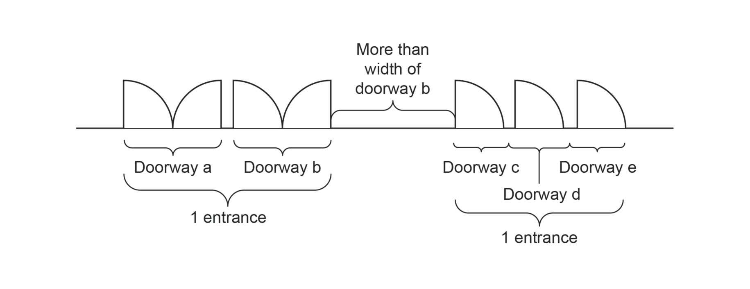
22 Paragraph D3.5(d) of Part D3 of Schedule 1
Omit “designated”, substitute “identified with signage”.
23 Paragraph D3.6(a) of Part D3 of Schedule 1
Repeal the paragraph, substitute:
(a) braille and tactile signage complying with Part D4 must:
(i) incorporate the international symbol of access or deafness, as appropriate, in accordance with AS 1428.1 and identify each:
(A) sanitary facility, except a sanitary facility associated with a bedroom in a Class 1b building or a sole-occupancy unit in a Class 3 or Class 9c building; and
(B) space with a hearing augmentation system; and
(ii) identify each door required by Part E4.5 of the BCA to be provided with an exit sign and state:
(A) “Exit”; and
(B) “Level”; and
any of the following:
(C) the floor level number;
(D) a floor level descriptor;
(E) a combination of (C) and (D); and
24 At the end of clause D3.6 of Part D3 of Schedule 1
Add:
; and (g) in a building subject to clause F2.9, directional signage complying with Part D4 must be provided at the location of each:
(i) bank of sanitary facilities; and
(ii) accessible unisex sanitary facility, other than one that incorporates an accessible adult change facility;
to direct a person to the location of the nearest accessible adult change facility within that building.
25 Subclause D3.8(3) of Part D3 of Schedule 1
Omit “Class 9c aged care building”, substitute “Class 9c building”.
26 Subclause D3.8(3) of Part D3 of Schedule 1
Omit “the requirements for stairway handrails in AS 1428.1”, substitute “AS/NZS 1428.4.1”.
27 Subparagraph D3.9(b)(ii) of Part D3 of Schedule 1
Omit “; and”, substitute “.”.
28 Subparagraph D3.9(b)(iii) of Part D3 of Schedule 1
Repeal the subparagraph.
29 Paragraph D3.10(2)(b) of Part D3 of Schedule 1
Omit “at a maximum gradient of 1:14”.
30 Subclause D3.10(3) of Part D3 of Schedule 1
Omit “in length”.
31 Subclause D4.3(2) of Part D4 of Schedule 1
Repeal the subclause, substitute:
(2) Title case must be used for all tactile characters, and:
(a) upper case tactile characters must have a height of not less than 15 mm and not more than 55 mm, except that the upper case tactile characters on a sign identifying a door required by Part E4.5 of the BCA to be provided with an exit sign must have a height of not less than 20 mm and not more than 55 mm; and
(b) lower case tactile characters must have a minimum height of 50% of the related upper case characters.
32 Part D5 of Schedule 1 (figure D5.7)
Repeal the figure, substitute:
Figure D5.7 Clear swimming pool surround space for sling lift in the transfer position
Figure D5.7A—Plan view
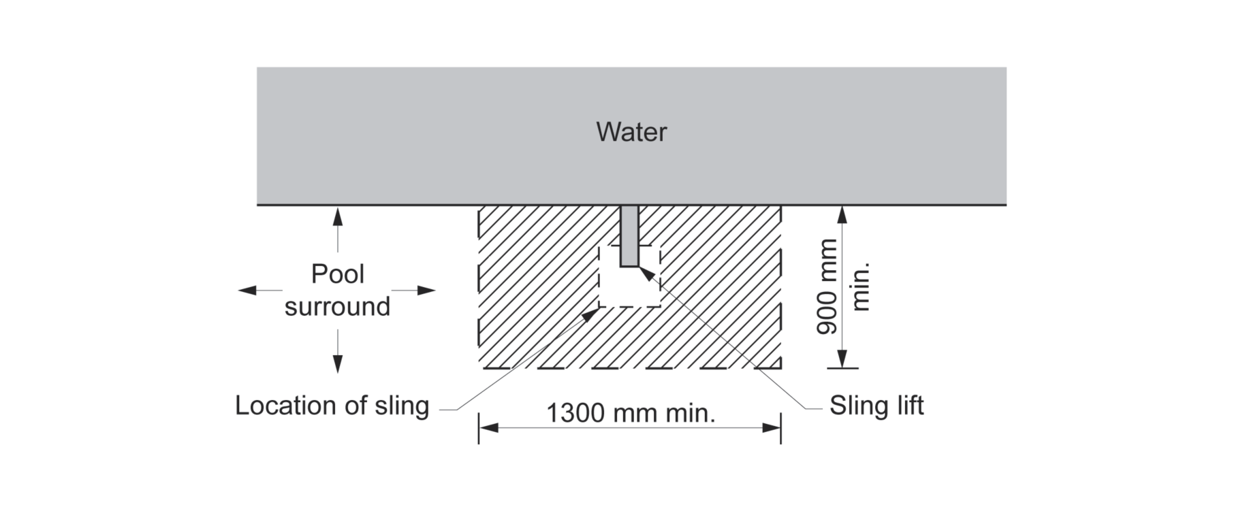
Figure D5.7B—Sectional elevation
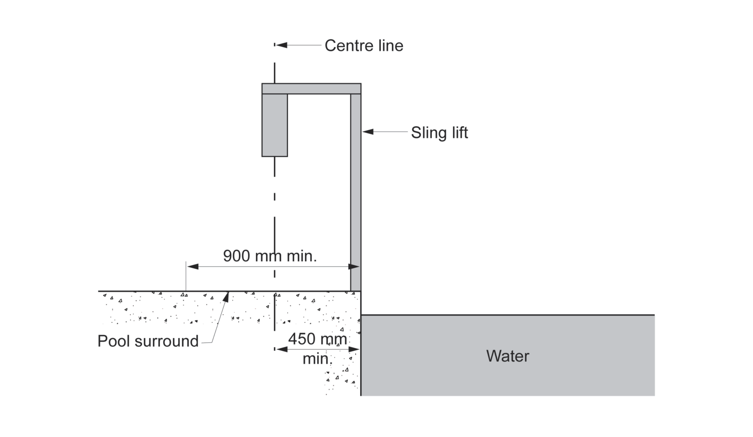
33 Paragraph E3.6(a) of Part E3 of Schedule 1
Omit “lift”.
34 Clause E3.6 of Part E3 of Schedule 1 (Table E3.6 (a))
Repeal the table (not including the heading), substitute:
Lift type | Limitations on use
Electric passenger lift | No limitation.
Electrohydraulic passenger lift | No limitation.
Inclined lift | No limitation.
Low-rise platform lift | Must not travel more than 1 m.
Low-rise, low-speed constant pressure lift | Must not:  (a) for an enclosed type, travel more than 4 m; or  (b) for an unenclosed type, travel more than 2 m; or  (c) be used in high traffic public use areas in buildings such as a theatre, cinema, auditorium, transport interchange, shopping complex or the like.
Small-sized, low-speed automatic lift | Must not travel more than 12 m.
Stairway platform lift | Must not:  (a) be used to serve a space in a building accommodating more than 100 persons calculated according to clause D1.13 of the BCA; or  (b) be used in a high traffic public use area such as a theatre, cinema, auditorium, transport interchange, shopping centre or the like; or  (c) be used where it is possible to install another type of passenger lift; or  (d) connect more than 2 storeys; or  (e) where more than 1 stairway lift is installed, serve more than 2 consecutive storeys; or  (f) when in the folded position, encroach on the minimum width of a stairway required by clause D1.6 of the BCA.
35 Clause E3.6 of Part E3 of Schedule 1 (table E3.6 (b))
Repeal the table (not including the heading), substitute:
Feature | Application
Hand rail complying with the provisions for a mandatory handrail in AS 1735.12 | All lifts except:  (a) a stairway platform lift; and  (b) a low-rise platform lift.
Lift floor dimension of not less than 1,400 mm wide x 1,600 mm deep | All lifts which travel more than 12 m.
Lift floor dimensions of not less than 1,100 mm wide x 1,400 mm deep | All lifts which travel not more than 12 m except a stairway platform lift.
Lift floor dimensions of not less than 810 mm wide x 1,200 mm deep | A stairway platform lift.
Minimum clear door opening complying with AS 1735.12 | All lifts except a stairway platform lift.
Passenger protection system complying with AS 1735.12 | All lifts with a power operated door.
Lift landing doors at the upper landing | All lifts except a stairway platform lift.
Lift car and landing control buttons complying with AS 1735.12 | All lifts except:  (a) a stairway platform lift; and  (b) a low-rise platform lift.
Lighting in accordance with AS 1735.12 | All enclosed lift cars.
(a) Automatic audible information within the lift car to identify the level each time the car stops; and  (b) audible and visual indication at each lift landing to indicate the arrival of the lift car; and  (c) audible information and audible indication required by (a) and (b) is to be provided in a range of between 20–80 dB(A) at a maximum frequency of 1,500 Hz | All lifts serving more than 2 levels.
Emergency hands-free communication, including a button that alerts a call centre of a problem and a light to signal that the call has been received | All lifts except a stairway platform lift.
36 Clause F2.4 of Part F2 of Schedule 1 (tables F2.4 (a) and F2.4 (b), column headed “Class of building”, cell dealing with Class 3 and Class 9c)
Omit “aged-care building”.
37 At the end of Part F2 of Schedule 1
Add:
F2.9 Accessible adult change facilities
(1) Accessible adult change facilities required by subclause (2):
(a) must be constructed in accordance with Part F3; and
(b) cannot be combined with another sanitary compartment.
(2) One unisex accessible adult change facility must be provided in an accessible part of a:
(a) Class 6 building that is a shopping centre having a design occupancy of not less than 3,500 people, calculated on the basis of the floor area and containing a minimum of 2 sole-occupancy units; and
(b) Class 9b sports venue or the like that:
(i) has a design occupancy of not less than 35,000 spectators; or
(ii) contains a swimming pool that has a perimeter of not less than 70 m and that is required by Table D3.1 to be accessible; and
(c) museum, art gallery or the like having a design occupancy of not less than 1,500 patrons; and
(d) theatre or the like having a design occupancy of not less than 1,500 patrons; and
(e) passenger use area of an airport terminal building within an airport that accepts domestic and/or international flights that are public transport services as defined in the Transport Standards.
(3) For the purposes of subclause (2), design occupancy must be calculated in accordance with clause D1.13 of the BCA, but excluding any area that:
(a) can only be accessed by staff, employees, contractors, maintenance personnel and the like; or
(b) is subject to an exemption under clause D3.4.
38 After Part F2 of Schedule 1
Insert:
Part F3 Accessible adult change facilities
F3.1 Scope
This Part contains the requirements for accessible adult change facilities.
F3.2 General requirements
(1) Each accessible adult change facility must:
(a) be constructed so that all required equipment and fixtures are contained within the same room; and
(b) if it is a unisex facility, be located such that it can be entered without crossing an area reserved for one sex only.
(2) In each accessible adult change facility, the following must be provided:
(a) a hoist complying with clause F3.3;
(b) a toilet pan, seat, backrest and grabrails complying with clause F3.4;
(c) a washbasin and tap complying with clause F3.5;
(d) fixtures and fittings as specified in clause F3.6;
(e) a change table complying with clause F3.7;
(f) changing rails complying with clause F3.8;
(g) an automated sliding entrance door complying with clause F3.9;
(h) signage complying with clause F3.10;
(i) operating instructions for the hoist and change table in accordance with clause F3.11;
(j) circulation spaces complying with Figure F3.2.
Figure F3.2 Required circulation spaces
Figure F3.2A—Turning space, each side of the pan and in front of the pan
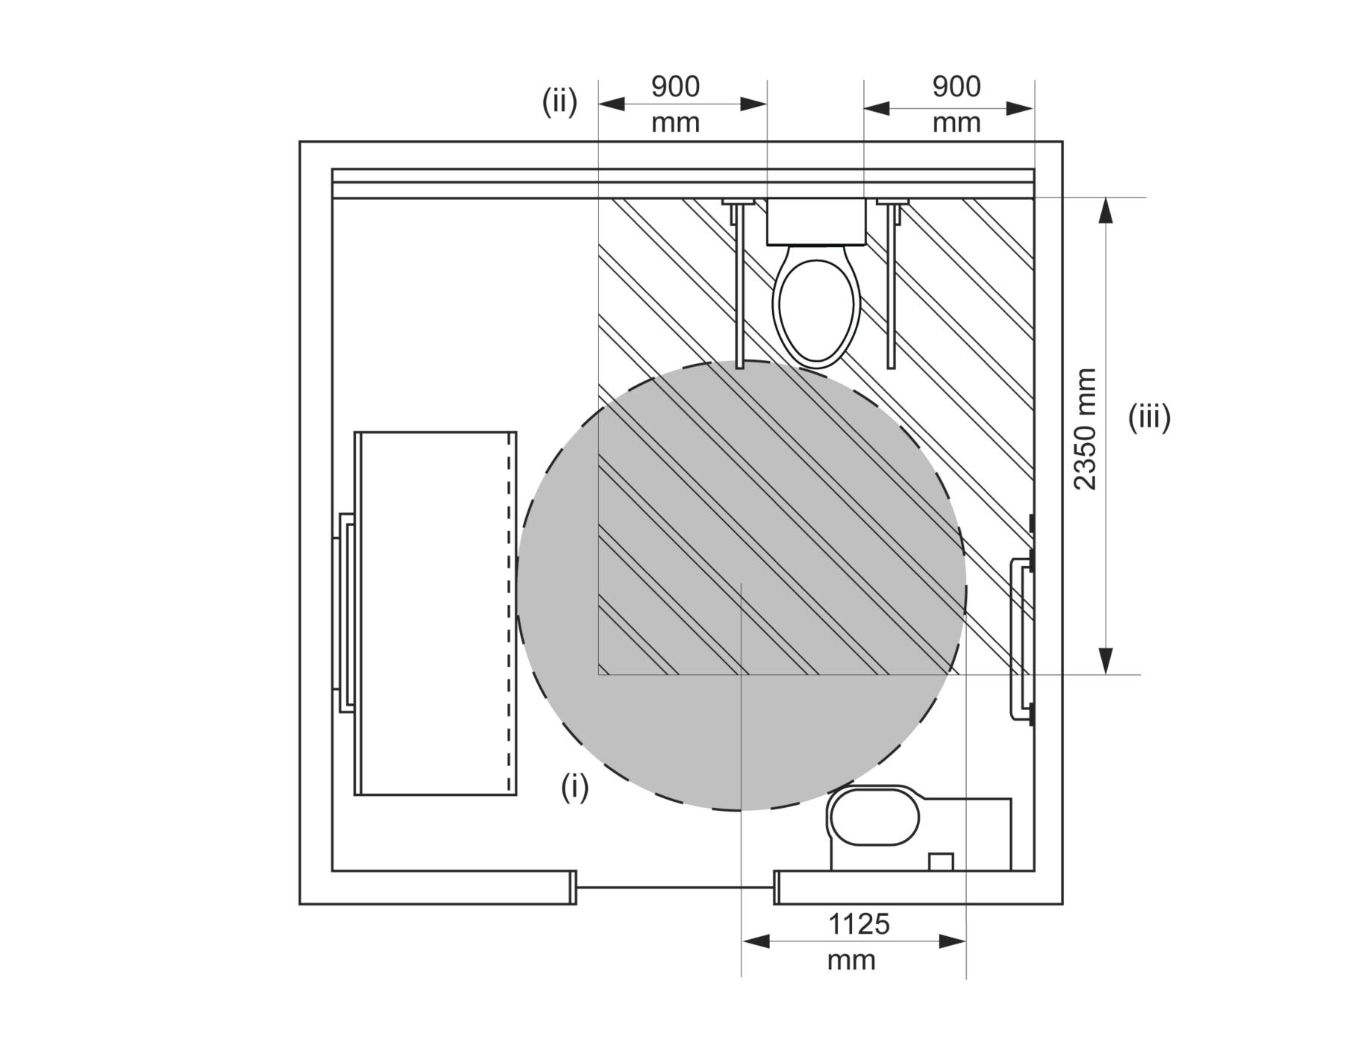
Figure F3.2B—Turning space and circulation space for a washbasin
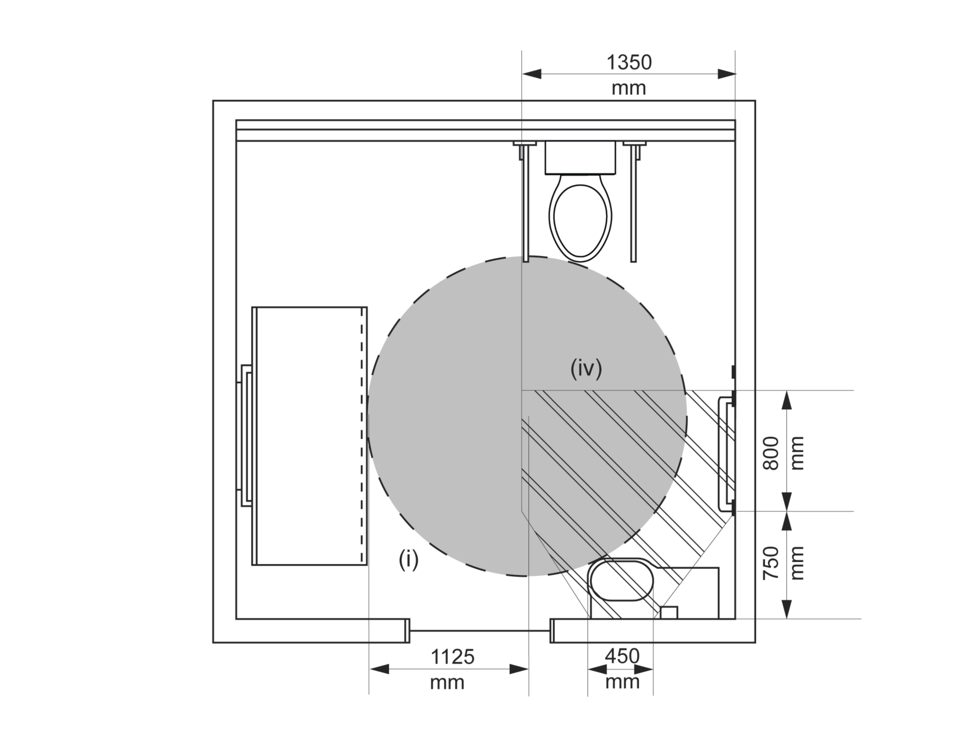
Figure F3.2C—Turning space and circulation space for changing rails
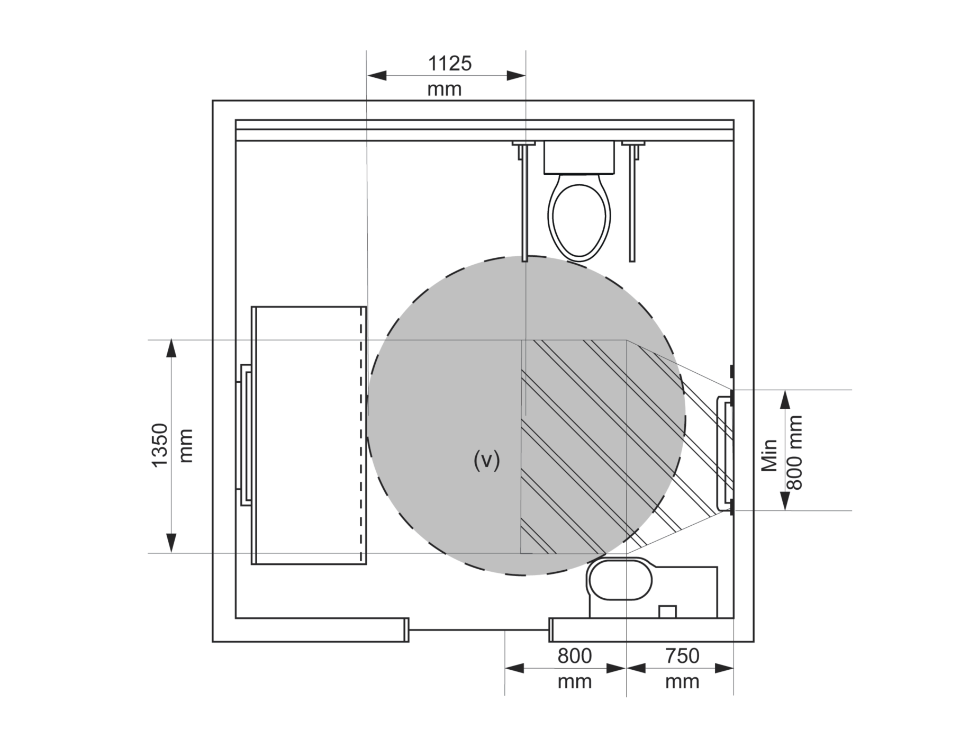
Notes to Figures F3.2A, F3.2B and F3.2C:
- The Roman numerals shown in Figures F3.2A, F3.2B, and F3.2C indicate the following required circulation spaces:
  - turning space—a full circle of 1,125 mm radius;
  - each side of the pan—900 mm (measured from each edge of the pan);
  - in front of the pan—2,350 mm (measured from the wall behind the pan, and therefore includes the pan itself);
  - for a washbasin—the width of the basin (450 mm) increasing to a width of 1,350 mm measured at a distance of 750 mm out from the wall against which the washbasin is mounted then continuing at that width for a further 800 mm (to a total of 1,550 mm out from the wall);
  - for changing rails—the width of the rails increased to a width of 1,350 mm at a distance of 750 mm out from the wall to which the rails are fixed then continuing at that width for a further 800 mm (to a total of 1,550 mm out from the wall).
- All required circulation spaces must extend for a minimum height of 2,000 mm above finished floor level.
- Required circulation spaces may be overlapped.
- The floor surface must have a slip resistance classification of not less than R10 or P3 when tested in accordance with AS 4586.
F3.3 Hoist
The hoist must:
(a) provide a constant charge in-line room coverage hoist system (also known as an “XY” system or gantry) including 2 parallel fixed rails and a moving traverse rail; and
(b) provide coverage over the entire room; and
(c) have a maximum safe working load of not less than 180 kg; and
(d) be capable of sustaining a static load of not less than 1.5 times the rated load; and
(e) have a minimum lifting height of 2,100 mm.
F3.4 Toilet pan, seat, backrest and grabrails
(1) The toilet pan must be of the centrally located (“peninsula-type”) design.
(2) The toilet pan must be installed so that:
(a) the front edge of the pan is 800 mm (±10 mm) from the rear wall; and
(b) the top of the seat is between 460 mm and 480 mm above finished floor level; and
(c) there is a minimum clearance of 900 mm, measured horizontally, between each side of the pan and any adjacent wall or privacy screen.
(3) The toilet seat must:
(a) be of the full-round type (not open-fronted) with minimal contours to the top surface; and
(b) be securely fixed in position when in use; and
(c) have seat fixings that provide lateral stability to the seat when the seat is in use; and
(d) be load-rated to 150 kg; and
(e) have a minimum luminance contrast of 30% against the pan, wall and floor; and
(f) remain in the fully upright position when raised.
(4) Hand-operated flushing controls must:
(a) be located on the centreline of the toilet, at a height of:
(i) not less than 600 mm; and
(ii) not more than 1,100 mm;
above finished floor level; and
(b) not be located within the area required for any grabrails or backrest; and
(c) have the button mounted so that it is proud of the wall surface, and activates the flushing operation before the button becomes level with the surrounding surface.
(5) An automatically activated flushing system need not comply with the requirements of subclause F3.4(4).
(6) The backrest must:
(a) be capable of withstanding a force, in any direction, of not less than 1,100 N; and
(b) have a minimum height, between the lower edge of the backrest and the top of the seat, of between 120 mm and 150 mm; and
(c) have a vertical height, between the upper and lower edges of the backrest, of between 150 mm and 200 mm; and
(d) have a width of between 350 mm and 400 mm; and
(e) be positioned such that the face of the backrest achieves an angle of between 95° and 100° back from the seat, when the seat is in use.
(7) Grabrails must be installed adjacent to each side of the pan and must be:
(a) of the drop-down type; and
(b) located such that:
(i) the top of each rail is between 800 mm and 810 mm above finished floor level; and
(i) the rails are between 750 mm and 770 mm apart, measured centre-to-centre, and equidistant to the centreline of the pan; and
(c) at least 850 mm long; and
(d) with a diameter of between 30 mm and 40 mm; and
(e) securely fixed to withstand a force, in any direction, of not less than 1,100 N; and
(f) provided with a toilet paper dispenser on one side; and
(g) capable of being lifted up or swung away when not in use, so as to allow unimpeded access to the toilet pan.
F3.5 Washbasin and tap
(1) The washbasin must be installed so that the rim of the basin is between 800 mm and 830 mm above finished floor level.
(2) Exposed heated water supply pipes must be insulated or located so as not to pose a hazard.
(3) Water supply or sanitary drainage pipes must not encroach on the space under the basin.
(4) The washbasin must have an integrated shelf not less than 300 mm long.
(5) Water taps must have a single lever flick-mixer handle or a sensor plate or the like.
(6) Where lever handles are provided, they must be installed with a clear space of not less than 50 mm between the tap and any adjacent surface.
(7) Heated water must be provided and temperature controlled in accordance with Part B2 of NCC Volume Three.
Note: In 2020, NCC Volume Three could be accessed from www.abcb.gov.au.
F3.6 Fixtures and fittings
Mirrors
(1) A vertical mirror must be provided at the washbasin, with a reflective surface that:
(a) is not less than 600 mm wide; and
(b) has its bottom edge not more than 900 mm above finished floor level; and
(c) has its top edge not less than 1,850 mm above finished floor level.
(2) If a second vertical mirror is provided in the facility, it must have a reflective surface that:
(a) is not less than 600 mm wide; and
(b) has its bottom edge not less than 600 mm above finished floor level; and
(c) has its top edge not less than 1,850 mm above finished floor level.
Towel dispensers, hand dryers, soap dispensers and the like
(3) Towel dispensers, hand dryers, soap dispensers and the like must be operable using one hand, and must be installed with their output or operative components:
(a) between 900 mm and 1,100 mm above finished floor level; and
(b) not less than 500 mm from any internal corner.
(4) A soap dispenser must be installed above the integrated shelf required by subclause F3.5(4).
Clothing hook
(5) A clothing hook must be installed so that it is located:
(a) at a height of between 1,200 mm and 1,350 mm above finished floor level; and
(b) adjacent to the washbasin; and
(c) not less than 500 mm from any internal corner.
Sling hook
(6) A sling hook with a minimum projection of 50 mm from the wall must be installed beside the change table at a height of 1,500 mm above finished floor level.
Note: The purpose of the sling hook is to store the sling when it is not in use.
Disposal bins
(7) A sanitary disposal bin must be provided in the corner adjacent to the toilet pan.
(8) An incontinence pad disposal bin must be provided in the corner adjacent to the change table.
F3.7 Change table
(1) The change table must be:
(a) permanently installed, with one of the long edges up against a wall and with a retractable safety rail on the opposite side; and
(b) motorised for the purposes of height adjustment; and
(c) height adjustable between 450 mm and 900 mm above finished floor level; and
(d) not less than 700 mm wide; and
(e) not less than 1,800 mm long.
(2) The change table must have a maximum safe working load of not less than 180 kg, including when raising or lowering the table.
(3) The change table must not encroach on any required circulation space.
(4) A dispenser for sanitary wipes must be provided.
(5) A shelf not less than 400 mm long and 150 mm wide must be provided.
F3.8 Changing rails
Changing rails must be installed as two horizontal and parallel rails fixed to a wall, not less than 800 mm long, each with a diameter between 30 mm and 40 mm, and
(a) the lower rail must be installed between 800 mm and 810 mm above finished floor level; and
(b) the upper rail must be installed between 1,000 mm and 1,010 mm above finished floor level; and
(c) the rails must be able to withstand a force of not less than 1,100 N in any direction.
F3.9 Door and door controls
The entrance door and associated door controls must be automated and must comply with the following:
(a) the threshold must incorporate a smooth transition without a step or lip;
(b) the minimum clear opening width must be:
(i) 1,100 mm in locations where beach wheelchairs are likely to be used; or
(ii) 950 mm in all other locations;
(c) the doorway must achieve a luminance contrast of at least 30% between:
(i) the door leaf and door jamb; or
(ii) the door leaf and adjacent wall; or
(iii) the architraves (where used) and adjacent wall; or
(iv) the door leaf and architrave (where used); or
(v) the door jamb and adjacent wall;
(d) the operation of the door must be calibrated such that:
(i) it has a gentle opening and closing movement; and
(ii) there is sufficient dwell time for a user to safely travel through the doorway;
(e) the door must be fitted with a fail-safe opening mechanism that opens the door if an obstruction is detected during its closing movement;
(f) door controls must be located internally and externally:
(i) between 900 mm and 1,200 mm above finished floor level; and
(ii) not less than 500 mm from any internal corner;
(g) door control buttons must:
(i) have a minimum diameter of 25 mm; and
(ii) be proud of the surrounding surface; and
(iii) activate the door operation before the button becomes level with the surrounding surface; and
(iv) be of a contrasting colour to the surrounding plate;
(h) the surrounding plates of both internal and external door controls must include the words “Push to Open”;
(i) the following indicator lights must be provided:
(i) “Occupied” and “Vacant” on the external plate;
(ii) “Locked” and “Unlocked” on the internal plate;
(j) braille and tactile signage complying with Part D4 must identify the door controls.
F3.10 Signage
(1) External signage must incorporate:
(a) the symbol shown in Figure F3.10.1; and
(b) the words “Accessible Adult Change Facility”.
(2) The symbol required by paragraph F3.10(1)(a) must have a blue (B21, ultramarine) background with the hoist and table elements shown in white.
(3) Signage must be braille and tactile signage complying with Part D4.
Figure F3.10.1 Symbol
F3.11 Operating instructions
Signage provided within the facility must include the following information for the hoist and change table:
(a) operating instructions; and
(b) safe working load limits.

