Food Standards (Application A1163 – Food Irradiation definition of herbs and spices) Variation

The Board of Food Standards Australia New Zealand gives notice of the making of this variation under section 92 of the Food Standards Australia New Zealand Act 1991. The variation commences on the date specified in clause 3 of this variation.

Dated 13 January 2020

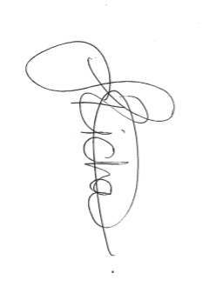

Standards Management Officer
Delegate of the Board of Food Standards Australia New Zealand

Note:

This variation will be published in the Commonwealth of Australia Gazette No. FSC 131 on 17 January 2020. This means that this date is the gazettal date for the purposes of clause 3 of the variation.

1 Name
This instrument is the Food Standards (Application A1163 – Food Irradiation definition of herbs and spices) Variation.
2 Variation to a standard in the Australia New Zealand Food Standards Code
The Schedule varies a Standard in the Australia New Zealand Food Standards Code.
3 Commencement
The variation commences on the date of gazettal.
Schedule
[1] Standard 1.5.3 is varied by omitting subsection 1.5.3—4(3) and substituting

(3) In this section:
herbs and spices includes (but is not limited to) a herb or a spice described in Schedule 22.

