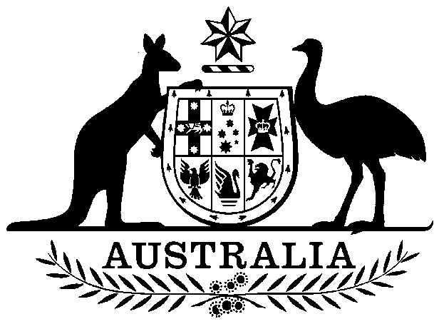

COMMONWEALTH OF AUSTRALIA

##### **Environment Protection and Biodiversity Conservation Act 1999**

###### DECLARATION OF AN APPROVED WILDLIFE TRADE OPERATION – QUEEN ANTS HARVESTING, CANBERRA, ACT – PAUL HAILES – OCTOBER 2019

I, Nathan Sibley, A/g Assistant Secretary, Environment Approvals and Wildlife Trade Branch, as Delegate of the Minister for the Environment, have considered in accordance with section 303FN of the *Environment Protection and* *Biodiversity Conservation Act 1999* (EPBC Act) the application from Mr Paul Hailes, public comments on the proposal as required under section 303FR and advice on the ecological sustainability of the operation. I am satisfied on those matters specified in section 303FN of the EPBC Act. I hereby declare the operations for the harvesting of queen ants that are harvested in the Australian Capital Territory in accordance with the management regime, as assessed under the EPBC Act, but not including

* specimens that belong to eligible listed threatened species, as defined under section 303BC of the EPBC Act, or
* specimens that belong to taxa listed under section 303CA of the EPBC Act (Australia’s CITES list)

to be an approved wildlife trade operation, in accordance with subsection 303FN(2) and paragraph 303FN(10)(b), for the purposes of the EPBC Act.

Unless amended or revoked, this declaration:

1. is valid until **30 September 2022** and;
2. is subject to the conditions applied under section 303FT specified in the Schedule.

Dated this 15th day of November 2019

Nathan Sibley

Delegate of the Minister for the Environment

A person whose interests are affected by this declaration may, within 28 days, make an application in writing to the Department of the Environment and Energy for the reasons for the decision.

An application for independent review of the decision (under section 303GJ(1) of the *Environment Protection and Biodiversity Conservation Act 1999*) may be made to the Administrative Appeals Tribunal (AAT), on payment of the relevant fee by the applicant, either within 28 days of receipt of the reasons for the decision, or within 28 days of this declaration if reasons for the decision are not sought. Applications should be made to the Deputy Registrar, AAT in your Capital City. Please visit the AAT’s website at <http://www.aat.gov.au/> for further information.

You may make an application under the *Freedom of Information Act 1982* (Cth) to access documents relevant to this decision. For further information, please visit <http://www.environment.gov.au/foi/index.html>.

Further enquiries should be directed to the Director, Wildlife Trade Assessments Section, Department of the Environment and Energy, Telephone: (02) 6274 1917 Email: wta@environment.gov.au.

# SCHEDULE

Declaration of Queen Ant Harvesting, Canberra in the Australian Capital Territory as an approved wildlife trade operation, October 2019

**ADDITIONAL PROVISIONS (section 303FT)**

Relating to the harvesting of queen ants, other than specimens of species listed under Part 13 and Part 13A of the *Environment Protection and Biodiversity Conservation Act 1999* (EPBC Act), taken in the Australian Capital Territory:

**Condition 1:**

The approved wildlife trade operation must be carried out in accordance with the management regime as described in the application and associated materials as assessed and approved by the Department of the Environment and Energy.

Harvest is limited to queen ants located in the Australian Capital Territory and must not involve any excavation or damage to existing nests or colonies.

Maximum number of individual queen ants each year (1 January – 31 December):

*Amblyopone* spp. 10

*Aphaenogaster* spp. 50

*Camponotus* spp. 1000

*Crematogaster* spp. 50

*Iridomyrmex* spp. 1000

*Melophorus* spp. 50

*Myrmecia* spp. 400

*Notoncus* spp. 50

*Pheidole* spp. 100

*Polyrhachis* spp. 50

*Rhytidoponera* spp. 50

**Condition 2:**

Mr Paul Hailes, or an authorised representative, must inform the Department of the Environment and Energy of any intended material changes to the management arrangements that may affect the assessment against which decisions under the *Environment Protection and Biodiversity Conservation Act 1999* are made.

**Condition 3:**

Mr Paul Hailes, or an authorised representative, must provide a report to the Department of the Environment and Energy annually. The report must outline the number of each taxa, where possible identified to species level, that were harvested, and the date and location of their harvest.