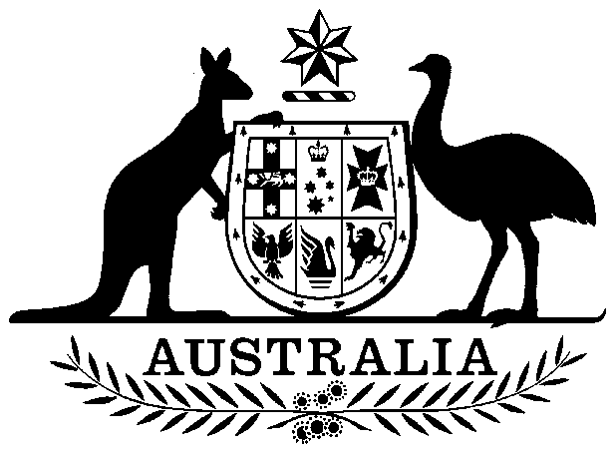
COMMONWEALTH OF AUSTRALIA
Environment Protection and Biodiversity Conservation Act 1999
DECLARATION OF AN
APPROVED WILDLIFE TRADE OPERATION

I, Nathan Sibley, A/g Assistant Secretary, Environment Approvals and Wildlife Trade Branch, as Delegate of the Minister for the Environment under the Environment Protection and Biodiversity Conservation Act 1999, am satisfied that the ‘Wildlife trade operation for the harvest of Yacca Gum Xanthorrhoea semiplana ssp. tateana from private land on Kangaroo Island, South Australia’ is a small-scale operation as defined by Regulation 9A.20 under subsection 303FN(10). I declare under subsection 303FN(2) that the ‘Wildlife trade operation for the harvest of Yacca Gum Xanthorrhoea semiplana ssp. tateana from private land on Kangaroo Island, South Australia’ is an approved wildlife trade operation.

This declaration has effect subject to the following conditions applied under S303FT:

- The operation is to be undertaken in accordance with the proposal submitted on
7 June 2019.
- Harvest is restricted to dead stumps of Yacca Gums (Xanthorrhoea semiplana ssp. tateana) collected on private land on Kangaroo Island, South Australia. Additional taxa can be exported only on application after approval from the Department of Environment and Energy.
- This declaration is valid for three years from the date of registration on the Federal Register of Legislation.
- Accurate up-to-date records must be maintained and include all information necessary for the reporting outlined in Condition 5. If requested, records will be made available to the Department of the Environment and Energy.
- A report detailing the weight of Yacca Gum stumps harvested and exported annually must be provided to the Department of the Environment and Energy by 30 June each year of the operation.

Dated this .......15th...... day of .....November......... 2019

Nathan Sibley

Delegate of the Minister for the Environment and Energy

A person whose interests are affected by this declaration may, within 28 days, make an application in writing to the Department of the Environment and Energy for the reasons for the decision.
An application for independent review of the decision (under section 303GJ(1) of the Environment Protection and Biodiversity Conservation Act 1999) may be made to the Administrative Appeals Tribunal (AAT), on payment of the relevant fee (currently $884 or reduced fee where applicable due to financial hardship) by the applicant, either within 28 days of receipt of the reasons for the decision, or within 28 days of this declaration if reasons for the decision are not sought. Applications should be made to the Deputy Registrar, AAT in your Capital City. Please visit the AAT’s website at http://www.aat.gov.au/ for further information.
You may make an application under the Freedom of Information Act 1982 (Cth) to access documents relevant to this decision. For further information, please visit http://www.environment.gov.au/foi/index.html.
Further enquiries should be directed to the Director, Wildlife Trade Assessments Section, Department of the Environment and Energy; Email: wta@environment.gov.au, Telephone: (02) 6274 1900 (option 2).

