National Capital Plan – Amendment 92 – Uncommitted land Adjacent to the Australian National University¹
Australian Capital Territory (Planning and Land Management) Act 1988
I, NOLA MARINO, Assistant Minister for Regional Development and Territories, approve this amendment of the National Capital Plan under section 19(1)(a) of the Australian Capital Territory (Planning and Land Management) Act 1988.
Dated 24 November 2019
NOLA MARINO
Assistant Minister for Regional Development and Territories

1 Name of instrument
This instrument is the National Capital Plan – Amendment 92 – Uncommitted Land Adjacent to the Australian National University
2 Commencement
This instrument commences on the date of its registration.
3 Amendment of National Capital Plan
Schedule 1 amends the National Capital Plan.

Schedule 1 Amendment
(section 3)

The National Capital Plan is amended by the following:

Section 4.17 Australian National University Precinct Code
- Delete Figure 134: ‘Land use for the Australian National University Precinct’, and replace with the following figure:
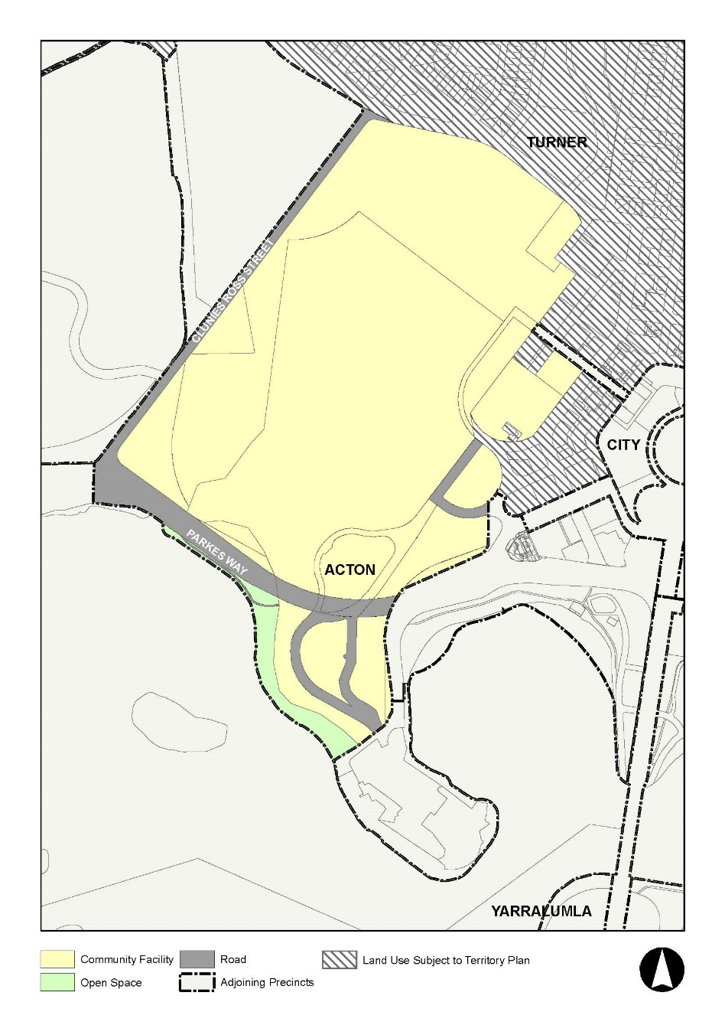
- Insert the following clause following Figure 134:
A ‘Community Protections Facility’ is permitted on Block 1 Section 86 Acton.
- Delete Figure 135 ‘Australian National University – Campus Structure Figure’, and replace with the following figure:
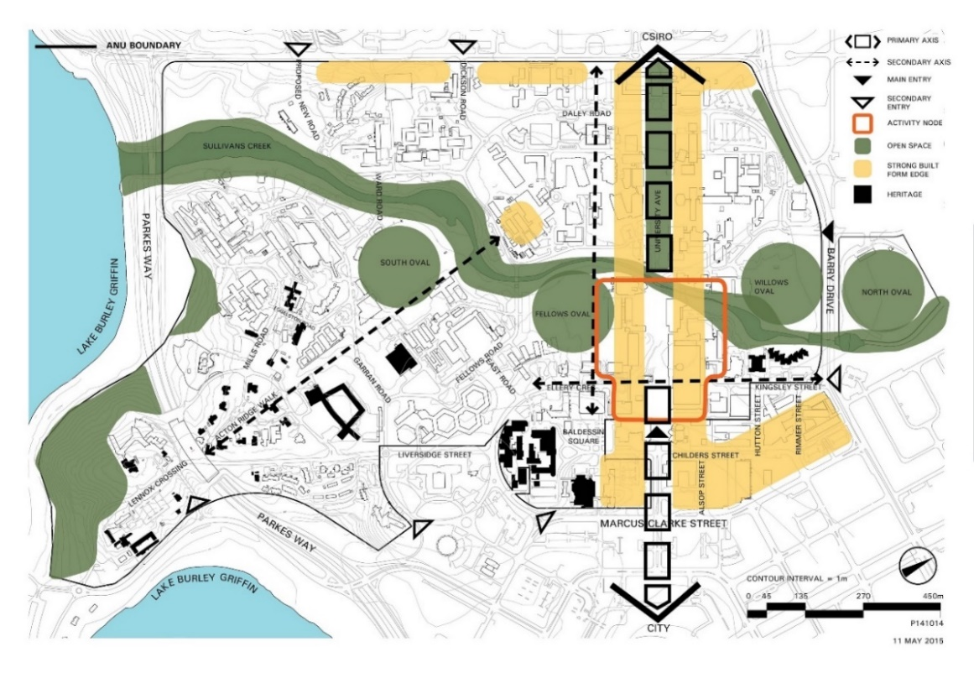
- Delete Figure 136 ‘Australian National University – Restricted Development Zones’, and replace with the following figure:
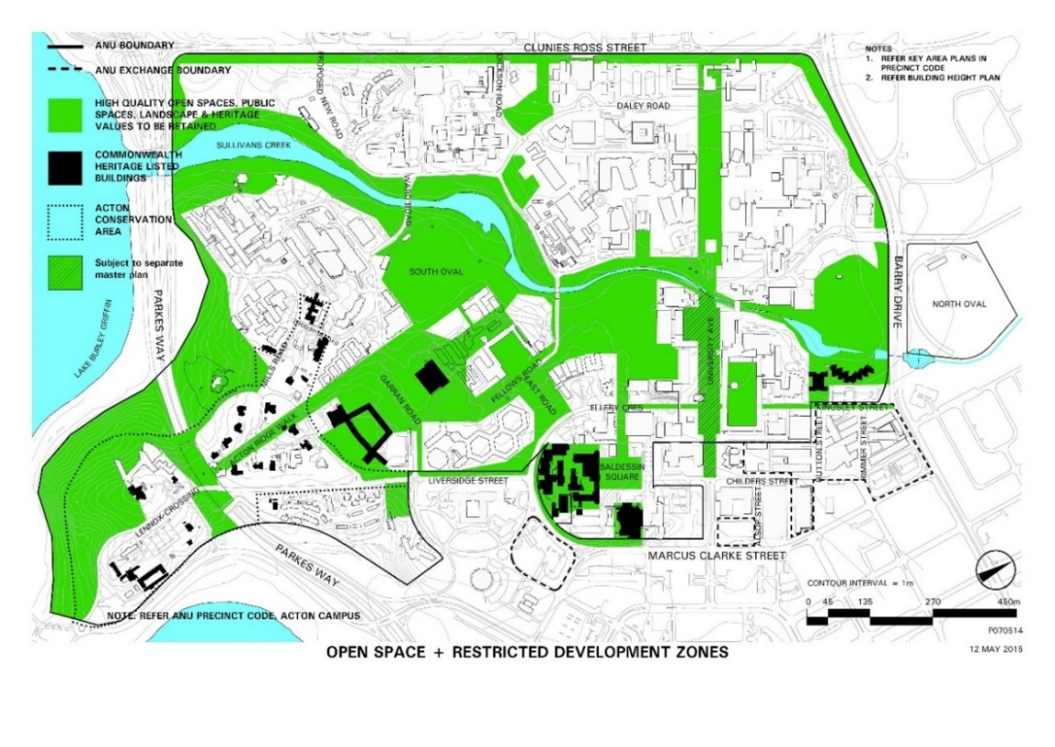
- Delete Figure 137 ‘Australian National University – Indicative Building Heights’, and replace with the following figure:
- Delete Figure 138 ‘Australian National University – Heritage Items’, and replace with the following figure:
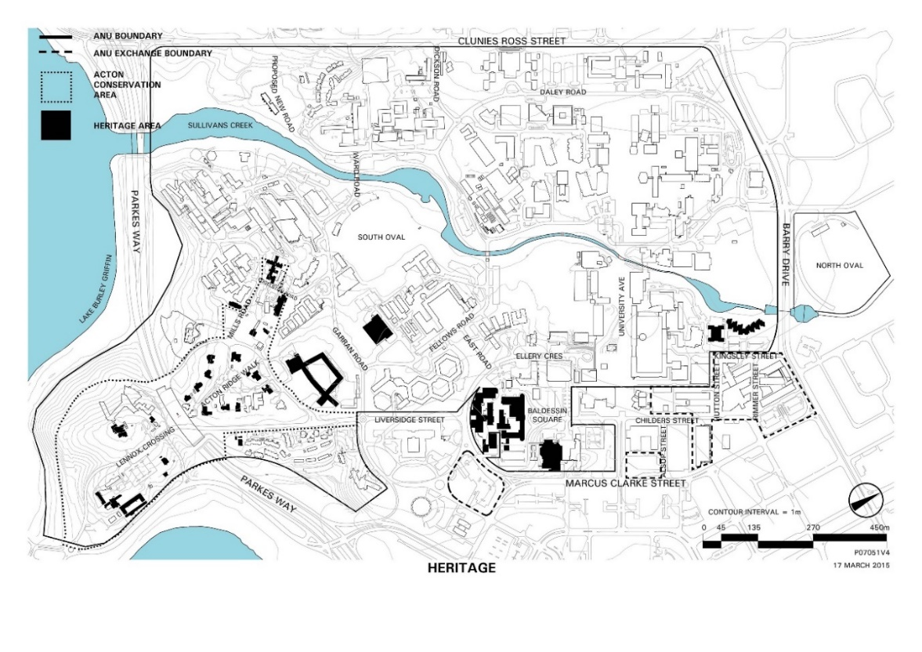

Note
1. All legislative instruments and compilations are registered on the Federal Register of Legislation kept under the Legislative Instruments Act 2003. See http://www.legislation.gov.au

