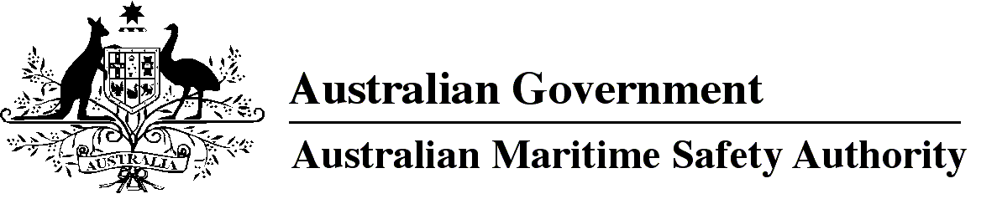

AMSA MO 2019/8

Marine Order 12 (Construction — subdivision and stability, machinery and electrical installations) Amendment Order 2019

I, Allan Schwartz, Acting Chief Executive Officer of the Australian Maritime Safety Authority, make this Marine Order under subsection 342(1) of the *Navigation Act 2012*.

19 November 2019

Allan Schwartz  
Acting Chief Executive Officer

1 Name of Marine Order

This Marine Order is *Marine Order 12 (Construction — subdivision and stability, machinery and electrical installations) Amendment Order 2019*.

2 Commencement

This Marine Order commences on 1 January 2020.

3 Amendment of *Marine Order 12 (Construction — subdivision and stability, machinery and electrical installations) 2016*

Schedule 1 amends *Marine Order 12 (Construction — subdivision and stability, machinery and electrical installations) 2016*.

Schedule 1 Amendment

[1] Subparagraph 2(1)(a)

omit

Regulation 21

insert

Regulations 19-1 and 21

**Note**

1. All legislative instruments and compilations of legislative instruments are registered on the Federal Register of Legislation under the *Legislation Act 2003.* See https://www.legislation.gov.au.