

Consumer Goods (Quad Bikes) Safety Standard 2019

I, Michael Sukkar, Assistant Treasurer, make the following safety standard.

Dated 10 October 2019

Michael Sukkar

Assistant Treasurer

Contents

Part 1—Preliminary 1

1 Name 1

2 Commencement 1

3 Authority 1

4 Definitions 1

5 Meaning of *quad bike* etc. 2

6 Second‑hand quad bikes 3

7 Incorporated material 4

Part 2—Requirements for all quad bikes 5

8 Scope of this Part 5

9 Compliance with the US Standard 5

10 Compliance with the European Standard 5

11 Rollover warning label 6

12 Lateral roll stability testing 7

13 Lateral roll stability tag 7

Part 3—Requirements for general use quad bikes 9

14 Scope of this Part 9

15 General use quad bikes—operator protection devices 9

16 General use quad bikes—minimum lateral roll, forward pitch and rearward pitch requirements 9

Part 4—Application, saving and transitional provisions 11

17 Application of this instrument as made 11

Schedule 1—Test procedures 12

Part 1—General 12

Part 2—Tilt table 13

Part 3—Test quad bike set‑up 14

Part 4—Anthropomorphic test device 15

Part 5—Determination of centre of gravity position 16

Part 6—Tilt test procedure 17

Division 6.1—Lateral roll 17

Division 6.2—Pitch 18

Part 7—Instrumentation 19

Part 1—Preliminary

1 Name

This instrument is the *Consumer Goods (Quad Bikes) Safety Standard 2019*.

2 Commencement

(1) Each provision of this instrument specified in column 1 of the table commences, or is taken to have commenced, in accordance with column 2 of the table. Any other statement in column 2 has effect according to its terms.

| Commencement information | | |
| --- | --- | --- |
| Column 1 | Column 2 | Column 3 |
| Provisions | Commencement | Date/Details |
| 1. The whole of this instrument | The day after this instrument is registered. | 11 October 2019 |

Note: This table relates only to the provisions of this instrument as originally made. It will not be amended to deal with any later amendments of this instrument.

(2) Any information in column 3 of the table is not part of this instrument. Information may be inserted in this column, or information in it may be edited, in any published version of this instrument.

3 Authority

This instrument is made under subsection 104(1) of the Australian Consumer Law.

Note: The reference to the Australian Consumer Law is a reference to Schedule 2 to the *Competition and Consumer Act 2010* as it applies as a law of the Commonwealth, States and Territories: see section 140K of that Act and corresponding provisions of Acts of States and Territories applying that Schedule.

4 Definitions

Note: A number of expressions used in this instrument are defined in the *Competition and Consumer Act 2010*, for the Australian Consumer Law in Schedule 2 to that Act, including the following:

(a) Australian Consumer Law;

(b) consumer;

(c) label;

(d) regulator;

(e) safety standard;

(f) supply.

In this instrument:

***50 PAM H3 ATD*** (short for 50th Percentile Average Male Hybrid III Anthropomorphic Test Device): see clause 1.1 of Schedule 1 (test procedures).

***ATD*** (short for Anthropomorphic Test Device): see clause 1.1 of Schedule 1 (test procedures).

***category***, of quad bike: see section 5.

***European Standard*** means the European Standard *EN15997:2011 COR 2012: All terrain vehicles (ATVs—Quads)—Safety requirements and test methods*, published by the Comité Européen de Normalisation.

Note: See also section 7.

***general use quad bike*** means a Type I, Category G or a Type II, Category G quad bike (see section 5).

***incorporated***: see section 7.

***lateral roll stability*** means the ability for a quad bike to resist tipping over laterally (sideways).

***lateral roll stability tag***: see section 13.

***pitch*** means a vehicle rolling over longitudinally (longways), either rearwards or forwards.

Note: See also the definition of ***rollover***.

***quad bike***: see section 5.

***rollover*** means a quad bike rolling over laterally (sideways) or longitudinally (longways).

***rollover warning***: see section 11.

***static stability***: see clause 1.1 of Schedule 1 (test procedures).

***tilt table ratio*** or ***TTR***: see clause 1.1 of Schedule 1 (test procedures).

***TTR***: see the definition of ***tilt table ratio***.

***type***, of quad bike: see section 5.

***US Standard*** means the American National Standard *ANSI/SVIA 1–2017: American National Standard for Four Wheel All‑Terrain Vehicles*, published by the American National Standards Institute, Inc..

Note: See also section 7.

5 Meaning of *quad bike* etc.

(1) A ***quad bike*** is an off‑road vehicle propelled by mechanical energy designed to travel on 4 wheels, with a seat designed to be straddled by the operator and handlebars for steering control.

(2) A reference in this instrument, and in any other instrument, or other writing, incorporated by or under this instrument, to a type and category of quad bike mentioned in the following table is taken to be a reference to a quad bike that meets the description for that type and category in the table.

| Types and categories of quad bikes | | | |
| --- | --- | --- | --- |
| Item | Type | Category | Description |
| 1 | Type I | Categories G, S, Y and T | *Type I (single operator)*  A quad bike intended for use by a single operator and no passenger.  This applies in addition to the descriptions of the relevant categories of Type I quad bike given elsewhere in this table. |
| 2 | Type I | Category G | *Type I, general use model*  A quad bike intended for recreational or utility use, or both, by an operator not less than 16 years of age. |
| 3 | Type I | Category S | *Sports model*  A quad bike intended for recreational use by an experienced operator not less than the 16 years of age. |
| 4 | Type I | Category Y | *Youth model (ages 6 to 15)*  A quad bike of appropriate size intended for recreational use under adult supervision by an operator under 16 years of age. |
| 5 | Type I | Category Y‑6+ | *Youth model (ages 6 to 9)*  A Type I, Category Y quad bike intended for recreational use under adult supervision by an operator of 6, 7, 8 or 9 years of age. |
| 6 | Type I | Category Y‑10+ | *Youth model (ages 10 to 13)*  A Type I, Category Y quad bike intended for recreational use under adult supervision by an operator of 10, 11, 12 or 13 years of age. |
| 7 | Type I | Category Y‑12+ | *Youth model (ages 12 to 15)*  A Type I, Category Y quad bike intended for recreational use under adult supervision by an operator of 12, 13, 14 or 15 years of age. |
| 8 | Type I | Category T | *Transition model*  A quad bike of appropriate size intended for recreational use by:  (a) an operator of 14 or 15 years of age under adult supervision; or  (b) an operator of not less than 16 years of age (not requiring adult supervision). |
| 9 | Type II | Category G | *Type II (maximum 1 passenger), general use model*  A quad bike intended for recreational or utility use, or both, by an operator not less than 16 years of age, that:  (a) is intended for use with or without a passenger; and  (b) has a seating position behind the operator designed to be straddled by no more than one passenger. |

6 Second‑hand quad bikes

(1) This instrument does not apply in relation to a second‑hand quad bike, subject to subsection (2).

(2) This instrument applies in relation to a quad bike if:

(a) it has been imported into Australia; and

(b) when it was imported, it was second‑hand.

7 Incorporated material

(1) If this instrument, or any instrument or other writing incorporated by or under this instrument, incorporates, with or without modification, any other instrument or writing, the instrument or writing is incorporated as in force or existing at the time this instrument commences.

(2) An instrument or other writing is ***incorporated*** by or under another instrument or writing if any matter contained in the instrument or writing is applied, adopted or incorporated by or under the other instrument or writing.

Note 1: See section 14 of the *Legislation Act 2003*.

Note 2: Incorporated instruments and writings could in 2019 be accessed as follows:

(a) the US Standard could be purchased from the website of the Specialty Vehicle Institute of America (https://svia.org);

(b) the Australian Standard mentioned in paragraphs 9(a) and 10(b) could be purchased from SAI Global’s website (https://www.saiglobal.com);

(c) the United States Department of Agriculture Forest Service Standard mentioned in paragraphs 9(a) and 10(b) could be accessed free of charge at the Forest Service’s website (https://www.fs.fed.us/t‑d/programs/fire);

(d) the European Standard could be purchased from SAI Global’s website (https://www.saiglobal.com);

(e) the US Military Standard mentioned in clause 4.1 of Schedule 1 could be purchased from SAI Global’s website (https://www.saiglobal.com);

(f) the Australian Competition and Consumer Commission could make a copy of incorporated instruments and writings available for viewing at any of its offices, subject to licensing conditions.

Part 2—Requirements for all quad bikes

8 Scope of this Part

Quad bikes of all types and categories mentioned in section 5 must comply with the following requirements:

(a) the requirements covered by section 9 or 10;

(b) the requirements covered by sections 11, 12 and 13.

Note 1: On request by the regulator, a supplier of quad bikes may be required to nominate the applicable safety standard under paragraph (a): see section 108 of the Australian Consumer Law.

Note 2: This Part starts to apply 12 months after this instrument commences (see section 17). The requirements in this Part become mandatory when this Part starts to apply.

9 Compliance with the US Standard

The requirements covered by this section are those set out in sections 4 to 8 of the US Standard (including the related Figures set out in the standard), subject to the following modifications:

(a) omit section 4.18, substitute the following section:

**4.18 Spark Arrester.** All ATVs (quad bikes) equipped with an internal combustion engine shall have a spark arrester of a type that:

(i) meets the requirements of Australian Standard *AS 1019‑2000: Internal combustion engines—Spark emission control devices,* published by Standards Australia; or

(ii) is qualified according to *Standard 5100‑1d: Standard for Spark Arresters for Internal Combustion Engines* published by the United States Department of Agriculture Forest Service in February 2013;

(b) add at the end of section 4.21.1 (which provides for the general requirements for owners’ manuals) the following subsection:

(3) The owner’s manual shallprovide information alerting consumers to the risk of rollovers, when the risk of rollover is increased (for example on inclined terrain, while carrying a load, when there are hidden objects on the ground, wet or slippery surfaces) and how to best operate the ATV safely in higher risk conditions;

(c) a reference to each of the following terms is taken to be a reference to a quad bike within the meaning of section 5 of this instrument:

(i) all‑terrain vehicle;

(ii) ATV.

Note: If a quad bike complies with section 9 (compliance with the US Standard), it is not required to comply with section 10 (compliance with the European Standard): see section 8.

10 Compliance with the European Standard

The requirements covered by this section are those set out in clauses 5 to 7 of the European Standard (including the related annexes set out in the Standard), subject to the following modifications:

(a) omit subclause 5.2.18.1 (Longitudinal stability) and annex F;

(b) after subclause 5.2.23, insert the following subclause:

**5.2.24 Spark Arrester.** All ATVs (quad bikes) equipped with an internal combustion engine shall have a spark arrester of a type that:

(i) meets the requirements of Australian Standard *AS 1019‑2000: Internal combustion engines—Spark emission control devices,* published by Standards Australia; or

(ii) is qualified according to *Standard 5100‑1d: Standard for Spark Arresters for Internal Combustion Engines* published by the United States Department of Agriculture Forest Service in February 2013;

(c) after the second sentence of subclause 7.3 (which provides requirements for instruction handbooks), insert:

“In particular, the instruction handbook shall provide information alerting consumers to the risk of rollovers, when the risk of rollover is increased (for example on inclined terrain, while carrying a load, when there are hidden objects on the ground, wet or slippery surfaces) and how to best operate the vehicle safely in higher risk conditions.”;

(d) a reference to each of the following terms is taken to be a reference to a quad bike within the meaning of section 5 of this instrument:

(i) all‑terrain vehicle;

(ii) ATV.

Note: If a quad bike complies with section 10 (compliance with the European Standard), it is not required to comply with section 9 (compliance with the US Standard): see section 8.

11 Rollover warning label

(1) A warning (the ***rollover warning***) in the form, and with the content, required by this section must be fixed to a quad bike so that, when the quad bike is used, it will be clearly visible and legible.

(2) The rollover warning must be 73 mm high and 75 mm wide, or have larger dimensions in the same proportion.

(3) The rollover warning must have the following form and content (scaled to dimensions complying with subsection (2)):

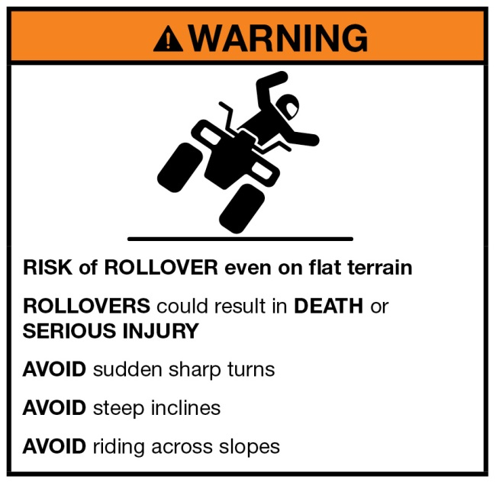

12 Lateral roll stability testing

The lateral roll stability of each type and category of quad bike must be tested in accordance with Schedule 1.

Note: General use quad bikes must meet minimum lateral stability and forward and rearward pitch standards: see section 16.

13 Lateral roll stability tag

(1) A tag (the ***lateral roll stability tag***) in the form, and with the content, required by this section must be attached to a quad bike so that it is clearly visible and legible.

(2) The lateral roll stability tag for a quad bike must record, in the form indicated under subsection (4), the minimum angle the quad bike tipped sideways onto 2 wheels (its tilt table angle) when that type and category of quad bike was tested under section 12 (see also Division 6.1 of Schedule 1).

(3) The lateral roll stability tag must be 178 mm high and 113 mm wide, or have larger dimensions in the same proportion.

(4) The lateral roll stability tag must have the following form and content (scaled to dimensions complying with subsection (3)):

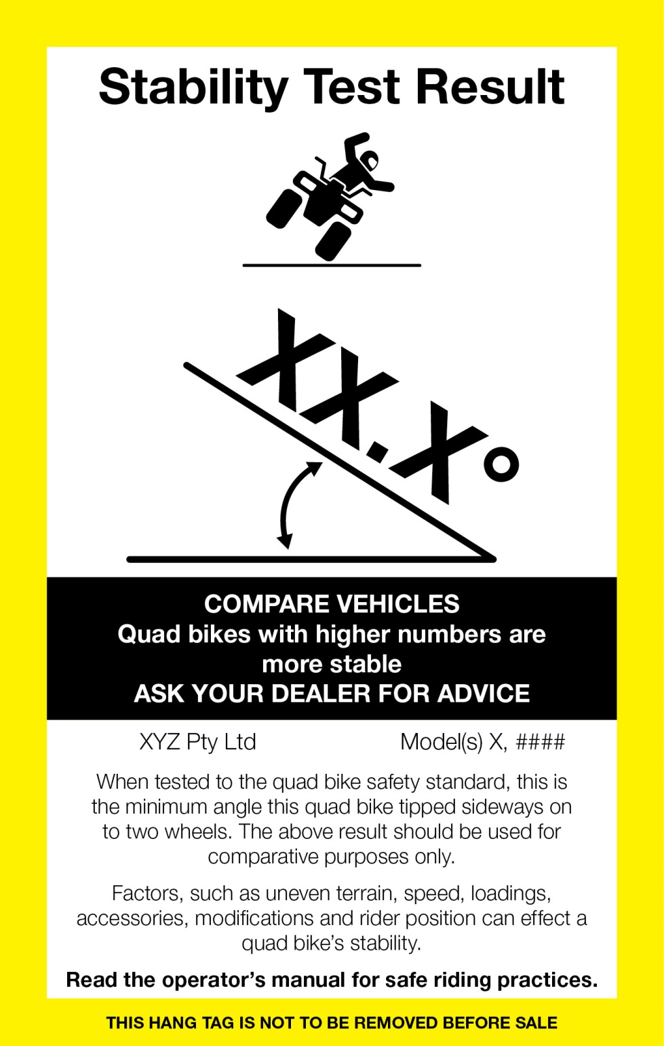

Part 3—Requirements for general use quad bikes

14 Scope of this Part

General use quad bikes must comply with the requirements in sections 15 and 16.

Note 1: General use quad bikes are Type I, Category G quad bikes and Type II, Category G quad bikes: see the definition of ***general use quad bike*** in section 4. For descriptions of each type and category, see section 5.

Note 2: This Part starts to apply 24 months after this instrument commences (see section 17). The requirements in this Part become mandatory when this Part starts to apply.

15 General use quad bikes—operator protection devices

A general use quad bike must have one of the following devices fitted, or integrated into its design:

(a) an ATV Lifeguard, in the model manufactured by Ag‑Tech Industries Ltd. (New Zealand) and available for supply on 6 April 2019;

(b) a Quadbar, in the model manufactured by QB Industries Pty Ltd. and available for supply on 6 April 2019;

(c) a device of a type that offers the same, or better, level of protection for operators from the risk of serious injury, or death, as a result of being crushed or pinned in the event of a rollover, as is offered by a device of a type mentioned in paragraph (a) or (b).

Note 1: This section starts applying (together with the rest of this Part) 24 months after the day this instrument commenced (see subsection 17(2) of this instrument).

Note 2: When this instrument commenced, there was no standard published by Standards Australia (or any other appropriate body) relating to operator protection devices for general use quad bikes. If such a standard is published after the commencement of this instrument, under subsection 105(1) of the Australian Consumer Law the Commonwealth Minister may declare that the published standard applies to such operator protection devices (with or without additions or variations). This section may also be amended as a consequence when such a declaration is made.

16 General use quad bikes—minimum lateral roll, forward pitch and rearward pitch requirements

Requirements

(1) When tested in accordance with Schedule 1, each type and category of general use quad bike must meet the performance requirements provided by this section.

Note: For testing requirements, see Part 6 of Schedule 1.

Lateral roll

(2) The tilt table ratio for lateral roll stability must be equal to or greater than 0.55.

Forward pitch

(3) The tilt table ratio for forward pitch must be equal to or greater than 0.8.

Rearward pitch

(4) The tilt table ratio for rearward pitch must be equal to or greater than 0.8.

Part 4—Application, saving and transitional provisions

17 Application of this instrument as made

(1) Part 2 of this instrument, and Schedule 1 to this instrument, apply in relation to a quad bike on or after the day that is 12 months after the day this instrument commences.

(2) Part 3 of this instrument applies in relation to a quad bike on or after the day that is 24 months after the day this instrument commences.

Schedule 1—Test procedures

Note: See section 12.

Part 1—General

1.1 In this Schedule:

***50 PAM H3 ATD*** (short for 50th Percentile Average Male Hybrid III Anthropomorphic Test Device) means an ATD configured to represent the 50th percentile average male.

***ATD*** means an anthropomorphic test device.

***CoG*** means centre of gravity.

***static stability*** means the ability for a stationary body to resist tipping over.

Note: Key properties that affect the static stability of a quad bike are track width, wheelbase and the position of the centre of gravity.

***tilt table ratio*** or ***TTR***, means the tangent of the maximum tilt table angle (see clauses 6.1.10 and 6.2.11).

Note: Some other terms used in this Schedule are defined in section 4 of this instrument. For the meaning of ***quad bike*** (and types and categories of quad bike), see section 5 of this instrument.

1.2 The static stability of Type I, Category G (general use) and Category S (sports) and Type II, Category G (general) quad bikes is to be measured using a tilt table, with a 50PAM H3 ATD simulated rider positioned in a standardised seating position as described in Part 4 of this Schedule.

1.3 The static stability of Type I, Category Y (youth) and Category T (transition) quad bikes is to be measured using a tilt table without an ATD.

1.4 The static stability factor for each direction (forward or rearward pitch, or lateral roll) is calculated as Tan (tilt table angle at 2 wheel lift).

1.5 Type I, Category G and Type II, Category G quad bikes are to be tested for each direction (forward and rearward pitch and lateral roll), and must meet the minimum performance requirements under section 16 of this instrument.

1.6 Type I, Category S, Category Y and Category T quad bikes are to be tested for lateral roll only.

Part 2—Tilt table

2.1 The tilt table must have an adjustable slope, single plane tilt‑table structure, with a range of 0° to 80° from horizontal.

2.2 The tilt table must have a surface that is rigid, flat and large enough to support all 4 quad bike wheels.

2.3 The tilt table surface must support a load cell under each of the 4 quad bike wheels.

2.4 A high friction surface is to be installed on the top surface of the downhill side load cells to prevent the low side tyres from slipping (anti‑slip tape or expanded mesh may suit).

2.5 The tilt table must have a tilt rate of nominally less than 1.0 degree per second (for at least the last 20° before tyre lift‑off).

Part 3—Test quad bike set‑up

3.1 The test quad bike is to be prepared to kerb mass, that is, all standard equipment fitted and vehicle fluids are to be filled to maximum capacity (engine oil, transmission and differential fluids, coolant, brakes and fuel).

3.2 The tyres are to be inflated to the manufacturer’s recommended pressures. Where more than one pressure is specified, the lowest pressure is to be used.

3.3 Adjustable suspension is to be set at the value specified at the dealer delivered configuration.

Part 4—Anthropomorphic test device

4.1 For Type I Category G and Category S and Type II, Category G quad bikes, use the 50 PAM H3 ATD, clothed in form‑fitting cotton clothing and shoes equivalent to those specified in US Military Standard MIL‑S‑13192: P: Shoes, Men’s, Dress, Oxford.

4.2 The ATD is to be secured to the seat so as to prevent independent movement.

4.3 The ATD pelvis is to remain parallel with the plane of the rider seat during tilting. Nominally, this is achieved by securing each leg downward toward the footrest. Hands are to be secured to the hand grips.

4.4 The ATD is to be positioned such that each hand is gripping the hand controls with the web of the hand in contact with the inner ridge of the hand grip. The arms are to be fully extended and the pelvis is to be centred laterally on the seat and located longitudinally such that the back angle (measured flat from the spine box) is vertical (±2.5°); the head roll angle is to be horizontal (±0.5°). The thighs are to be in contact with the fuel tank/cowling and the feet are to be positioned on the footrest with the leading edge of the heel in contact with the rear edge of the footrest.

4.5 The ATD pelvis angle and H point dimensions are to be recorded relative to the rear upper edge of the footrest (vertical (y) and horizontal (z) dimensions).

4.6 ATD limb joint stiffness is to be set at 1g.

Note: If the ATD cannot straddle the cowling, a pedestrian sit/stand pelvis may be required to be fitted to the device.

Part 5—Determination of centre of gravity position

5.1 Record the quad bike’s wheelbase and track width (front and rear). Check against the manufacturer’s documentation to confirm that the sample quad bike is within the manufacturer’s tolerances.

5.2 In test condition, weigh the quad bike on a flat, level surface to obtain the 4 individual wheel masses and calculate the quad bike’s longitudinal CoG and lateral CoG position.

Part 6—Tilt test procedure

Division 6.1—Lateral roll

6.1.1 Position the quad bike on the tilt table with each wheel centred on a load cell.

6.1.2 Quad bikes are to be tested facing in both directions, to account for offset CoG position where this occurs. Both results must be reported. The quad bike’s characteristic lateral roll stability result is to be the lower of the 2 results achieved from testing in both roll directions.

6.1.3 Align the quad bike so that a line passing through the outer edges of the 2 downhill tyres is parallel to the line of the tilt axis of the tilt table.

6.1.4 Set the steering mechanism in the straight ahead position.

6.1.5 Apply the park brake or park mechanism to stop the quad bike from rolling.

6.1.6 Affix 2 catch straps (of less than 1 kg mass) between the quad bike and the tilt table with sufficient slack to allow full decompression (extension) of the uphill suspension and minimal wheel lift at tip‑over.

6.1.7 Raise the tilt table until both uphill tyres have lost contact with the ground (that is, both uphill load cells show no load).

6.1.8 Record the tilt table angle at the moment of second uphill wheel lift (tip‑over).

6.1.9 Return the tilt table to the horizontal position.

6.1.10 The static rollover threshold of the vehicle in g’s of lateral acceleration (1g = acceleration due to gravity), referred to as the tilt table ratio (or TTR), is calculated as Tan of tilt platform angle at 2 wheel lift (Tan Ø). The TTR is approximately equal to the static stability factor (or SSF) with variation due to CoG displacement due to vehicle body roll and suspension articulation, compliance in steering and suspension joints and deformation of the wheels and tyres.

Division 6.2—Pitch

6.2.1 Type 1, Category G and Type II, Category G quad bikes are to be tested in both forward and rearward pitch directions.

6.2.2 Position the quad bike on the tilt table with each wheel centred on a load cell.

6.2.3 Align the quad bike so that a line passing through the centreline of the contact patches of the 2 downhill tyres is parallel to the line of the tilt axis of the tilt table.

6.2.4 Set the steering mechanism in the straight ahead position.

6.2.5 Apply the park brake or park mechanism, or fix the wheel or the brake assembly (if required) to stop the quad bike from rolling.

6.2.6 If the low side tyres slip on the load cell surface prior to uphill wheel lift, affix a ratchet strap over each low side wheel such that the line of action of the strap passes through the contact patch of the tyre and the axle centreline, whilst still allowing the tyre to roll about the contact patch when the vehicle tips.

6.2.7 Affix 2 catch straps (of less than 1 kg mass) between the vehicle and the tilt table with sufficient slack to allow full decompression (extension) of the uphill suspension and minimal wheel lift at tip‑over.

6.2.8 Raise the tilt table until both uphill tyres have lost contact with the ground (that is, both uphill load cells show no load).

6.2.9 Record the tilt table angle at the moment of second uphill wheel lift (tip‑over).

6.2.10 Return the tilt table to the horizontal position.

6.2.11 The static pitch‑over threshold of the vehicle in g’s of lateral acceleration (1g = acceleration due to gravity), referred to as the tilt table ratio (or TTR), is calculated as Tan of tilt table angle at 2 wheel lift (Tan Ø). The TTR is approximately equal to the static stability factor (or SSF) with variation due to CoG displacement due to vehicle body pitch and suspension articulation, compliance in steering and suspension joints and deformation of the wheels and tyres.

Part 7—Instrumentation

7.1 Four load cells with at least 700 kg load capacity and resolution of at least 0.5 kg.

7.2 Tilt angle sensor with a range of at least 80° and a resolution of at least 0.1°.

7.3 Data acquisition system acquisition rate of at least 100 samples per second (100Hz).

7.4 Real time videography (front 45° view).