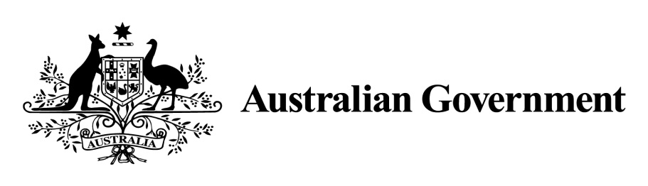

National Land Transport Act 2014

VARIATION OF THE ROADS TO RECOVERY LIST 2019

Instrument No. 2019/4
I, OLIVER HOLM, General Manager, South East Infrastructure Investment, Department of Infrastructure, Transport, Cities and Regional Development, under Sections 88(2A) of the National Land Transport Act 2014 (the Act), vary the Roads to Recovery List 2019 which was made by the Minister on 31 October 2018, and amended by Instrument No. 2019/2 made on 1 July 2019 and 2019/3 made on 29 July 2019 as follows:

- Name of variation

This variation instrument is the Roads to Recovery List 2019 Variation Instrument No. 2019/4.

- Variation

(a) In Schedule 1 of the List relating to Western Australia:
Omit the amount specified in Column 2 of Schedule 1 to the List for each applicable person or body named in Column 1 of the schedule to this instrument and replace omitted amount with the amount specified for that person or body in Column 2 of the schedule to this instrument.

(b) In Schedule 2 of the List:
Omit the amount specified in the List for Western Australia in Column 2 of Schedule 2 and replace the omitted amount with the amount $2,398,578.

- Commencement

This instrument commences on the day after registration.

Dated: 27 September 2019

OLIVER HOLM
General Manager
South East Infrastructure Investment
Infrastructure Investment Division
Department of Infrastructure, Transport, Cities and Regional Development

Schedule 1 to Instrument 2019/4

Item | Column 1 - Funding recipients | Column 2 – Funding amounts
292 | Shire of Beverley | $3,174,662
323 | Shire of Denmark | $2,315,601
324 | Shire of Derby-West Kimberley | $3,838,545
330 | Shire of East Pilbara | $7,808,410
334 | Shire of Gingin | $4,058,478
339 | Shire of Halls Creek | $3,170,004
345 | City of Kalgoorlie-Boulder | $5,471,043
356 | Shire of Laverton | $3,108,759
362 | Shire of Menzies | $2,743,138
364 | Shire of Mingenew | $5,091,033
371 | Shire of Mundaring | $5,765,327
373 | Shire of Murray | $6,435,031
378 | Shire of Ngaanyatjarraku | $3,675,596
387 | Town of Port Hedland | $2,449,555
389 | Shire of Ravensthorpe | $3,371,513
397 | City of Swan | $9,922,820
402 | Shire of Upper Gascoyne | $3,150,284
418 | Shire of Wyndham-East Kimberley | $3,687,008

Schedule 2 to Instrument 2019/4

Item | Column 1 – States and areas of States | Column 2 – Funding amounts
1 | Western Australia | $2,398,578

