

Food Standards (Application A1102 – L-carnitine in Food) Variation

The Board of Food Standards Australia New Zealand gives notice of the making of this variation under section 92 of the Food Standards Australia New Zealand Act 1991. The variation commences on the date specified in clause 3 of this variation.

Dated 18 July 2019
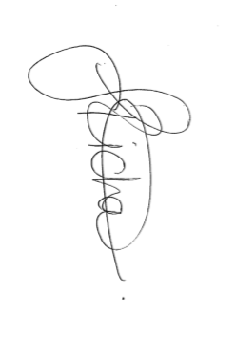

Standards Management Officer
Delegate of the Board of Food Standards Australia New Zealand

Note:

This variation will be published in the Commonwealth of Australia Gazette No. FSC 127 on 25 July 2019. This means that this date is the gazettal date for the purposes of clause 3 of the variation.

1 Name
This instrument is the Food Standards (Application A1102 – L-carnitine in Food) Variation.
2 Variation to a standard in the Australia New Zealand Food Standards Code
The Schedule varies a Standard in the Australia New Zealand Food Standards Code.
3 Commencement
The variation commences on the date of gazettal.
Schedule
[1] Schedule 29 – Special purpose foods
[1.1] The table to section S29—19
Omit
L-carnitine | 100 mg
substitute:
L-carnitine | 2 g

