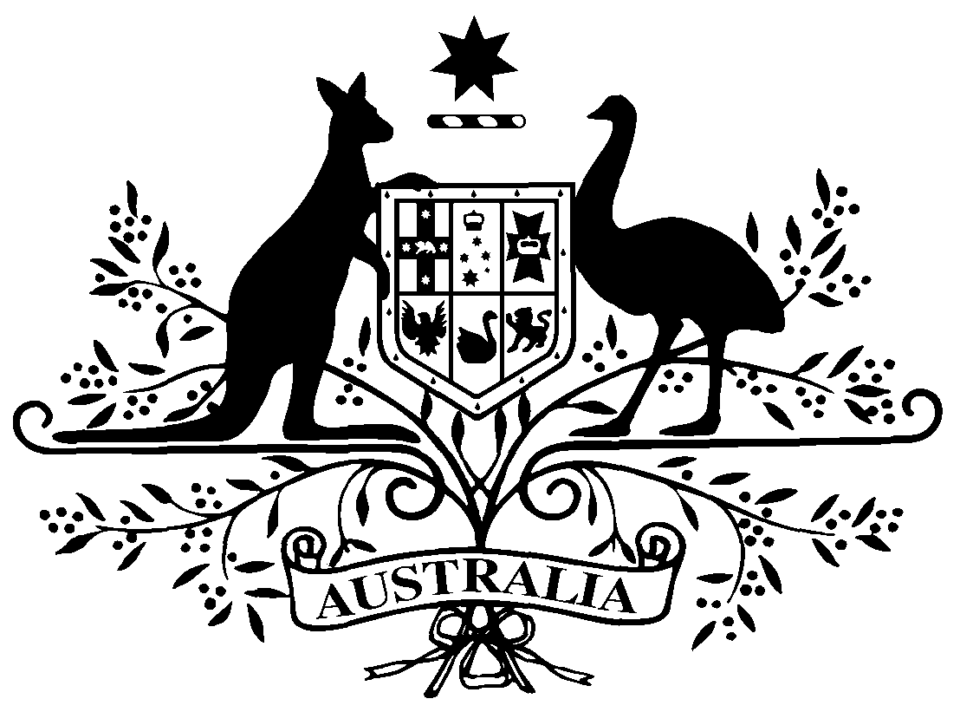

PB 44 of 2019
National Health (Pharmaceutical Benefits Scheme- Exempt items - Section 84AH) Amendment Determination 2019 (No. 2)
National Health Act 1953
I, THEA DANIEL, Assistant Secretary, Pricing and PBS Policy Branch, Technology Assessment and Access Division, Department of Health, delegate of the Minister for Health, make this Determination under section 84AH of the National Health Act 1953.
Dated 24 May 2019

THEA DANIEL

Assistant Secretary
Pricing and PBS Policy Branch
Technology Assessment and Access Division
Department of Health

1 Name of Instrument
- This instrument is the National Health (Pharmaceutical Benefits Scheme-Exempt items - Section 84AH) Amendment Determination 2019 (No. 2).
- This instrument may also be cited as PB 44 of 2019.
2 Commencement
This instrument commences on 1 June 2019.
3 Amendments to PB 81 of 2017
The Schedule amends the legislative instrument titled National Health (Pharmaceutical Benefits Scheme – Exempt items – Section 84AH) Determination 2017 (PB 81 of 2017) (as amended)

Schedule Amendments

- In the Schedule , after entry for Glyceryl Trinitrate, Sublingual spray (pump pack) 400 micrograms per dose, 200 doses
Insert:

Hydromorphone | Oral liquid containing hydromorphone hydrochloride 1 mg per mL, 200 mL | Oral

