

Aboriginal and Torres Strait Islander Heritage Protection (Bellwood Sacred Site) Declaration 2019
I, Melissa Price, Minister for the Environment, make the following declaration.
Dated 5 April 2019
Melissa Price
Minister for the Environment

Part 1—Preliminary matters

1 Name
This instrument is the Aboriginal and Torres Strait Islander Heritage Protection (Bellwood Sacred Site) Declaration 2019.

2 Commencement
This instrument commences on the day after registration.

3 Authority
This instrument is made under section 10 of the Aboriginal and Torres Strait Islander Heritage Protection Act 1984.

4 Definitions
Note: A number of expressions used in this instrument are defined in the Aboriginal and Torres Strait Islander Heritage Protection Act 1984, including the following:
(a) Aboriginal;
(b) area;
(c) significant Aboriginal area.
In this instrument:
Act means the Aboriginal and Torres Strait Islander Heritage Protection Act 1984.
authorised person has the meaning given by subsection 6(5).
declared area means the area specified in section 5 of this instrument.
Geocentric Datum of Australia means the Geocentric Datum of Australia as defined in Gazette No. 35 of 6 September 1995 (GDA94 geocentric data set).
land includes vegetation.
MGA means Map Grid of Australia 1994.
Part 1 has the meaning given by item 1 of Schedule 1.
Part 2 has the meaning given by item 2 of Schedule 1.
Part 3 has the meaning given by item 3 of Schedule 1.

Part 2—Declaration of an area as a significant Aboriginal area to be preserved and protected from injury or desecration

5 Declared area
(1) The area to which this declaration applies (the declared area) is the area known as ‘Bellwood Sacred Site’ in Nambucca Heads in New South Wales, and which consists of the whole of Part 1, Part 2, and Part 3.
Note: Part 1, Part 2 and Part 3 are defined in Schedule 1.
(2) The position of the declared area is to be determined by reference to the Geocentric Datum of Australia.
Note: Geocentric Datum of Australia is defined in section 4.
(3) The following map illustrates the declared area:
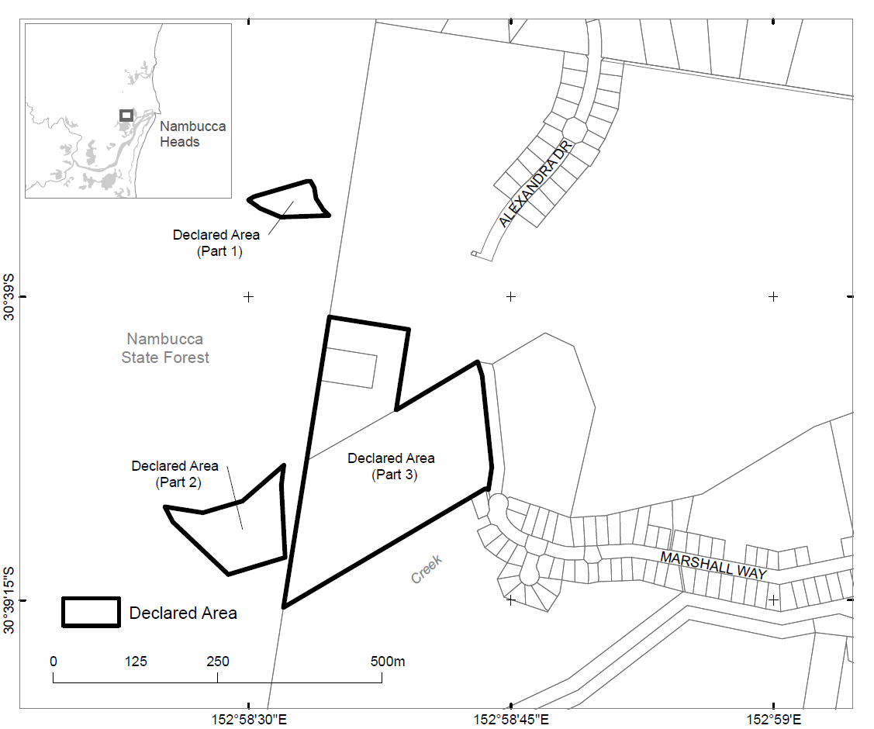

6 Prohibitions and restrictions with respect to the declared area
(1) For section 10 of the Act, the declared area is a significant Aboriginal area that is to be preserved and protected from injury and desecration.
(2) A person must not do any act in, on or near the declared area that will, or is likely to, injure or desecrate the declared area.
Note: Subsection 3(2) of the Act relevantly states that for the purposes of the Act, an area shall be taken to be injured or desecrated if:
(i) it is used or treated in a manner inconsistent with Aboriginal tradition;
(ii) by reason of anything done in, on or near the area, the use or significance of the area in accordance with Aboriginal tradition is adversely affected; or
(iii) passage through or over, or entry upon, the area by any person occurs in a manner inconsistent with Aboriginal Tradition.
Note: Under subsection 22(1) of the Act, a person commits an offence if the person engages in conduct that contravenes a provision of a declaration made under Part II of the Act in relation to a significant Aboriginal area.
(3) Without limiting subsection (2), a person must not:
(a) pass through or over, or enter, the declared area; or
(b) bulldoze, grade, drill, dig, excavate, cut, fill, blast, clear, demolish, tunnel, burn, remove, or otherwise damage land in the declared area; or
(c) build or construct any road, building or structure in, or intruding into, the declared area; or
(d) kill, cut down, poison, deface, burn, remove or otherwise damage any tree in the declared area; or
(e) cause any projectile or aerial device to enter into the declared area.
(4) Subsections (2) and (3) do not apply to acts done by an authorised person:
(a) for the purposes of practising or observing Aboriginal traditions, observances, cultural practices, customs, or beliefs;
(b) for the purposes of education, research, management, monitoring, revegetation, restoration or rehabilitation; or
(c) where doing the act is authorised or required by law.
(5) A person is an authorised person in relation to the doing of an act if:
(a) the person is an elder of the Gumbaynggirr Nation; or
(b) the person has received permission to do the act from:
(i) an elder of the Gumbaynggirr Nation; or
(ii) the Nambucca Heads Local Aboriginal Land Council; or
(c) the person is authorised or required by law to do the act.
(6) For the purposes of paragraph 5(c), a person is not authorised or required by law to do an act merely because the person has received an approval, permission, authority or consent to undertake activities in connection with using or developing land in, on or near the declared area.

7 Period of effect
This instrument has effect for 25 years beginning on the date this instrument commences.

8 Repeal
This instrument is repealed the day after the end of the period specified in section 7 of this instrument.

Schedule 1—Parts 1, 2 and 3 of the declared area

1 Part 1 of the declared area
(1) Part 1 consists of the whole of the area bounded by a line commencing at the point in item 1 of the following table and proceeding through each of the coordinates listed in column 1 of the table in the manner described in column 2 of the table:
Item | Column 1 | Column 2
 | The line runs from this point… | thence…
1 | MGA Zone 56 497604.7E and 6609332.7N | generally East to the point in item 2
2 | 497612.7E and 6609338.2N | generally East to the point in item 3
3 | 497693.5E and 6609361.7N | generally East to the point in item 4
4 | 497699E and 6609361.7N | generally South East to the point in item 5
5 | 497704.8E and 6609351.3N | generally South to the point in item 6
6 | 497707.4E and 6609335.5N | generally South East to the point in item 7
7 | 497718.7E and 6609317.3N | generally South East to the point in item 8
8 | 497726.8E and 6609309.3N | generally West to the point in item 9
9 | 497654E and 6609306.5N | generally North West to the point in item 10
10 | 497622.6E and 6609320N | generally North West to the point in item 11
11 | 497604.7E and 6609332.7N | concluding at that point.
(2) Directions included in the table in subitem (1) are indicative only.

2 Part 2 of the declared area
(1) Part 2 consists of the whole of the area bounded by a line commencing at the point in item 1 of the following table and proceeding through each of the coordinates listed in column 1 of the table in the manner described in column 2 of the table:
Item | Column 1 | Column 2
 | The line runs from this point… | thence…
1 | MGA Zone 56 497477.1E and 6608865.8N | generally East to the point in item 2
2 | 497535E and 6608856.7N | generally East to the point in item 3
3 | 497595.3E and 6608874.4N | generally North East to the point in item 4
4 | 497658.1E and 6608929.2N | generally South to the point in item 5
5 | 497654.5E and 6608899N | generally South to the point in item 6
6 | 497660.4E and 6608789.1N | generally West to the point in item 7
7 | 497573.7E and 6608762.4N | generally North West to the point in item 8
8 | 497489.7E and 6608842.7N | generally North West to the point in item 9
9 | 497477.1E and 6608865.8N | concluding at that point.
(2) Directions included in the table in subitem (1) are indicative only.

3 Part 3 of the declared area
(1) Part 3 consists of the whole of the area bounded by a line commencing at the point in item 1 of the following table and proceeding through each of the coordinates listed in column 1 of the table in the manner described in column 2 of the table:
Item | Column 1 | Column 2
 | The line runs from this point… | thence…
1 | MGA Zone 56 497727.9E and 6609154.5N | generally East to the point in item 2
2 | 497848.5E and 6609135.5N | generally South to the point in item 3
3 | 497829.2E and 6609012.9N | generally North East to the point in item 4
4 | 497953.4E and 6609086.5N | generally South East to the point in item 5
5 | 497960.4E and 6609065.4N | generally South East to the point in item 6
6 | 497975E and 6608926.3N | generally South to the point in item 7
7 | 497969.9E and 6608891.9N | generally North West to the point in item 8
8 | 497965.5E and 6608893.8N | generally South West to the point in item 9
9 | 497658.2E and 6608712.5N | generally North along the forest boundary to the point in item 10
10 | 497727.9E and 6609154.5N | concluding at that point.
(2) Directions included in the table in subitem (1) are indicative only.

