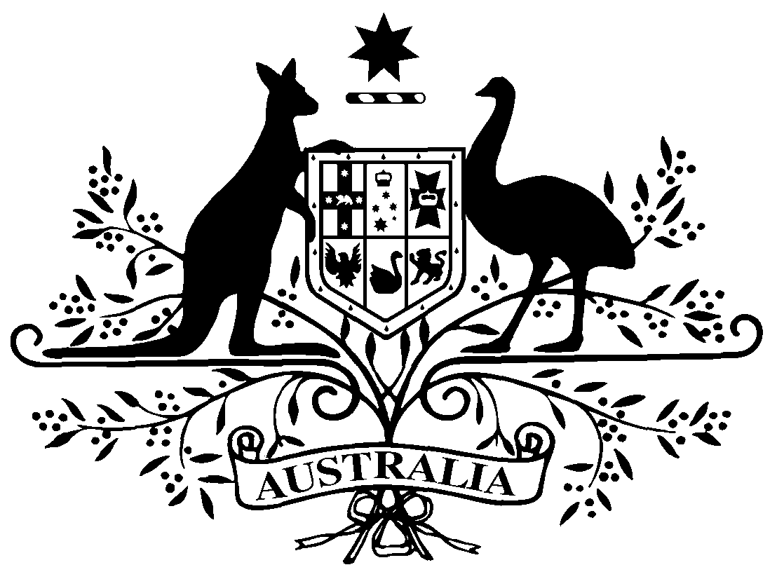

**PB 27 of 2019**

**National Health (Pharmaceutical Benefits Scheme- Exempt items - Section 84AH) Amendment Determination 2019 (No. 1)**

*National Health Act* *1953*

I, THEA DANIEL, Assistant Secretary, Pricing and PBS Policy Branch, Technology Assessment and Access Division, Department of Health, delegate of the Minister for Health, make this Determination under section 84AH of the *National Health Act 1953*.

Dated 27 March 2019

**THEA DANIEL**

Assistant Secretary

Pricing and PBS Policy Branch

Technology Assessment and Access Division

Department of Health

**1 Name of Instrument**

1. This instrument is the *National Health (Pharmaceutical Benefits Scheme-Exempt items - Section 84AH) Amendment Determination 2019 (No. 1).*
2. This instrument may also be cited as PB 27 of 2019.

**2 Commencement**

This instrument commences on 1 April 2019.

**3 Amendments to PB 81 of 2017**

The Schedule amends the legislative instrument titled *National Health (Pharmaceutical Benefits Scheme – Exempt items – Section 84AH) Determination 2017 (PB 81 of 2017)* (as amended)

Schedule Amendments

1. In the Schedule , after entry for Indometacin, Suppository 100 mg

*Omit:*

|  |  |  |
| --- | --- | --- |
| Levodopa with carbidopa | Tablet (modified release) 200 mg-50 mg (as monohydrate) | Oral |