

Aboriginal and Torres Strait Islander Heritage Protection (Butterfly Cave, West Wallsend, NSW) Declaration 2019

I, Melissa Price, Minister for the Environment, make the following declaration.

Dated 31 January 2019

Melissa Price

Minister for the Environment

Part 1—Preliminary matters

1 Name

This instrument is the *Aboriginal and Torres Strait Islander Heritage Protection (Butterfly Cave, West Wallsend, NSW) Declaration 2019*.

2 Commencement

This instrument commences on the day after registration.

3 Authority

This instrument is made under section 10 of the *Aboriginal and Torres Strait Islander Heritage Protection Act 1984*.

4 Definitions

In this instrument:

***Act*** means the *Aboriginal and Torres Strait Islander Heritage Protection Act 1984*.

***authorised person*** has the meaning given by subsection 6(5).

***boundary line*** has the meaning given by item 1 of Schedule 1.

***declared area*** means the area described in section 5 of this instrument.

***Geocentric Datum of Australia 1994 (GDA94)*** means Australia’s current national datum system. A geodetic datum is a system of latitude and longitude coordinates and reference points that is used to locate places on the Earth.

***MGA94*** means the Map Grid of Australia, the standard map projection associated with GDA94. It is a ‘Cartesian coordinate system’ which uses eastings and northings rather than latitude/longitude, and in which the world is divided up into 60 zones for reference.

***land*** includes soil and vegetation.

Note: A number of expressions used in this instrument are defined in the *Aboriginal and Torres Strait Islander Heritage Protection Act 1984*, including the following:

(a) Aboriginal;

(b) area;

(c) significant Aboriginal area.

Part 2—Declaration to preserve and protect a significant Aboriginal area

5 Declared area

1. The area to which this declaration applies (the ***declared area****)* is the area bounded by the ***boundary line***.

Note: The ***boundary line*** is defined in Schedule 1.

1. The position of the declared area is to be determined by reference to the Geocentric Datum of Australia 94 and MGA94 .

Note: ***Geocentric Datum of Australia*** and ***MGA94*** are defined in section 4.

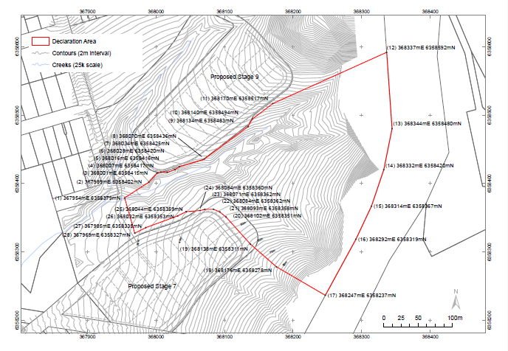 (3) The following map illustrates the declared area:

6 Prohibitions and restrictions with respect to the declared area

(1) For section 10 of the Act, the declared area is a significant Aboriginal area that is to be preserved and protected from injury and desecration.

(2) A person must not do any act in, on or near the declared area that will, or is likely to, injure or desecrate the declared area.

Note: Subsection 3(2) of the Act relevantly states that for the purposes of the Act, an area shall be taken to be injured or desecrated if:

(i) it is used or treated in a manner inconsistent with Aboriginal tradition;

(ii) by reason of anything done in, on or near the area, the use or significance of the area in accordance with Aboriginal tradition is adversely affected; or

(iii) passage through or over, or entry upon, the area by any person occurs in a manner inconsistent with Aboriginal Tradition.

Note: Under subsection 22(1) of the Act, a person commits an offence if the person engages in conduct that contravenes a provision of a declaration made under Part II of the Act in relation to a significant Aboriginal area.

(3) Without limiting subsection (2), a person must not:

(a) pass through or over, or enter, the declared area; or

(b) conduct any activity that will, or is likely to, damage or deface any rock or land in the declared area; or

(c) bulldoze, grade, drill, excavate, cut, fill, blast, clear, demolish, tunnel, burn, remove, or otherwise damage land in the declared area; or

(d) build or construct any road, building or structure in, or intruding into, the declared area; or

(e) conduct any activity that will, or is likely to, disturb soil or vegetation in the declared area, [except where consistent with a plan of management made under the *National Parks and Wildlife Act 1974* (NSW) that has been endorsed by the Awabakal Local Aboriginal Land Council];

(f) disturb vegetation on land surrounding the declared area in a manner that will increase the visibility of the area.

Note: Under subsection 22(1) of the Act, a person commits an offence if the person engages in conduct that contravenes a provision of a declaration made under Part II of the Act in relation to a significant Aboriginal area.

(4) Subsections (2) and (3) do not apply to acts done by an authorised person:

(a) for the purposes of practising or observing Aboriginal traditions, observances, cultural practices, customs, or beliefs;

(b) for the purposes of education, research, management, monitoring, revegetation, restoration or rehabilitation; or

(c) where doing the act is authorised or required by law.

(5) A person is an ***authorised person*** in relation to the doing of an actif:

(a) the person has received permission to do the act from the Awabakal Local Aboriginal Land Council; or

(b) the person is authorised or required by law to do the act.

(6) For the purposes of paragraph 5(b), a person is authorised or required by law to do an act if a plan of management under the *National Parks and Wildlife Act 1974* (NSW) that has been developed in consultation with, and endorsed by the Awabakal Local Aboriginal Land Council and that plan of management authorises or requires the doing of the act.

(7) For the purposes of paragraph 5(b), subject to subsection (6), a person is not authorised or required by law to do an act merely because the person has received an approval, permission, authority or consent to undertake activities in connection with using or developing land in, on or near the declared area.

Schedule 1—Boundary line

1 Boundary line of the declared area

(1) The ***boundary line*** is a line commencing at the point in item 1 of the following table and proceeding through each of the coordinates listed in column 1 of the table in the manner described in column 2 of the table:

|  |  |  |
| --- | --- | --- |
| Item | Column 1 | Column 2 |
|  | **The line runs from this point…** | **thence…** |
| 1 | The whole of the area bounded by a line commencing at the point MGA Zone 56 367954mE and 6358379mN | and then generally north east to the point |
| 2 | 367989mE and 6358402mN | then generally north east to the point |
| 3 | 368001mE and 6358415mN | then generally north east to the point |
| 4 | 368007mE and 6358417mN | then generally east to the point |
| 5 | 368016mE and 6358416mN | then generally north east to the point |
| 6 | 368028mE and 6358420mN | then generally north east to the point |
| 7 | 368034mE and 6358425mN | then generally north east to the point |
| 8 | 368070mE and 6358436mN | then generally north east to the point |
| 9 | 368134mE and 6358483mN | then generally north east to the point |
| 10 | 368140mE and 6358494mN | then generally north east to the point |
| 11 | 368170mE and 6358517mN | then generally north east to the point |
| 12 | 368337mE and 6358592mN | then generally south to the point |
| 13 | 368344mE and 6358480mN | then generally south west to the point |
| 14 | 368332mE and 6358420mN | then generally south west to the point |
| 15 | 368314mE and 6358367mN | then generally south west to the point |
| 16 | 368292mE and 6358319mN | then generally south west to the point |
| 17 | 368247mE and 6358237mN | then generally north west to the point |
| 18 | 368176mE and 6358278mN | then generally north west to the point |
| 19 | 368138mE and 6358311mN | then generally north west to the point |
| 20 | 368102mE and 6358351mN | then generally north west to the point |
| 21 | 368093mE and 6358358mN | then generally north west to the point |
| 22 | 368084mE and 6358362mN | then generally west to the point |
| 23 | 368071mE and 6358362mN | then generally west to the point |
| 24 | 368064mE and 6358360mN | then generally west to the point |
| 25 | 368044mE and 6358359mN | then generally south west to the point |
| 26 | 368032mE and 6358353mN | then generally south west to the point |
| 27 | 367985mE and 6358335mN | then generally south west to the point |
| 28 | 367969mE and 6358327mN | then generally north west back to the point of commencement |

(2) Directions included in the table in subitem (1) are indicative only.