**Shire of Christmas Island Repeal Local Law 2018**

I, GORDON SINCLAIR THOMSON, President of the Shire of Christmas Island, publish the *Shire of Christmas Island Repeal Local Law 2018* under subsections 3.12 (5) of the *Local Government Act 1995* (W A) as applied by the *Christmas Island Act 1958*.

Dated 12 April 2018

GORDON SINCLAIR THOMSON

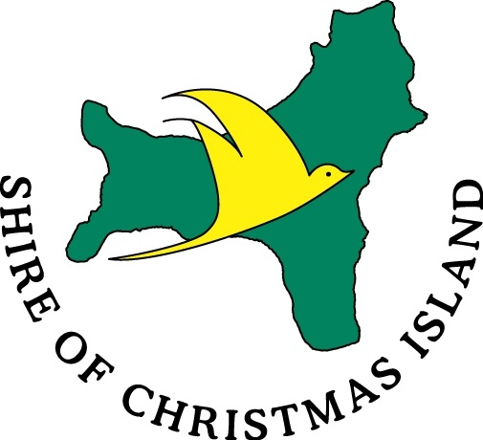

**REPEAL LOCAL LAW**

**MARCH 2018**

**LOCAL GOVERNMENT ACT (WA) (CI) 1995**

Shire of Christmas Island

**REPEAL LOCAL LAW 2017**

**Preamble**

Under the powers conferred by the *Local Government Act 1995*, and under all other powers enabling it, the Council of the Shire of Christmas Island resolved on *27 March 2018* to make the following local law.

**Part 1 - Introducing Matters**

**1.1 Title**

This local law may be cited as the *Shire of Christmas Island Repeal Local Law 2017.*

**1.2 Commencement**

In accordance with section 74A of the Interpretation Act 1984 (WA) (CI) (Amendment) Ordinance 1992, the local law must be registered as a notifiable instrument and comes into operation once it has been registered as a notifiable instrument. Notifiable instruments are published in the Federal Register.

**1.3 Content and Intent**

(1) This local law;

(a) Provides for the repeal of obsolete local laws;

(b) Identifies the obsolete local laws by giving their names, date they were first published in the *Gazette* and any date of subsequent amendments.

(2) This local law is intended to result in;

(a) More efficient and effective Local Government, by removing obsolete local laws.

**Part 2 - Substance of this Law**

**2.1 Repeal**

The following local laws and all subsequent amendments are hereby repealed;

1. Standing Orders Local Law published in the *Government Gazette* on 18 February 2000 and theStanding Orders Amendment Local Law 2010published in the *Indian Ocean Territories Government Gazette* on 15 June 2010.
2. Health Local Law published in the *Government Gazette* on 31 August 2000 and the Health Amendment Local Law 2010published in the *Indian Ocean Territories Government Gazette* on 15 June 2010.
3. Dogs Local Law published in the *Government Gazette* on 16 April 2001 and the Dogs Amendment Local Law 2010published in the *Indian Ocean Territories Government Gazette* on 15 June 2010.
4. Parking and Parking Facilities Local Law published in the *Government Gazette* on 29 November 2002 and the Parking and Parking Facilities Amendment Local Law 2010published in the *Indian Ocean Territories Government Gazette* on 15 June 2010.
   1. Amend
5. Cats Local Law published in the *Indian Ocean Territories Government Gazette* on 30 September 2010.