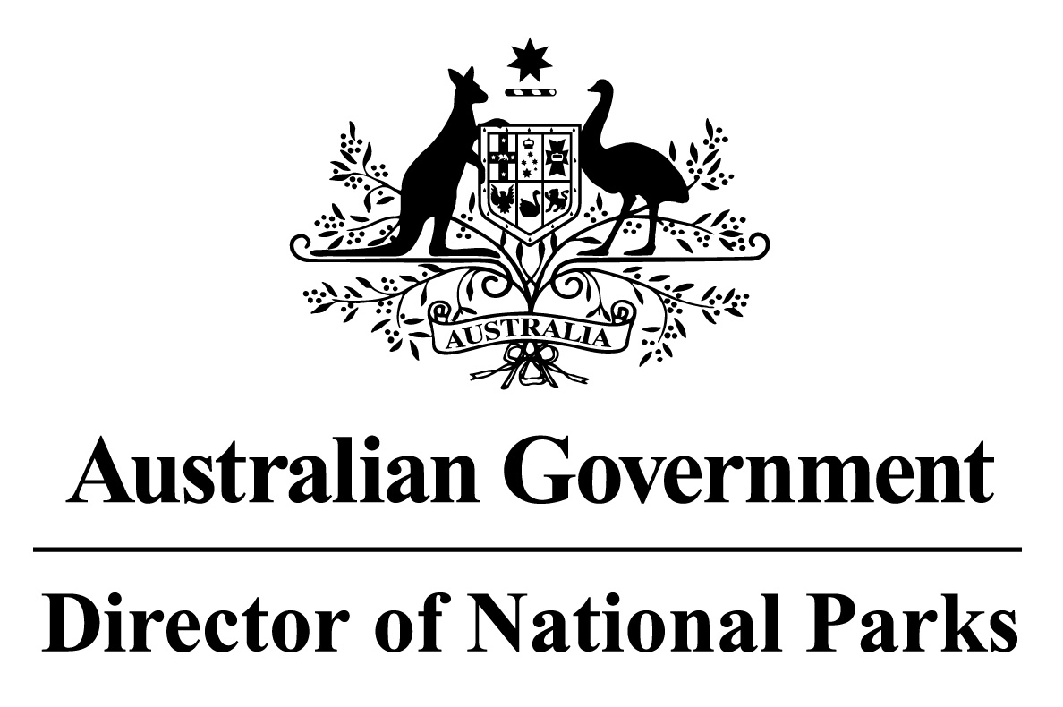
Environment Protection and Biodiversity Conservation Regulations 2000

Subregulation 12.56(2)
DETERMINATION PROHIBITING ANCHORING OF COMMERCIAL FISHING VESSELS
NORTH NETWORK OF MARINE PARKS – PARK ZONES ASSIGNED TO IUCN CATEGORY II (NATIONAL PARK)
I, JASON MUNDY, Acting Director of National Parks, under subregulation 12.56(2) of the Environment Protection and Biodiversity Conservation Regulations 2000, HEREBY DETERMINE that each of the zones within Oceanic Shoals, Gulf of Carpentaria, and West Cape York Marine Parks that are assigned to IUCN category II (national park), being the areas shown in marine park maps in Schedule 2 and described in Schedule 4 to the North Marine Parks Network Management Plan 2018, as specified in the Schedule hereto, is an area of water where vessels used in connection with commercial fishing activities cannot be anchored.
Note : This determination does not prevent anchoring in the areas described in the Schedule hereto due to circumstances of force majeure or distress or for the purposes of rendering assistance to persons, vessels or aircraft in danger or distress.
Dated this 27 th day of June 2018
SIGNED
Jason Mundy
SCHEDULE
NORTH NETWORK OF MARINE PARKS– PARK ZONES ASSIGNED TO IUCN CATEGORY II (NATIONAL PARK)
List of relevant zone and clause numbers in Schedule 4 to the North Marine Parks Network Management Plan 2018:
Marine Park | Zone Number/s | Clause describing the area boundary
Oceanic Shoals Marine Park | 1 | 2.3
Gulf of Carpentaria Marine Park | 1 | 7.3
West Cape York Marine Park | 1, 4 | 8.3, 8.6

