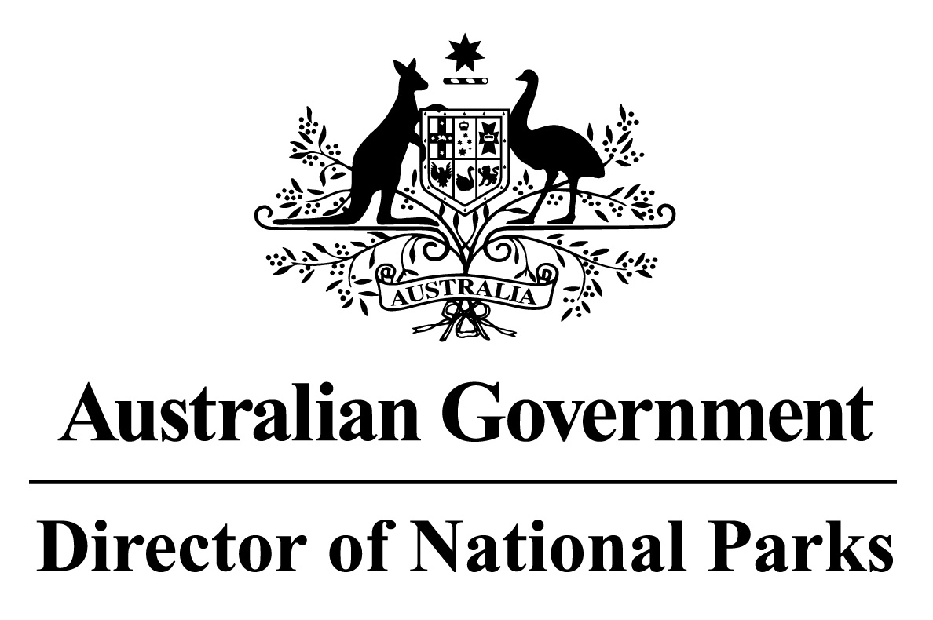
Environment Protection and Biodiversity Conservation Regulations 2000
Subregulation 12.32(3)
DETERMINATION OF BURIAL AREAS
TEMPERATE EAST NETWORK OF MARINE PARK
– PARKS AND PARK ZONES EXCLUDING SPECIAL PURPOSE ZONE (TRAWL)
I, JASON MUNDY, Acting Director of National Parks, under subregulation 12.32(3) of the Environment Protection and Biodiversity Conservation Regulations 2000, HEREBY DETERMINE that the area of each Marine Park comprised in the Temperate East Network of Marine Parks, excluding the areas of the Special Purpose Zone Trawl in Solitary Islands, Hunter and Jervis Marine Parks, being the areas shown in marine park maps in Schedule 2 and described in Schedule 4 to the Temperate East Marine Parks Network Management Plan 2018, as specified in the Schedule hereto, is a burial area.
Note: Sea burials are subject to the Environment Protection (Sea Dumping) Act 1981 and must be conducted in accordance with a permit under that Act.
Dated this 27 th day of June 2018
SIGNED
Jason Mundy
SCHEDULE
TEMPERATE EAST NETWORK OF MARINE PARKS – PARK AND PARK ZONE BURIAL AREAS
List of relevant zone and clause numbers in Schedule 4 to the Temperate East Marine Parks Network Management Plan 2018:
Marine Park | Zone Number/s | Clause describing the area boundary
Gifford Marine Park | Entire area of marine park | 1.1
Norfolk Marine Park | Entire area of marine park | 2.1
Lord Howe Marine Park | Entire area of marine park | 3.1
Central Eastern Marine Park | Entire area of marine park | 4.1
Solitary Islands Marine Park | 1, 2 | 5.3, 5.4
Cod Grounds Marine Park | Entire area of marine park | 6.1
Hunter Marine Park | 2 | 7.4
Jervis Marine Park | 2 | 8.4

