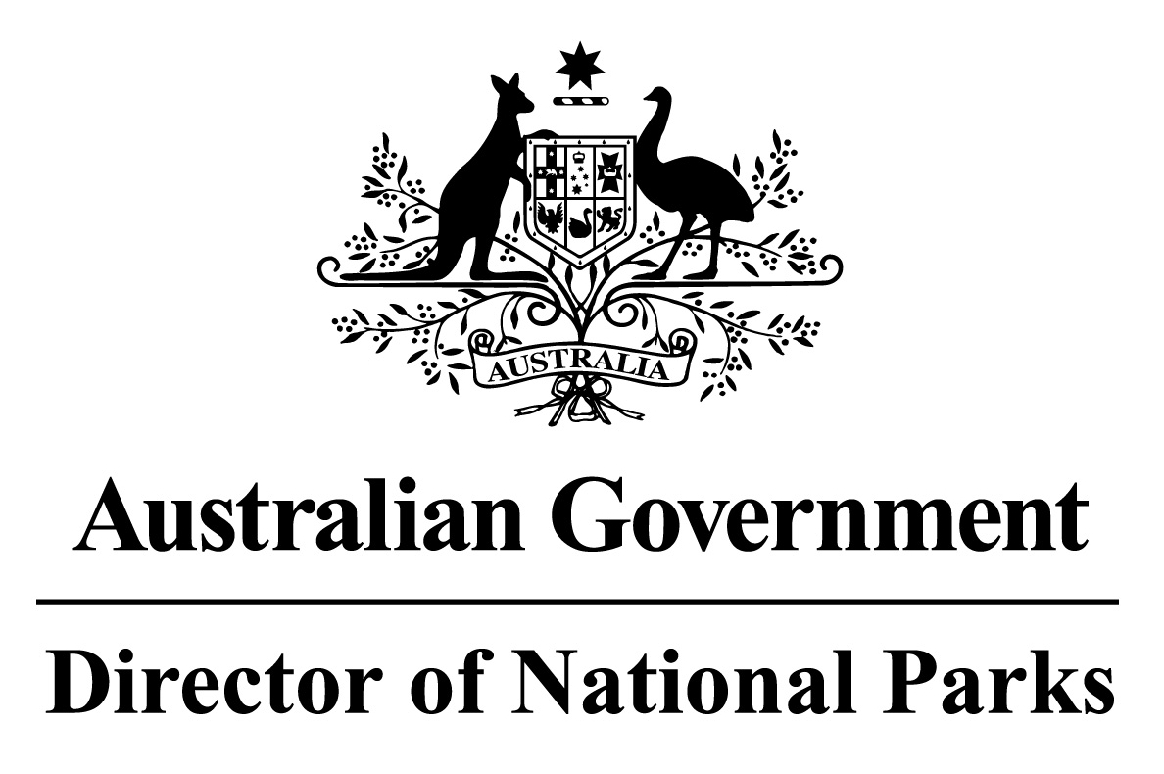

*Environment Protection and Biodiversity Conservation Regulations 2000*

Sub-regulation 12.34(3)

**DETERMINATION OF COMMERCIAL FISHING PRACTICES**

**NORTH-WEST NETWORK OF MARINE PARKS**

I, JASON MUNDY, Acting Director of National Parks, under sub-regulation 12.34(3) of the *Environment Protection and Biodiversity Conservation Regulations 2000* HEREBY DETERMINE that for each of the Marine Parks in the Network, being the marine parks listed in Schedule 1 hereto, the following practices in commercial fishing are to be followed:

1. vessels (other than vessels engaged in cage towing) transiting a Marine Park, or zone within a Marine Park, that is assigned to IUCN category II (national park), as described in Schedule 2 hereto, must travel at a speed greater than 5 knots; and
2. fish may only be processed or transhipped in zones in which use of a gear type or fishing method for the taking of that fish is authorised by the *North-west Marine Parks Network Management Plan 2018* or the Class Approval issued by the Director of National Parks for commercial fishing in the Network; and
3. vessels transiting or stopping and anchoring in zones in which fishing, or use of fishing gear on board the vessel, is not authorised by the *North-west Marine Parks Network Management Plan 2018* or the Class Approval issued by the Director of National Parks for commercial fishing in the Network, must have the fishing gear stowed and secured at all times.

Note: Paragraphs (b) and (c) do not apply to commercial fishing practices conducted in accordance with an authorisation issued by the Director of National Parks.

In this determination:

**stowed and secured** means all fishing apparatus, including nets and lines, are rendered inoperative, including that the apparatus is inboard the vessel, and otherwise completely out of the water; and

**transiting** means the continuous and expeditious passage of a vessel through an area whereby the vessel does not stop for any reason other than in response to an emergency or to render assistance to persons, aircraft or vessels in danger or distress.

Dated this 27 th day of June 2018

SIGNED

Jason Mundy

**SCHEDULE 1**

**NORTH-WEST NETWORK OF MARINE PARKS**

Shark Bay Marine Park

Carnarvon Canyon Marine Park

Ningaloo Marine Park

Gascoyne Marine Park

Montebello Marine Park

Dampier Marine Park

Eighty Mile Beach Marine Park

Roebuck Marine Park

Mermaid Reef Marine Park

Argo-Rowley Terrace Marine Park

Kimberley Marine Park

Ashmore Reef Marine Park

**SCHEDULE 2**

**IUCN II PARKS AND ZONES**

Mermaid Reef Marine Park, and the zones within Ningaloo, Gascoyne, Dampier, Argo-Rowley Terrace, and Kimberley Marine Parks that are assigned to IUCN category II (national park), being the areas shown in marine park maps in Schedule 2 and described in Schedule 4 to the *North-west Marine Parks Network Management Plan 2018*, as specified below:

|  |  |  |
| --- | --- | --- |
| **Marine Park** | **Zone Number/s** | **Clause describing the area boundary** |
| Ningaloo Marine Park | 2 | 3.4 |
| Gascoyne Marine Park | 1 | 4.3 |
| Dampier Marine Park | 1 | 6.3 |
| Mermaid Reef Marine Park | Entire area of marine park | 9.1 |
| Argo-Rowley Terrace Marine Park | 1 | 10.3 |
| Kimberley Marine Park | 2 | 11.4 |