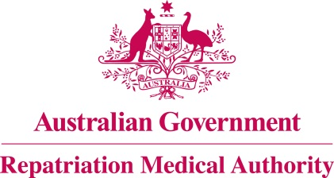

Amendment Statement of Principles

concerning

MIGRAINE
(Reasonable Hypothesis)

(No. 98 of 2018)
The Repatriation Medical Authority determines the following Amendment Statement of Principles under subsections 196B(2) and (8) of the Veterans' Entitlements Act 1986.

Dated 26 October 2018

The Common Seal of the
Repatriation Medical Authority
was affixed to this instrument
at the direction of:

Professor Nicholas Saunders AO
Chairperson

Contents
1 Name 3
2 Commencement 3
3 Authority 3
4 Amendment 3

- Name
This is the Amendment Statement of Principles concerning migraine (Reasonable Hypothesis) (No. 98 of 2018).
- Commencement
This instrument commences on 26 November 2018.
- Authority
This instrument is made under subsections 196B(2) and (8) of the Veterans' Entitlements Act 1986.
- Amendment
The Statement of Principles concerning migraine (Reasonable Hypothesis) (No. 7 of 2018) (Federal Register of Legislation No. F2018L00012) is amended in the following manner:

Section | Amendment
9(2a) | Insert the following factor in subsection 9(2a):  having concussion or moderate to severe traumatic brain injury before the clinical onset of migraine, where migraine has developed within the seven days of:  - injury to the head; or  - regaining consciousness following the injury to the head; or  - discontinuing medication that impairs the ability to sense or report headache following the injury to the head;
9(4a) | Insert the following factor in subsection 9(4a):  having concussion or moderate to severe traumatic brain injury before the clinical worsening of migraine, where migraine has worsened within the seven days of:  - injury to the head; or  - regaining consciousness following the injury to the head; or  - discontinuing medication that impairs the ability to sense or report headache following the injury to the head;

