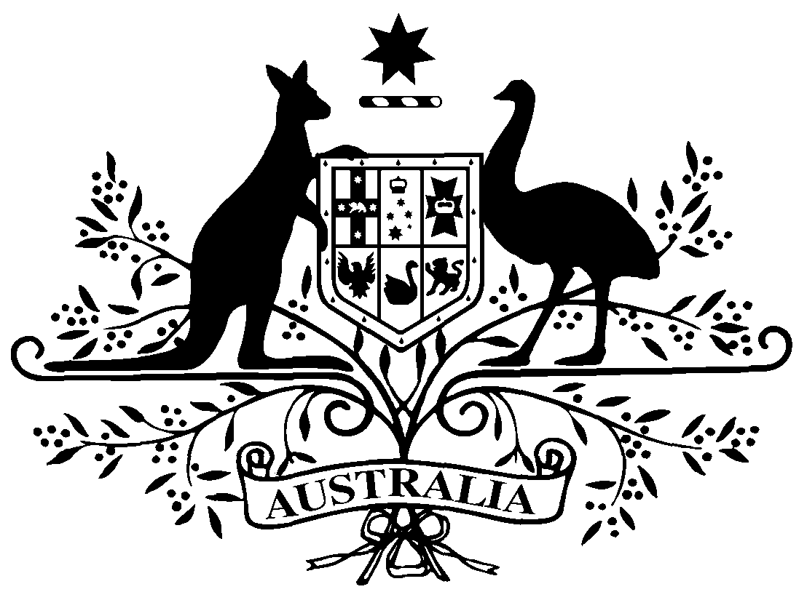

**PB 97 of 2018**

**National Health (Pharmaceutical Benefits Scheme- Exempt items - Section 84AH) Amendment Determination 2018 (No. 4)**

*National Health Act* *1953*

I, LISA LA RANCE, Assistant Secretary, Pricing and PBS Policy Branch, Technology Assessment and Access Division, Department of Health, delegate of the Minister for Health, make this Determination under section 84AH of the *National Health Act 1953*.

Dated 25 October 2018

**LISA LA RANCE**

Assistant Secretary

Pricing and PBS Policy Branch

Technology Assessment and Access Division

Department of Health

**1 Name of Instrument**

1. This instrument is the *National Health (Pharmaceutical Benefits Scheme-Exempt items - Section 84AH) Amendment Determination 2018 (No. 4).*
2. This instrument may also be cited as PB 97 of 2018.

**2 Commencement**

This instrument commences on 1 November 2018.

**3 Amendments to PB 81 of 2017**

Schedule 1 amends the legislative instrument titled *National Health (Pharmaceutical Benefits Scheme – Exempt items – Section 84AH) Determination 2017 (PB 81 of 2017)* (as amended)

Schedule 1 Amendments

1. Schedule 1, after entry for Escitalopram, Oral solution 20 mg (as oxalate) per mL, 15 mL

*Insert:*

|  |  |  |
| --- | --- | --- |
| Ethosuximide | Oral solution 250 mg per 5 mL, 200 mL | Oral |

1. Schedule 1, after entry for Glyceryl Trinitrate, Sublingual spray (pump pack) 400 micrograms per dose, 200 doses

*Omit:*

|  |  |  |
| --- | --- | --- |
| Hydromorphone | Oral liquid containing hydromorphone hydrochloride 1 mg per mL, 473 mL | Oral |