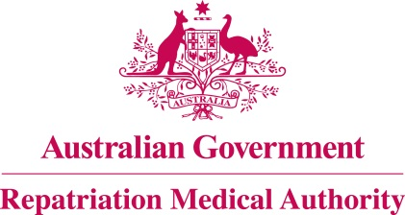

Amendment Statement of Principles

concerning

LOSS OF TEETH
(Reasonable Hypothesis)

(No. 83 of 2018)
The Repatriation Medical Authority determines the following Amendment Statement of Principles under subsections 196B(2) and (8) of the Veterans' Entitlements Act 1986.

Dated 24 August 2018

The Common Seal of the
Repatriation Medical Authority
was affixed to this instrument
at the direction of:

Professor Nicholas Saunders AO
Chairperson

Contents
1 Name 3
2 Commencement 3
3 Authority 3
4 Amendment 3

- Name
This is the Amendment Statement of Principles concerning loss of teeth (Reasonable Hypothesis) (No. 83 of 2018).
- Commencement
This instrument commences on 24 September 2018.
- Authority
This instrument is made under subsections 196B(2) and (8) of the Veterans' Entitlements Act 1986.
- Amendment
The Statement of Principles concerning loss of teeth (Reasonable Hypothesis) (No. 124 of 2015) (Federal Register of Legislation No. F2015L01678) is amended in the following manner:

Section | Amendment
9(9a) | Insert the following factor in subsection 9(9a):  having tooth wear involving the affected tooth at the time of the clinical onset of loss of teeth;

