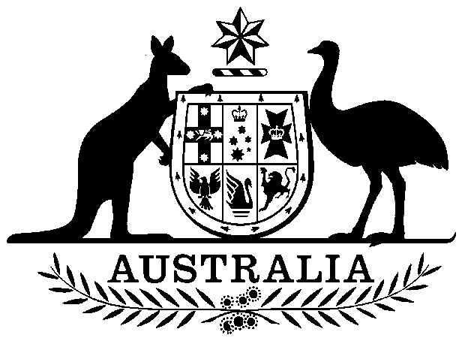

**COMMONWEALTH OF AUSTRALIA**

##### *Environment Protection and Biodiversity Conservation Act 1999*

**Amendment of List of Exempt Native Specimens – WESTERN AUSTRALIAN PILBARA FISH TRAWL MANAGED FISHERY, AUGUST 2018**

I, PAUL MURPHY, Assistant Secretary, Wildlife Trade and Biosecurity Branch, as Delegate of the Minister for the Environment and Energy, pursuant to subsection303DC(1)(a) of the *Environment Protection and Biodiversity Conservation Act 1999* (EPBC Act), hereby amend the list of exempt native specimens established under section 303DB of the EPBC Act by **deleting** from the list specimens and any associated restrictions or conditions as set out in **Schedule 1**, and by **including** in the list specimens and associated restrictions or conditions as set out in **Schedule 2**.

This instrument is a legislative instrument for the purposes of the *Legislation Act 2003*.

The instrument commences the day after it is registered.

All state and territory legislation referred to in Schedule 2 to the instrument is incorporated as in force at the time this instrument commences.

# Dated this 23rd day of August 2018

……………………Paul Murphy……………………..

Delegate of the Minister for the Environment and Energy

**SCHEDULE 1**

Under the heading Freshwater and Marine Animals delete from the list the following items and any associated notations:

|  |  |  |  |
| --- | --- | --- | --- |
| **Taxon/Item** | | **Common Name** | **Notation** |
| Specimens that are or are derived from fish or invertebrates taken in the Western Australian Pilbara Fish Trawl Interim Managed Fishery as defined in the management regime in force under the Fish Resources Management Act 1994 (WA) and Fish Resources Management Regulations 1995 (WA), but not including:   * specimens that belong to eligible listed threatened species, as defined under section 303BC of the EPBC Act, or * specimens that belong to taxa listed under section 303CA of the EPBC Act (Australia’s CITES List). | Western Australian Pilbara Fish Trawl Managed Fishery | | •   the specimen, or the fish or invertebrate from which it is derived, was taken lawfully;  •   the specimens are included in the list until 24 August 2018. |

**SCHEDULE 2**

Under the heading Freshwater and Marine Animals include in the list the following items and associated notations:

|  |  |  |  |
| --- | --- | --- | --- |
| **Taxon/Item** | | **Common Name** | **Notation** |
| Specimens that are or are derived from fish or invertebrates taken in the Western Australian Pilbara Fish Trawl Interim Managed Fishery as defined in the management regime in force under the *Fish Resources Management Act 1994* (WA) and Fish Resources Management Regulations 1995 (WA), but not including:   * specimens that belong to eligible listed threatened species, as defined under section 303BC of the EPBC Act, or * specimens that belong to taxa listed under section 303CA of the EPBC Act (Australia’s CITES List). | Western Australian Pilbara Fish Trawl Managed Fishery | | •   the specimen, or the fish or invertebrate from which it is derived, was taken lawfully;  •   the specimens are included in the list until 30 November 2018. |