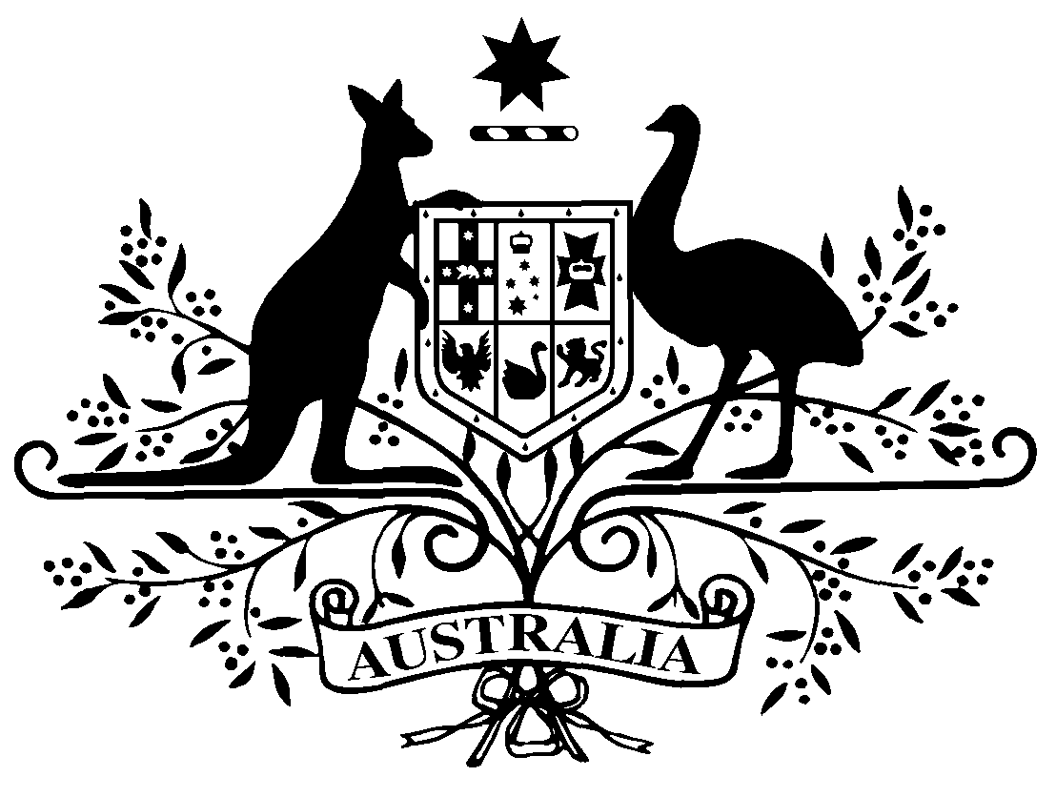

**PB 61 of 2018**

**National Health (Pharmaceutical Benefits Scheme- Exempt items - Section 84AH) Amendment Determination 2018 (No. 2)**

*National Health Act* *1953*

I, LISA LA RANCE, Assistant Secretary, Pricing and PBS Policy Branch, Technology Assessment and Access Division, Department of Health, delegate of the Minister for Health, make this Determination under section 84AH of the *National Health Act 1953*.

Dated 27 June 2018

**LISA LA RANCE**

Assistant Secretary

Pricing and PBS Policy Branch

Technology Assessment and Access Division

Department of Health

**1 Name of Instrument**

1. This instrument is the *National Health (Pharmaceutical Benefits Scheme-Exempt items - Section 84AH) Amendment Determination 2018 (No. 2).*
2. This instrument may also be cited as PB 61 of 2018.

**2 Commencement**

This instrument commences on 1 July 2018.

**3 Amendments to PB 81 of 2017**

Schedule 1 amends the legislative instrument titled *National Health (Pharmaceutical Benefits Scheme – Exempt items – Section 84AH) Determination 2017 (PB 81 of 2017)* (as amended)

Schedule 1 Amendments

1. Schedule 1, after entry for Amisulpride, Oral solution 100 mg per mL, 60 mL

*Omit:*

|  |  |  |
| --- | --- | --- |
| Amoxycillin | Powder for paediatric drops 100 mg (as trihydrate) per mL, 20 mL | Oral |

*Insert:*

|  |  |  |
| --- | --- | --- |
| Amoxicillin | Powder for paediatric drops 100 mg (as trihydrate) per mL, 20 mL | Oral |

1. Schedule 1, after entry for Carbamazepine, Oral suspension 100 mg per 5 mL, 300 mL

*Insert:*

|  |  |  |
| --- | --- | --- |
| Ciclosporin | Oral liquid 100 mg per mL, 50 mL | Oral |
| Ciclosporin | Capsule 10 mg | Oral |
| Ciclosporin | Solution concentrate for I.V. infusion 50 mg in 1 mL | Injection |

1. Schedule 1, after entry for Clozapine, Oral liquid 50 mg per mL, 100 mL

*Omit:*

|  |  |  |
| --- | --- | --- |
| Cyclosporin | Oral liquid 100 mg per mL, 50 mL | Oral |
| Cyclosporin | Capsule 10 mg | Oral |
| Cyclosporin | Solution concentrate for I.V. infusion 50 mg in 1 mL | Injection |

1. Schedule 1, after entry for Fluconazole, Powder for oral suspension 50 mg in 5 mL, 35 mL

*Omit:*

|  |  |  |
| --- | --- | --- |
| Frusemide | Oral solution 10 mg per mL, 30 mL | Oral |

*Insert:*

|  |  |  |
| --- | --- | --- |
| Furosemide | Oral solution 10 mg per mL, 30 mL | Oral |

1. Schedule 1, after entry for Hydromorphone, Oral liquid containing hydromorphone hydrochloride 1 mg per mL, 473 mL

*Omit:*

|  |  |  |
| --- | --- | --- |
| Indomethacin | Suppository 100 mg | Rectal |

*Insert:*

|  |  |  |
| --- | --- | --- |
| Indometacin | Suppository 100 mg | Rectal |

1. Schedule 1, after entry for Paracetamol, Suppositories 500 mg, 24

*Omit:*

|  |  |  |
| --- | --- | --- |
| Prochlorperazine | Injection containing prochlorperazine mesylate 12.5 mg in 1 mL | Injection |

*Insert:*

|  |  |  |
| --- | --- | --- |
| Prochlorperazine | Injection containing prochlorperazine mesilate 12.5 mg in 1 mL | Injection |