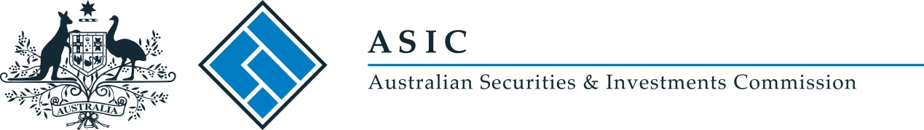
ASIC Class Rule Waiver [CW 18/0143]
I, Greg Yanco, delegate of the Australian Securities and Investments Commission, make the following legislative instrument.
Date: 5 March 2018

Greg Yanco

Contents
Part 1—Preliminary 3
1 Name of legislative instrument 3
2 Commencement 3
3 Authority 3
4 Schedules 3
Schedule 1—Amendments 4
ASIC Class Rule Waiver [17-0251] 4

Part 1—Preliminary

1 Name of legislative instrument
This instrument is ASIC Class Rule Waiver [CW 18/0143].

2 Commencement
This instrument commences on the day after it is registered on the Federal Register of Legislation.
Note: The register may be accessed at www.legislation.gov.au.

3 Authority
This instrument is made under subrule 1.2.1(1) of the ASIC Market Integrity Rules (ASX 24 Market) 2010.

4 Schedules
Each instrument that is specified in the Schedule to this instrument is amended as set out in the applicable items in the Schedule.

Schedule 1—Amendments

ASIC Class Rule Waiver [17-0251]
1 Paragraph 7
Omit “20 March 2018”, substitute “20 March 2020”.

