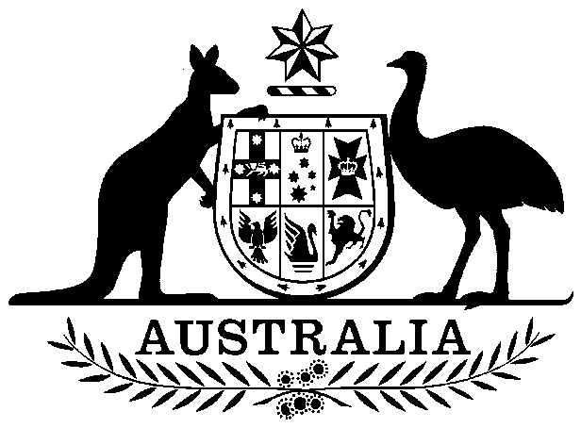

**COMMONWEALTH OF AUSTRALIA**

##### Environment Protection and Biodiversity Conservation Act 1999

**Amendment of List of Exempt Native Specimens – South Australian Lakes and Coorong Fishery, February 2018**

I, PAUL MURPHY, Assistant Secretary, Wildlife Trade and Biosecurity Branch, as Delegate of the Minister for the Environment and Energy, pursuant to subsection 303DC(1)(a) of the *Environment Protection and Biodiversity Conservation Act 1999* (EPBC Act), hereby amend the list of exempt native specimens established under section 303DB of the EPBC Act by including in the list the following:

* specimens that are or are derived from fish or invertebrates, other than specimens that belong to species listed under Part 13 of the EPBC Act (other than a species listed in the conservation dependent category), and specimens that belong to taxa listed under section 303CA of the EPBC Act (Australia’s CITES list), taken in the South Australian Lakes and Coorong Fishery, as defined in the Fisheries Management (Lakes and Coorong Fishery) Regulations 2009 (SA) and the Fisheries Management (General) Regulations 2017 (SA) in force under the *Fisheries Management Act 2007* (SA),

with a notation that inclusion of the specimens in the list is subject to the following restrictions or conditions:

* the specimen, or the fish or invertebrate from which it is derived, was taken lawfully, and
* the specimens are covered by the declaration of an approved wildlife trade operation under section 303FN of the EPBC Act in relation to the fishery.

This instrument is a legislative instrument for the purposes of the *Legislation Act 2003*.

The instrument commences the day after it is registered.

All state legislation referred to in the instrument is incorporated as in force at the time this instrument commences.

# Dated this 19th day of February 2018

….……………Paul Murphy……………………

Delegate of the Minister for the Environment and Energy