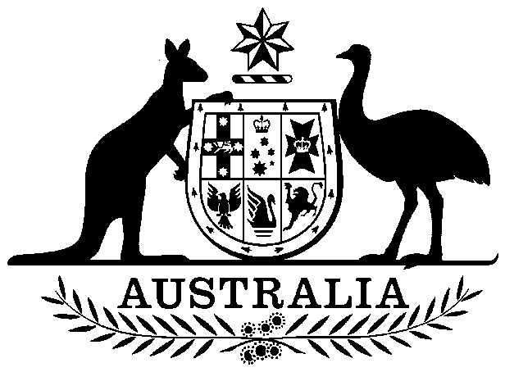

COMMONWEALTH OF AUSTRALIA

##### Environment Protection and Biodiversity Conservation Act 1999

###### DECLARATION OF AN APPROVED WILDLIFE TRADE OPERATION – CORAL SEA FISHERY, DECEMBER 2017

I, ILSE KIESSLING, Acting Assistant Secretary, Wildlife Trade and Biosecurity Branch, as Delegate of the Minister for the Environment and Energy, have considered in accordance with section 303FN of the *Environment Protection and* *Biodiversity Conservation Act 1999* (EPBC Act) the application from the Australian Fisheries Management Authority and advice on the ecological sustainability of the operation. I am satisfied on those matters specified in section 303FN of the EPBC Act. I hereby declare the operations for the harvesting of specimens that are or are derived from fish or invertebrates, other than specimens that belong to species listed under Part 13 of the EPBC Act (other than a species listed in the conservation dependent category), and specimens that belong to taxa listed under section 303CA of the EPBC Act (Australia’s CITES list), taken in the Commonwealth Coral Sea Fishery as defined in the management regime in force under the *Fisheries Management Act 1991* (Cth) and the Fisheries Management Regulations 1992 (Cth), to be an approved wildlife trade operation, in accordance with subsection 303FN(2) and paragraph 303FN(10)(d), for the purposes of the EPBC Act.

Unless amended or revoked, this declaration:

1. is valid until 18 December 2020 and;
2. is subject to the conditions applied under section 303FT specified in the Schedule.

Dated this 20 day of December 2017

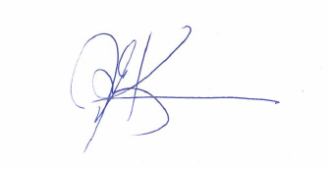

………….…….…………………………………

Delegate of the Minister for the Environment and Energy

A person whose interests are affected by this declaration may, within 28 days, make an application in writing to the Department of the Environment and Energy for the reasons for the decision.

An application for independent review of the decision (under section 303GJ(1) of the *Environment Protection and Biodiversity Conservation Act 1999*) may be made to the Administrative Appeals Tribunal (AAT), on payment of the relevant fee by the applicant, either within 28 days of receipt of the reasons for the decision, or within 28 days of this declaration if reasons for the decision are not sought. Applications should be made to the Deputy Registrar, AAT in your Capital City. Please visit the AAT’s website at <http://www.aat.gov.au/> for further information.

You may make an application under the *Freedom of Information Act 1982* (Cth) to access documents relevant to this decision. For further information, please visit <http://www.environment.gov.au/foi/index.html>.

Further enquiries should be directed to the Director, Wildlife Trade Assessments Section, Department of the Environment and Energy, Telephone: (02) 6274 1917 Email: sustainablefisheries@environment.gov.au.

# SCHEDULE

Declaration of the Harvest Operations of the Commonwealth Coral Sea Fishery as an approved wildlife trade operation, December 2017

**ADDITIONAL PROVISIONS (section 303FT)**

Relating to the harvesting of specimens that are or are derived from fish or invertebrates, other than specimens that belong to species listed under Part 13 of the EPBC Act (other than a species listed in the conservation dependent category), and specimens that belong to taxa listed under section 303CA of the EPBC Act (Australia’s CITES list), taken in the Commonwealth Coral Sea Fishery:

1. Operation of the Coral Sea Fishery will be carried out in accordance with management arrangements in force under the Commonwealth *Fisheries Management Act 1991*, Fisheries Management Regulations 1992 and relevant Commonwealth fisheries policies.
2. The Australian Fisheries Management Authority to inform the Department of the Environment and Energy of any intended material changes to the Coral Sea Fishery management arrangements that may affect the assessment against which *Environment Protection and Biodiversity Conservation Act 1999* decisions are made.
3. The Australian Fisheries Management Authority to produce and present reports to the Department of the Environment and Energy annually as per Appendix B of the *Guidelines for the Ecologically Sustainable Management of Fisheries - 2nd Edition*.
4. AFMA to limit the take of species listed under the Convention on the International Trade of Endangered Species (CITES), from the area of the Coral Sea Fishery to no more than:
   1. 40 tonnes of any mixture of species belonging to the family Acroporidae per year (1 July – 30 June).
   2. 50 individual humphead Maori wrasse (*Cheilinus undulates*) per year (1 July – 30 June).
5. AFMA to:
   1. review the species composition and spatial extent of all coral harvest when 20 tonnes of coral has been harvested.
   2. ensure that a disproportionate amount of coral species are not taken from a single reef.
6. AFMA to evaluate, document and seek to mitigate any risks posed by the Coral Sea Fishery to CITES-listed species. For coral species this will be undertaken at the reef-level, while for humphead Maori wrasse this will be undertaken at the sub-reef level.
7. AFMA to report the following to the CITES Scientific Authority of Australia, as part of the annual reporting referred to in Condition 3:
   1. the harvested weight and locations of harvest for each coral species
   2. the number of individual humphead Maori wrasse, their sex, lengths and locations of harvest
   3. any assessments, management changes or findings relevant to the management of CITES listed species in the Coral Sea Fishery.
8. AFMA to complete the following for all sectors of the Coral Sea Fishery:
   1. review and revise the ecological risk assessments
   2. develop and implement ecological risk management strategies
   3. review and revise the Bycatch and Discarding Workplan.