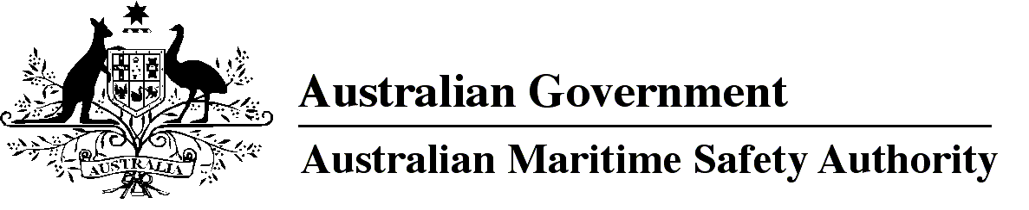
AMSA MO 2017/5
Marine Orders (Navigation Act) Administrative Amendment Order 2017
I, Michael Kinley, Chief Executive Officer of the Australian Maritime Safety Authority, make this Order under subsection 342(1) of the Navigation Act 2012.
5 October 2017
Michael Kinley
Chief Executive Officer

1 Name of Order
This Order is Marine Orders (Navigation Act) Administrative Amendment Order 2017.
2 Commencement
This Order commences on the day after it is registered.
3 Amendment of Marine Orders
Each Order mentioned in the title of a Schedule to this Order is amended in accordance with the Schedule.
Schedule 1 Marine Order 12 (Construction — subdivision and stability, machinery and electrical installations) 2016
[1] Subparagraph 10(1)(a)(i)
omit
3 and 6
insert
3, 5 and 6
[2] Section 23
substitute
23 Access to vessels in port — responsibility of persons boarding or disembarking
(1) A person boarding or leaving a vessel must use the means of access provided or identified by the master.
Penalty: 50 penalty units.
(2) An offence against subsection (1) is a strict liability offence.
(3) A person is liable to a civil penalty if the person contravenes subsection (1).
Civil penalty: 50 penalty units.
Schedule 2 Marine Order 25 (Equipment — lifesaving) 2014
[1] Subsection 4(1), after definition of GT
insert
launching appliance means a means of transferring a survival craft or rescue boat from its stowed position safely to the water.

[2] Section 30
substitute
30 Cargo vessels certified Class 2C — survival craft and rescue boats
(1) The vessel must comply with sections 33, 34 and 35 as if it were certified as Class 2A or 2B.
(2) If the vessel is less than 25 m long it must:
(a) comply with section 36 as if it were certified as Class 2A or 2B; and
(b) have at least 1 liferaft that complies with Table 3 of subsection 7A of Part C of the NSCV.
[3] Section 33
substitute
33 Survival craft and rescue boats — vessels at least 85 m long
(1) If the vessel is at least 85 m long, it must comply with the requirements mentioned in subsection (2) or (3).
(2) For subsection (1), the requirements are that the vessel carries:
(a) on each side of the vessel — at least 1 lifeboat with a total capacity of at least the number of persons that the vessel is certified to carry; and
(b) either:
(i) on each side of the vessel — at least 1 liferaft with a total capacity of at least half the number of persons that the vessel is certified to carry; or
(ii) at least 1 liferaft that has a total capacity of at least half the number of persons that the vessel is certified to carry and that is stowed to allow easy side-to-side transfer at a single open deck level.
(3) For subsection (1), the requirements are that the vessel carries:
(a) at least 1 free-fall lifeboat that:
(i) complies with section 4.7 of the LSA Code; and
(ii) has a total capacity of at least the number of persons that the vessel is certified to carry; and
(b) on each side of the vessel — at least 1 inflatable or rigid liferaft that:
(i) complies with section 4.2 or 4.3 of the LSA Code; and
(ii) has a total capacity of at least the number of persons that the vessel is certified to carry; and
(iii) is served by a launching appliance.
[4] Schedule 1, subsubparagraph 10(1)(b)(iii)(A)
substitute
(A) AS/NZS 4280.1:2017 406 MHz satellite distress beacons — Marine emergency position-indicating radio beacons (EPIRB), as amended from time to time; or

[5] Schedule 1, subclause 10(1), note 1
omit
4280.1:2003
insert
4280.1:2017, as amended from time to time,
[6] Schedule 1, clause 13
omit
in force
insert
amended
Schedule 3 Marine Order 27 (Safety of navigation and radio equipment) 2016
[1] Paragraph 26(8)(e), note
omit
[2] Subsection 26(8), note
substitute
Note for paragraph (e) The handbook for GMDSS ship station operators is available from the AMSA website at http://www.amsa.gov.au.
Note AMSA will consider exempting a vessel to which Chapter IV of SOLAS does not apply from paragraphs (8)(g) to (j).
Schedule 4 Marine Order 28 (Operations standards and procedures) 2015
[1] Subsection 2(1), note
after
http://www.imo.org/publications.
insert
The STCW Convention (ATS series number [1984] ATS 7) and STCW Code (ATS series number [1997] ATS 33) including any amendments in force are in the Australian Treaties Series accessible from the Australian Treaties Library on the AustLII website at http://www.austlii.edu.au.
Schedule 5 Marine Order 32 (Cargo handling equipment) 2016
[1] Section 4, note 1
after
http://www.amsa.gov.au.
insert
Copies of incorporated documents will be made available for viewing free of charge at the nearest AMSA office, on request.
[2] Schedule 3, subclause 13(3), definition of safety factor
after
2017
insert
or in Appendix E of the ILO Code
[3] Schedule 3, subclause 13(4)
substitute
(4) Material, design, manufacture, marking, testing and certification of flat synthetic-webbing slings must comply with:
(a) AS 1353.2-1997 Flat Synthetic Webbing Slings Part 2: Care and use, as in force on 1 January 2017; or
(b) Appendix E of the ILO Code.
Note Standards mentioned in this clause will be made available for viewing free of charge at AMSA offices on request — see note 1 under section 4.
Schedule 6 Marine Order 34 (Sold bulk cargoes) 2016
[1] Section 21, note
omit
31 (Vessel surveys and certification) 2015
insert
1 (Administration) 2013
Schedule 7 Marine Order 63 (Vessel reporting systems) 2015
[1] Schedule 3, clause 2, note
omit
Guidelines for the onboard operational use of shipborne automatic identification systems (AIS) adopted by IMO Resolution A.917(22)
insert
Revised guidelines for the onboard operational use of shipborne automatic identification systems (AIS), adopted by IMO Resolution A.1106(29),
Schedule 8 Marine Order 91 (Marine pollution prevention — oil) 2014
[1] Paragraph 37(1)(a)
omit
IMO Resolution MEPC.107(49)
insert
the Revised guidelines and specifications for pollution prevention equipment for machinery space bilges of ships, adopted by IMO Resolution MEPC.107(49), as amended from time to time
Note
1. All legislative instruments and compilations of legislative instruments are registered on the Federal Register of Legislation under the Legislation Act 2003. See https://www.legislation.gov.au.

