

**Food Standards (Application A1125 – Endo ß(1,4) Xylanase as a Processing Aid (Enzyme)) Variation**

The Board of Food Standards Australia New Zealand gives notice of the making of this variation under section 92 of the *Food Standards Australia New Zealand Act 1991*. The variation commences on the date specified in clause 3 of this variation.

5 September 2017

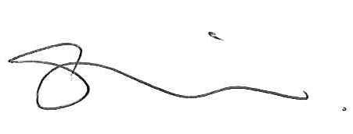

Standards Management Officer

Delegate of the Board of Food Standards Australia New Zealand

**Note:**

This variation will be published in the Commonwealth of Australia Gazette No. FSC 114 on 7 September 2017. This means that this date is the gazettal date for the purposes of clause 3 of the variation.

Name

This instrument is the *Food Standards (Application A1125 – Endo ß(1,4) Xylanase as a Processing Aid (Enzyme)) Variation*.

2 Variation to a standard in the *Australia New Zealand Food Standards Code*

The Schedule varies a Standard in the *Australia New Zealand Food Standards Code*.

3 Commencement

The variation commences on the date of gazettal.

**Schedule**

**[1] Schedule 18** is varied by inserting in the table to subsection S18—9(3), in alphabetical order

|  |  |  |
| --- | --- | --- |
| Endo-1,4-beta-xylanase (EC 3.2.1.8) from *Bacillus subtilis*, containing the gene for Endo-1,4-beta-xylanase isolated from *Pseudoalteromonas haloplanktis*. | For use in the manufacture of bakery and other cereal-based products. | GMP |