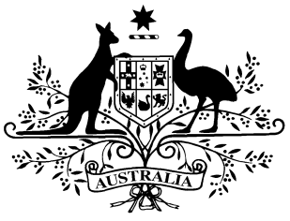

PB 59 of 2017

National Health (IVF Program) Special Arrangement Amendment Instrument 2017 (No. 1)

*National Health Act 1953*

I, JULIANNE QUAINE, Assistant Secretary, Pharmaceutical Access Branch, Pharmaceutical Benefits Division, Department of Health, delegate of the Minister for Health and Minister for Sport, make this Instrument under subsection 100(2) of the *National Health Act 1953*.

Dated 25 JULY 2017

JULIANNE QUAINE

Assistant Secretary

Pharmaceutical Access Branch

Pharmaceutical Benefits Division

Department of Health

1 Name of Instrument

(1) This Instrument is the *National Health (IVF Program) Special Arrangement Amendment Instrument 2017 (No. 1)*.

(2) This Instrument may also be cited as PB 59 of 2017.

2 Commencement

This Instrument commences on 1 August 2017.

3 Amendment of PB 60 of 2015

Schedule 1 amends the *National Health (IVF Program) Special Arrangement 2015* (PB 60 of 2015).

Schedule 1 Amendments

1. Schedule 1, after the entry for the listed drug Chorionic Gonadotrophin in the form Injection set containing 3 ampoules powder for injection 1,500 units and 3 ampoules solvent 1 mL

*insert:*

Chorionic Gonadotrophin Injection set containing powder for injection 1,500 units, 3 and solvent 1 mL, 3 Injection Pregnyl C(100)