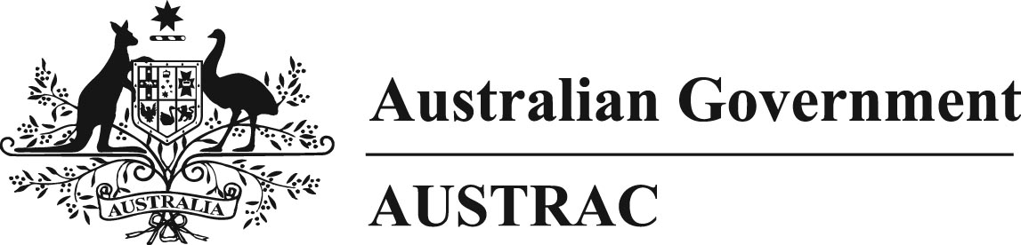

**Explanatory Statement – *Anti-Money Laundering and Counter-Terrorism Financing Rules Amendment Instrument 2017 (No. 3)* amending the *Anti-Money Laundering and Counter-Terrorism Financing Rules Instrument 2007 (No. 1)***

**Purpose and operation of Anti-Money Laundering/Counter‑Terrorism Financing Rules (AML/CTF Rules) amending Chapter 51.**

1. Section 229 of the *Anti-Money Laundering and Counter-Terrorism Financing Act 2006* (AML/CTF Act) provides that the AUSTRAC Chief Executive Officer (AUSTRAC CEO) may, by writing, make AML/CTF Rules prescribing matters required or permitted by any other provision of the AML/CTF Act.

**Background**

2. Part 51.3 was inserted into Chapter 51 in 2012 to address an anomaly whereby International Funds Transfer Instructions (IFTIs) between PayPal Australia and PayPal Europe were reportable to AUSTRAC, whereas those between PayPal Australia and PayPal USA and PayPal Singapore were not.

3. This anomaly arose as PayPal Australia is a ‘financial institution’[1] under the AML/CTF Act because it is an authorised deposit-taking institution (ADI). As a result PayPal Australia can only send or receive an IFTI – Electronic (IFTI-E) (which are reported under Chapter 16 of the AML/CTF Rules). This means that PayPal Australia transactions with PayPal Europe are reportable as PayPal Europe is a financial institution (ADI) because it is a bank licensed in Luxembourg.

4. However, neither PayPal USA nor PayPal Singapore are financial institutions and therefore these transactions with PayPal Australia cannot be reportable as IFTI-Es. These transactions were also not reportable under Chapter 17 of the AML/CTF Rules as IFTI – Designated Remittance Arrangements (IFTI-DRAs) because these reports must be between ‘non-financiers’[2].

5. To resolve this anomaly, Part 51.3 of Chapter 51 specified PayPal USA and PayPal Singapore as both ordering and beneficiary institutions (in effect making them financial institutions) thereby making the transactions between PayPal Australia and PayPal US and PayPal Singapore reportable to AUSTRAC as IFTI-Es under Chapter 16.

**New Amendments to Chapter 51**

6. In November 2016, the Hong Kong Monetary Authority licenced PayPal Hong Kong as a Stored Value Facility Licensee. As a result PayPal transactions that related to Hong Kong and which were previously processed by PayPal Singapore are now processed by PayPal Hong Kong. This created a ‘reporting gap’ to AUSTRAC whereby PayPal Australia is a financial institution but PayPal Hong Kong is not as it is a non-financier.

7. To capture the IFTI transactions between PayPal Australia and PayPal Hong Kong, amendments to Chapter 51 have been made specifying PayPal Hong Kong as both an ordering and beneficiary institution under section 8 (person-to-person electronic funds transfer instructions) and section 9 (same-person electronic funds transfer instructions) of the AML/CTF Act.

8. Accordingly, PayPal Hong Kong is now a financial institution for the purposes of the AML/CTF Rules and therefore will report IFTI-E transactions under Chapter 16.

**Statement of Compatibility with the *Human Rights (Parliamentary Scrutiny) Act 2011***

9. The *Human Rights (Parliamentary Scrutiny) Act 2011* requires a Statement of Compatibility declaring that the relevant instrument is compatible with the human rights and freedoms recognised or declared in the international instruments listed in section 3 of that Act.

10. The Statement of Compatibility for the *Anti-Money Laundering and Counter-Terrorism Financing Rules Amendment Instrument 2017 (No. 3)* is included in this Explanatory Statement at page 4. The acting AUSTRAC CEO, as the rule-maker of this legislative instrument, has stated that it is compatible with the human rights and freedoms recognised or declared in the international instruments listed in section 3 of the *Human Rights (Parliamentary Scrutiny) Act 2011*.

**Notes on sections**

**Section 1**

This section sets out the name of the Instrument, i.e. the *Anti-Money Laundering and Counter-Terrorism Financing Rules Amendment Instrument 2017 (No. 3).*

**Section 2**

This section specifies that the Instrument commences on the day after it is registered.

**Section 3**

This section contains the details of the amendment:

Schedule 1 amends the *Anti-Money Laundering and Counter-Terrorism Financing Rules Instrument 2007 (No. 1)*.

**Schedule 1**

This schedule amends Chapter 51.

**Notes on Paragraphs**

**Chapter 51**

**Item 1**

This item repeals the existing Part 51.3 and substitutes a new Part 51.3 specifying the details regarding PayPal Hong Kong.

**Legislative instruments**

These AML/CTF Rules are legislative instruments as defined in section 8 of the *Legislation Act 2003*.

**Likely impact**

The amendments to Chapter 51 will not adversely impact PayPal Australia as the resolution of the IFTI reporting anomaly will not require PayPal Australia to submit an increased number of IFTI reports, because they were previously submitted to AUSTRAC before ceasing in November 2016.

**Assessment of benefits**

The amendments to Chapter 51 will remove a legal and regulatory anomaly and thereby ensure that certain IFTI reports will now be reported under the AML/CTF Rules. The information supplied in such reports will contribute to intelligence information relevant to potential money-laundering and/or terrorism-financing activity.

**Consultation**

The amendments to Chapter 51 were published on the AUSTRAC website from 22 May 2017 until 5 May 2017. No submissions were received.

AUSTRAC has consulted with the Australian Taxation Office, the Department of Immigration and Border Protection, the Australian Federal Police, the Australian Criminal Intelligence Commission and the Office of the Australian Information Commissioner.

**Ongoing consultation**

AUSTRAC will conduct ongoing consultation with stakeholders on the operation of these AML/CTF Rules.

**Statement of Compatibility with Human Rights**

*Prepared in accordance with Part 3 of the Human Rights (Parliamentary Scrutiny) Act 2011*

***Anti-Money Laundering and Counter-Terrorism Financing Rules Amendment Instrument 2017 (No. 3)***

This Instrument is compatible with the human rights and freedoms recognised or declared in the international instruments listed in section 3 of the *Human Rights (Parliamentary Scrutiny) Act 2011*.

**Overview of the legislative instrument**

The Instrument amends Chapter 51 to allow the reporting of International Funds Transfer Instructions to AUSTRAC by a specified reporting entity (PayPal Hong Kong).

**Human rights implications**

It is considered that this Instrument does not engage any of the applicable rights or freedoms.

**Conclusion**

This Instrument is, therefore, compatible with human rights as it does not raise any human rights issues.

Gavin McCairns

Acting Chief Executive Officer

Australian Transaction Reports and Analysis Centre

1. Section 5 of the AML/CTF Act defines a ‘financial institution’ as an ADI, bank, building society, credit union or a person specified in the AML/CTF Rules.
2. Section 5 of the AML/CTF Act defines a ‘non-financier’ as being a person who is not an ADI, bank, building society, credit union or a person specified in the AML/CTF Rules.