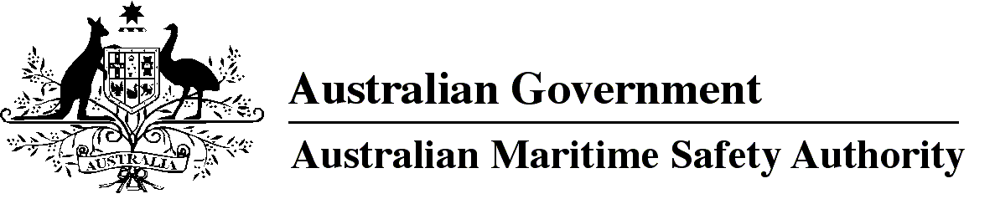

AMSA MO 2017/3

Marine Order 502 (Vessel identifiers — national law) 2017

I, Gary Prosser, Acting Chief Executive Officer of the Australian Maritime Safety Authority, (the National Marine Safety Regulator under section 9 of the *Marine Safety (Domestic Commercial Vessel) National Law*), make this Order under subsection 163(1) of the *Marine Safety (Domestic Commercial Vessel) National Law*.

22 June 2017

**Gary Prosser**  
Acting Chief Executive Officer

1 Name of Order 3

1A Commencement 3

1B Repeal of *Marine Order 502 (Vessel identifiers — national law) 2013* 3

2 Application for unique identifier 3

3 Criterion for issue of unique identifier 3

4 Display of unique identifier 3

5 Permitted removal or alteration of unique identifier 3

6 Notification requirements 4

1 Name of Order

This Order is *Marine Order 502 (Vessel identifiers — national law) 2017*.

1A Commencement

This Order commences on 1 July 2017.

1B Repeal of *Marine Order 502 (Vessel identifiers — national law) 2013*

*Marine Order 502 (Vessel identifiers — national law) 2013* is repealed.

2 Application for unique identifier

For paragraph 76(1)(c) of the national law, an application for a unique identifier must be made in accordance with *Marine Order 501 (Administration — national law) 2013*.

*Note 1*A fee may be charged — see section 9 of the National Law Act.

*Note 2*   For the definition of ***unique identifier*** see section 6 of the national law. ***National law*** and some other terms used in this Order aredefined in *Marine Order 501 (Administration — national law) 2013*.

*Note 3*An application for a unique identifier may be made at any time, including before or during the course of construction of a domestic commercial vessel.

3 Criterion for issue of unique identifier

For paragraph 77(1)(a) of the national law, the criterion for issue of a unique identifier is that the National Regulator has not previously issued a unique identifier for the vessel.

*Note*The National Regulator may issue a unique identifier for a domestic commercial vessel that holds an ***old unique identifier*** as defined in subsection 14(1) of the *Marine Safety (Domestic Commercial Vessel) National Law Regulation 2013*. This is because old unique identifiers are not issued by the National Regulator but by an agency of a State or the Northern Territory before 1 July 2013.

4 Display of unique identifier

(1) For section 79 of the national law, a unique identifier must be displayed clearly and prominently on the vessel.

(2) The unique identifier must be displayed within 21 days of being issued.

(3) However, if application was made for the unique identifier before or during the course of construction of the vessel, the unique identifier must be displayed before the vessel is launched.

5 Permitted removal or alteration of unique identifier

A unique identifier may only be removed or altered if:

(a) the owner has notified the National Regulator in writing that the vessel has ceased to be a domestic commercial vessel; or

(b) an exemption from a requirement to display a unique identifier is in effect for the vessel.

6 Notification requirements

(1) For paragraph 78(c) of the national law, the owner of a domestic commercial vessel that has a unique identifier must tell the National Regulator within 14 days of any of the following events:

(a) transfer of ownership of the vessel;

(b) sinking or scrapping of the vessel;

(c) the vessel ceases to be a domestic commercial vessel.

Penalty: 50 penalty units.

(2) An offence against subsection (1) is a strict liability offence.

*Note*   If a form is approved for the notification, the approved form must be used and is available on the AMSA website at http://www.amsa.gov.au — see *Marine Order 501 (Administration — national law)* *2013*.

Note

1. All legislative instruments and compilations of legislative instruments are registered on the Federal Register of Legislation under the *Legislation Act 2003.* See https://www.legislation.gov.au.