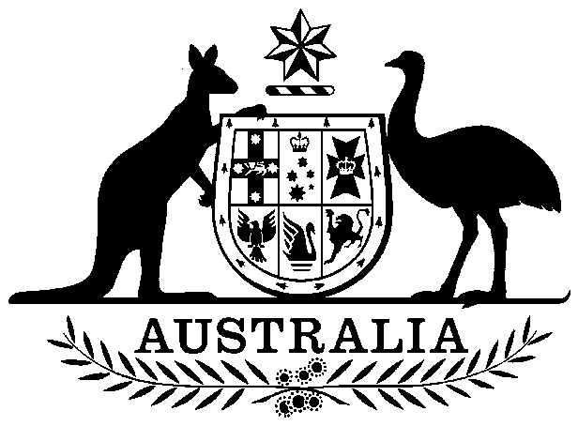

**COMMONWEALTH OF AUSTRALIA**

##### Environment Protection and Biodiversity Conservation Act 1999

**Amendment of List of Exempt Native Specimens**

I, PAUL MURPHY, Assistant Secretary, Wildlife Trade and Biosecurity Branch, as Delegate of the Minister for the Environment and Energy, pursuant to subsection303DC(1)(a) of the *Environment Protection and Biodiversity Conservation Act 1999* (EPBC Act), hereby amend the list of exempt native specimens established under section 303DB of the EPBC Act by revoking the conditions to which the inclusion of the following item in the list is subject:

* specimens that are or are derived from fish or invertebrates, other than

specimens that belong to species listed under Part 13 of the EPBC Act,

and specimens that belong to taxa listed under section 303CA of the EPBC Act (Australia’s CITES list), taken in the Queensland East Coast Otter Trawl Fishery

and imposing the following conditions to which inclusion of the specimens in the list is subject:

* the specimen, or the fish or invertebrate from which it is derived, was taken lawfully, and
* the specimens are included in the list until 17 November 2017.

# Dated this 23rd day of May 2017

….………………………Paul Murphy……………………….

Delegate of the Minister for the Environment and Energy