# Instrument NumberAEB 17/1583

I, Pieter van Dijk, a delegate of the Civil Aviation Safety Authority, make this instrument under paragraph 39.004(3)(a) of the Civil Aviation Safety Regulations 1998.

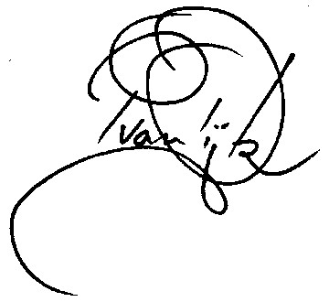

Pieter van Dijk

Continuing Airworthiness Section Manager

30 March 2017

Approval – Means of Compliance with Transport Canada Airworthiness Directive (AD) CF-2011-24 - Wing to Fuselage Attachment Joints - Barrel Nut Cracking

1. Duration

This instrument:

1. commences on the date of registration; and
2. ceases to have effect if Transport Canada AD CF-2011-24 (the AD) is amended.
3. Application

This instrument applies to a registered operator who operates a type of aircraft mentioned in the AD, as in force at the date of this instrument, issued by Transport Canada.

1. Approval

I approve, as a means of compliance with the AD, the replacement of alloy steel barrel nuts with INCONEL barrel nuts in accordance with either:

(a) Bombardier modification summary package 4-123841, 4-113769 or 4-113768, as in force at the date of this instrument, or

(b) Bombardier service bulletin 84-57-26, as in force at the date of this instrument.